Teacher’s Name Benjamin Spiers

Subject/Grade 6th Grade US History to 1865 School Year Spring 2014

I. Setting (Describe the population  and special learning  circumstances.) | I taught five classes of 6th Grade US History to 1865. For the SMART goal I am using my 6th Period class which has a total of twenty-one students. Twenty of those students turned in the first of three essays for the baseline data. Out of those twenty students, one has an IEP and another student is likely socio-economically disadvantaged.
II. Content/Subject/Field Area  (The area/topic addressed based  on learner achievement, data  analysis, or observational data) | For my class there is no area that is required to be addressed by me in developing the SMART goal. I was interested in evaluating the writing ability of this class because I had not seen these students do any writing up to this point. Over the course of the next few weeks I will give a total of three one to two paragraph persuasive essay assignments in which students will argue with evidence why a person, event, or invention had the biggest impact in American history. These writing assignments will help prepare students for future Social Studies and English classes.
III. Baseline Data (What does the  current data show?) | I assessed the students’ first essay using a four point rubric in eight categories for a total of thirty-two points. The scores on the essay ranged from nineteen to twenty-seven. Thirteen out of twenty students (65%) scored at least a twenty-four on the essay. I consider an overall score of twenty-four or higher to be proficient, and twenty-eight or higher to be exemplary. The data shows that every student has room for growth in their next two essay assignments.  Data attached
IV. Goal Statement (Describe what  you want learners/program to  accomplish.) | For the next month, 100% of my students will make measurable progress in writing persuasive essays. By late April 2014 every student will increase their overall score by at least one point. By late April 75% percent of my students will have an overall score of at least twenty-four on their persuasive essays.
V. Means for Attaining Goal (Strategies used to accomplish the goal)

Strategy | Evidence | Target Date
Frames to help with student thoughts | Lesson plans, students completing the Frame and using it in their paper | Ongoing
Textbook readings to help students gather evidence | Lesson plans, evidence from textbook students use in essay | Ongoing
Provide feedback on papers to improve performance | Student use of comments on paper to help improve their next essay or essays | Ongoing
Provide feedback to class as whole during class time to improve performance | Lesson plans, talk about essays in class | Ongoing
Provide students the rubric to improve performance | Students use rubric in their essays to see what they need to do in order to write a good essay and score well. | Ongoing

SUPPORTING DATA AND ANALYSIS
VI. Baseline Data

Baseline Writing Prompt

Persuasive Essay: Out of the first five Presidents we studied as a class last unit, which one do you believe had the biggest impact on American History? Write a 1-2 paragraph response, as the bottom half of this page or typed on a computer. There is not a right answer, as the key is to provide strong evidence for why you believe which President had the biggest impact on American History.

Baseline Scores (out of 32 points)

Student | Score | Student | Score | Student | Score | Student | Score
1 | 25 | 6 | 20 | 11 | 24 | 16 | 21
2 | 22 | 7 | 25 | 12 | 24 | 17 | 25
3 | 26 | 8 | 24 | 13 | 25 | 18 | 21
4 | 24 | 9 | 27 | 14 | 19 | 19 | 26
5 | 22 | 10 | 23 | 15 | 24 | 20 | 24

Number of students with a Proficient Score of 24 or above: 13 (65%)

Number of students with an Exemplary Score of 28 or above: 0 (0%)

Student #14 and Student #18 will be the two students used for the micro analysis. One of these students is likely socio-economically disadvantaged.

VII. Mid-term data

Mid-Term Writing Prompt

Persuasive Essay: In 1-2 Paragraphs, argue whether you believe the abolitionist movement or the women’s suffrage movement had the biggest impact on American history. You can only choose one event you believe to be the most significant and there is not a wrong answer. The key here is to explain why you believe the event you choose is most important and support it with evidence.

Mid-term Scores (out of 32 points)

Student | Score | Student | Score | Student | Score | Student | Score
1 | 25 | 6 | 21 | 11 | 23 | 16 | 23
2 | 22 | 7 | 25 | 12 | 25 | 17 | 24
3 | 25 | 8 | 24 | 13 | 27 | 18 | 23
4 | 26 | 9 | 29 | 14 | 19 | 19 | 24
5 | 22 | 10 | 22 | 15 | 25 | 20 | 24

Number of students with a Proficient Score of 24 or above: 13 (70%)

Number of students with an Exemplary Score of 28 or above: 0 (0%)

Number of students with an Improved Score from their 1st Essay: 7 (35%)

In the mid-term essays twelve out of twenty students scored at least a twenty-four on their essay. Seven out of twenty students had improved scores from their first essay. Students had the rubric for the second essay and will have it again for the third essay. I also provided written feedback on each student’s essay. We also went over as a class what they could do to help improve their final essays.

Baseline vs. Mid-Term Essay Score Distribution

VIII. Final Essay Data

Final Essay Writing Prompt

Persuasive Essay: On this sheet of paper or typed up, write a 1-2 paragraph essay on what you believe to be the most significant invention from the Westward Expansion time period. Your choices are the steam locomotive, steamboat, mechanical reaper, or cotton gin. There is not a correct answer, as the key here is to support your answer with evidence.

Final Essay Scores (out of 32 points)

Student | Score | Student | Score | Student | Score | Student | Score
1 | 30 | 6 | 0 | 11 | 29 | 16 | 26
2 | 25 | 7 | 28 | 12 | 28 | 17 | 28
3 | 28 | 8 | 29 | 13 | 31 | 18 | 26
4 | 26 | 9 | 29 | 14 | 19 | 19 | 31
5 | 25 | 10 | 29 | 15 | 29 | 20 | 26

IX. SUMMARY of DATA IN RELATION TO SMART GOAL

Student | Baseline score | Midterm score | Final score
1 | 25 | 25 | 30
2 | 22 | 22 | 25
3 | 26 | 25 | 28
4 | 24 | 26 | 26
5 | 22 | 22 | 25
6 | 20 | 21 | 0 (did not turn in)
7 | 25 | 25 | 28
8 | 24 | 24 | 29
9 | 27 | 29 | 29
10 | 23 | 22 | 29
11 | 24 | 23 | 29
12 | 24 | 25 | 28
13 | 25 | 27 | 31
14 | 19 | 19 | 19
15 | 24 | 25 | 29
16 | 21 | 23 | 26
17 | 25 | 24 | 28
18 | 21 | 23 | 26
19 | 26 | 24 | 31
20 | 24 | 24 | 26

Score Distribution for all three essays

Number of students with a Proficient Score of 24 or above: 18 (90%)

Number of students with an Exemplary Score of 28 or above: 12 (60%)

Number of students with an Improved Score from their 1st Essay: 19 (95%)

X. Completed Rating Criteria Chart

Using Student Achievement Goal Setting in Teacher Performance Evaluation

Rating Teacher Performance on Standard 7 Using Student Achievement Goal Setting
Exemplary | More than 50 percent of students exceeded the goal with no more than 10 percent not meeting the goal
Proficient | At least 60 percent of students met or exceeded the goal
Developing /Needs Improvement | Less than 50 percent of students failed to meet the goal and 50 percent or more met or exceeded the goal
Unacceptable | Greater than 50 percent of students did not meet the goal

Checklist for Using Student Achievement Goal Setting in Teacher Performance Evaluation

Question | Response (Yes/No) | Action
Did 50 percent or more of the students exceed the goal and no more than 10 percent fail to meet the goal? | Yes | Rating=Exemplary
 | No | Continue
Add the percentage of students who met or exceeded the goal (moderate + high). Is this total 60 percent or higher?  Now remember the school district could change the percentage cuts e.g. 70% | Yes | Rating=Proficient
 | No | Continue
Did more than 50 percent of the students fail to meet the goal? | Yes | Rating=Unacceptable
 | No | Rating=Developing/Needs Improvement

SMART Goal: For the next month, 100% of my students will make measurable progress in writing persuasive essays. By late April 2014 every student will increase their overall score by at least one point. By late April 75% percent of my students will have an overall score of at least twenty-four on their persuasive essays.

Only one student failed to meet the SMART Goal of making measurable progress and improving their score by one point. Only two students failed to score over a twenty-four in one of their essays. Therefore, I was able to accomplish one out of my three SMART Goals.

Written Commentary
I. Purpose and Instructional Context
As a part of my SMART goal assignment during my spring student teaching, I gave one class of 6th Grade US History to 1865 three persuasive essays to complete over a six week period. I paid particularly close attention to two individuals writing over that six week period of time. These two students were Student 14 and Student 18 from the macro analysis. Throughout this paper I will refer to Student 14 as Student A, and Student 18 as Student B. These two students were both white males, and speak English fluently with no speech impediment. I am not sure about the two students socioeconomic status; however, I suspect Student A may be from a low income household. The evidence for this is that Student A indicated in his first essay that he did not have access to a computer at home. Both students do not have IEP’s and are able to function normally in a Social Studies classroom. Both students also currently have passing grades in the class.
I decided early on to choose Student A as one of the two students to do the micro analysis on because I noticed after grading the first essays; his was one of the lower scores in the class. Originally, I wanted to do my micro analysis on a student other than Student B. The second student I was originally going to do the micro analysis on was a High-Functioning Asperger’s Syndrome student with a couple of minor IEP accommodations like extended breaks or extra time during tests. This student’s first essay was one of the lower scores in the class as well. However, I noticed over the course of the three assignments he was having trouble getting in assignments in a timely manner; which is not uncommon for a student that has Asperger’s or Autism. Therefore, I decided to go with Student B as the other student to complete my micro-analysis since he was dependable in turning in his assignments. His first essay score was below the class average as well; however, it was not as low as Student A or the student with Asperger’s. It is also important to note Student A turned in some of his essays late; however, it was not as bad as receiving essays from the student with Asperger’s.
II. Planning and Instruction
Student A and Student B were part of a 6th Period class of twenty-one students in which I gave the whole class three persuasive essays to write. I chose this class because out of the five classes I taught because I thought this was the smartest class and the class best able to handle the writing assignments. I knew that in a couple of my other classes, the majority of students would not have been able to handle the writing load of the three assignments. I chose all three of my essays to be persuasive because I needed to keep the type of essay consistent in implementing my SMART Goal. Keeping the type of essay consistent for all three essays also gave students a better opportunity to improve on their essays. Another reason for me using a persuasive essay is that it is important for students to be able to argue a point with evidence. This is a skill that is important not just for students to have in Social Studies, but other classes and life as well.
During my student teaching I gave the class an essay about once every two weeks over a six to seven week time period. I usually gave the class about a week to complete an essay, as some students did turn in their essays a few days to several days late. I asked student responses in all three essays to be about one to two paragraphs long since this was a sixth grade class. If I was implementing a SMART goal with a high school class, I would have probably asked for or required a longer response. Some students in the class did write well-developed three to four paragraph essays for a sixth grade level. I did grade the essays by a rubric for the SMART Goal; however, students received full-credit for a numeric grade in the gradebook as long as they turned their essays in on time.
For the first persuasive essay I had the class argue which one of the first five presidents they thought had the biggest impact on US History. This essay met NCSS themes III People, Places, and Environments and VI Power, Authority, and Governance. Virginia SOL standards met during this essay were United States History to 1865 1e and 7c. This essay was given to students after we had completed the lesson on the first five US Presidents. I thought this essay would be a good way me to assess the classes’ writing ability and what they had learned about the first five US Presidents. The grading rubric was not given to students on their first essay. After grading the first essays I wrote up my SMART goals which were for the next month, 100% of my students will make measurable progress in writing persuasive essays, by late April 2014 every student will increase their overall score by at least one point, and by late April 75% percent of my students will have an overall score of at least twenty-four on their persuasive essays.
For the second persuasive essay I had the class argue whether they thought the abolitionist movement or the women’s suffrage movement had the biggest impact in American history. This essay met NCSS themes III People, Places, and Environments and V Individuals, Groups, and Institutions. Virginia SOL standards met during this essay were United States History to 1865 1e and 8d. This essay was given to students after we have completed the two lessons on the women’s suffrage movement and abolitionist movement. Similar to the first essay, I thought this essay would be a good way for me to assess what students had learned from the women’s suffrage movement and the abolitionist movement. I was also looking for students in this essay to improve from their first essay in terms of adding more details to support their answer, and making sure they proofread their papers. Unlike the first essay, students did have access to the rubric for this essay and the final essay. With the scoring rubric, students exactly knew what they had to do in order to do well on those two essays.
For the third persuasive essay I had the class argue which invention from the Westward Expansion time period they thought was the most significant. Their choices of inventions included the cotton gin, steamboat, steam locomotive, and mechanical reaper. This essay met NCSS themes III People, Places, and Environments and VIII Science, Technology, and Society. Virginia SOL standards met during this essay were United States History to 1865 1e and 8c. This essay was given to student’s following the Invention projects students completed and presented in front of the class. Like the first two essays, I thought this essay would be a good way for me to assess what students had learned from the invention projects. For this essay I was looking for continued improvement from the first two essays. For this essay I was particularly looking for students to be able to acknowledge the other viewpoint or in this essay the other inventions. I also thought that students would have a good opportunity to write a particular strong essay because each student had been able to become an expert on the invention they had to present on. For a majority of the class, this was their strongest essay.
For all three persuasive essays I scored them using a thirty-two point rubric with eight categories worth four points each (the rubric can be found in the appendix section). The eight categories were Position Statement, Support for Position, Evidence and Examples, Accuracy, Sequencing, Sentence Structure, Grammar & Spelling, and Capitalization & Punctuation. For what I consider a sixth grade writing level four points was Above Standards, three points Meets Standards, two points is Approaching Standards, and one point is Below Standards. Half of the rubric dealt with content knowledge, while the latter half of the rubric dealt with structure of the paper. I did this because it is important for students not just to be able to know social studies content, but be able to write a well-organized paper with good mechanics. The rubric did decrease the subjectivity of scoring the essays; however, I still found scoring the essays difficult at times. Anytime a teacher grades an essay with a rubric you could have scored a student’s essay one to two points higher or vice versa than the score the student receives. I did try to score the essays strict according to the rubric; so I gave students full-credit for turning in essays on time. That has its pros and cons; however, I wanted to help students become stronger writers not punish them with low grades according to the rubric.
To achieve my SMART Goals I tried to put students in a position to improve by doing several things. One, I kept the format of all three essays the same. Two, for all three essays the students already had the content taught to them in class, in order for them to have the evidence they needed to write strong essays. Third, for the second and third essays I provided students rubrics in order for them to know what they needed to do to perform well on their essays. Fourth, I provided written feedback on every student’s essay. The feedback included making corrections on their paper, commenting on strengths of their essays, and making recommendations to improve their future essays. Finally, I would usually take a few minutes after I passed out scored essays and before passing out new essay prompts to go over ways for students to do well on their essays. Some of the things I would go over include capitalization, writing a position statement, and providing evidence in a chronological order to support their position.
III. Two student’s responses analysis
Before I discuss specifically Student A’s and Student B’s writing, the class as a whole did not provide any major challenges for me in completing my SMART Goal. I think sometimes the biggest thing was getting some students to write great essays not just good ones. Throughout the SMART Goal process the challenge for me was getting Student B to write not just decent essays, but good essays. Having said that, getting Student A just to write a decent essay was a challenge throughout the whole SMART Goal Process. Student A had issues turning his essays in on time, and had trouble developing his thoughts on the essays. This ended up having a major impact on Student A’s essay scores throughout the SMART Goal Process.
Here is a chart below showing the essay scores of Student A and Student B from their first to third essay.

Student A did not make much improvement in his essays, as his score remained a nineteen throughout all three essays. Student A’s essay scores were the lowest in the whole class. There were major weaknesses in all three of Student A’s essays. One, in all three essays I gave many ones and two’s for below average grammar, sentence structure, capitalization, spelling, as well as punctuation. Student A did have a position statement in all three essays even though there was usually no elaboration on it. Student A did show some improvement from the first essay to the final essay in supporting his position statement with somewhat more accurate evidence. For example in Assignment 1, Student A discussed that, “If it was not for George Washington we would be speaking British right now…”. That is not an extremely accurate statement because one British is not a language unless you consider it a dialect of English, and even without George Washington we would probably not be speaking a British dialect of English. Compare that to Assignment 2 in which Student A talks about the abolitionist movement involving both “men and women”, to, “free the slaves.” Despite parts of the second essay not being completely accurate either, that was a strong improvement from Assignment one.
Student B was able to steadily improved his essays scores from twenty-one to twenty-three, and twenty-six for his final essay. All three of Student B’s essays were much more developed than Student A’s. The biggest weakness in Assignment 1 was the lack of accurate evidence to support Student B’s position statement. For example in Assignment 1, Student B said the Louisiana Purchase, “…was very expensive…”, which is not true because it was a bargain. Compare to Assignment 3 in which Student B mentions, “…the steamboat could travel up the Mississippi River..”. Despite parts of the final not being completely accurate either, that was a good improvement the first essay. One thing that also helped improve Student B’s scores consistently was that his essays (especially the final one) were much more polished than Student A’s. I provided feedback on both Student A’s and Student B’s rubric for Assignment to add more details, as well as to make sure they proofread their paper. Student A did not make much progress in adding more details or especially in proofreading his paper. However by Assignment 2, Student B was adding more relevant details to his paper; and by Assignment 3 Student B has less proofreading errors in his paper. These three essays indicate to me that Student B has a better understanding of the Social Studies topics dealt with in the essays than Student A. While Student B did have some inaccurate statements in all of his essays, Student A had more in all of his essays. This resulted in Student B being able to make a more persuasive argument in all three of his essays than Student A.
IV. Reflection
For the whole class I did not meet two of my SMART Goals, as Student A was not able to make measurable progress on his essays or improve his score by one point. Student A was the only student in the class not able to improve their essay score. For the whole class I did meet one of my SMART Goals as ninety percent of the class was able to score over a twenty-four by their final essay. Student B was able to achieve all of the SMART Goals as he was able to make measurable progress by improving his score from twenty-one on the first essay to twenty-six by the final essay.
Unfortunately, due to time constraints I will not be able to work further with Student A, Student B, or the whole class to further improve their writing. If I had more time in my field placement I would probably displayed good student examples from the final essay to help the class in writing strong essays. I would also continue to discuss strategies for students to write well developed essays, with good evidence to support their argument. For Student B specifically I would probably try to stress to him to try to continue in making sure his argument was supported with accurate evidence. Even though Student B makes some improvement in this department, he still has some statements in Assignment 3 that were slightly inaccurate. For example in Assignment 3 he claimed “…the steamboat was the only invention we learned that was improved.” That statement is clearly inaccurate as I taught the other major inventions from that time period were improved as well. On the other hand I would have to spend a lot more time with Student A to improve his writing. I would especially have to work with Student A on writing complete sentences and providing accurate statements to support his argument, both of which were lacking in all three essays.
I think using three persuasive essays as my SMART Goal to support student growth through writing was overall an effective approach. It is an approach that I will consider using in my future teaching. I think Student B’s essays and other students essays in the class provide evidence that many students were able to convey what they had learned in class to argue a position with evidence. For example in Assignment 2, Student B was able to mention that Harriet Tubman, “…helped give blacks slaves and woman to give them their freedom.” to help argue his position about why the abolitionist movement had a bigger impact on American history. If I had to do this SMART Goal again I would have probably considered having the essay be in-class instead of for homework. My reasoning for this is that Student A seemed to be rushed on some of his essays and did not take adequate time to work his essays. Student A even admitted in Assignment 1 and Assignment 2 that he was short on time. With an in-class I could make sure students remained focused on the assignment, had the resources they needed like the frames we did, and had enough time to complete the essay.
A couple of things affected how I was able to implement this SMART Goal. One, I had a very short time period to implement this SMART Goal, as most teachers have a year to be able to implement their SMART Goal. If I have a whole year to implement another SMART Goal in the future, I would definitely give out the assignments about every two months instead of two weeks. With the longer time frame I would also have more time throughout the year to go over writing strategies as a class, and even provide individualized instruction with students like Student A to improve their writing. Also, my inexperience with SMART Goals and need to strengthening my English content knowledge affected the implementation of this SMART Goal. Writing is a critical component of Social Studies, and writing strategies is something I need to continue to strengthen my content knowledge in. I think collaboration with an English teacher in my school will also help in future implementation of my SMART Goals. I stand by my decision to give students full credit for turning in the essays on time because for example Student B would have not gotten higher than a B- on his best essay and Student A would have failed. Especially with my inexperience in doing SMART Goals, providing a numeric grade is not always the best way to promote student growth.
Overall, I thought my the implementation of my SMART Goal through having students write three short persuasive essays was a good way to show student growth through writing. The essays helped students elaborate on what they learned in Social Studies to support the argument they were trying to make. As a result of these essays students were better prepared for their quizzes and tests. These essays have helped prepare this class for the writing they will have to do in the years to come not just in Social Studies classes, but other subjects as well. These persuasive essays have also helped these students be able to know how to argue a position with evidence, which will help them for a lifetime.

Appendix

TEACHING REASONING THROUGH WRITING
Copy this cover sheet three times and complete one for each prompt.
Assignment /Prompt # 1 Cover sheet

- Type/write your responses in the space provided.
What were your SMART GOALS for this project?

For the next month, 100% of my students will make measurable progress in writing persuasive essays. By late April 2014 every student will increase their overall score by at least one point. By late April 75% percent of my students will have an overall score of at least twenty-four on their persuasive essays.

Briefly describe the nature of this Assignment/Prompt.

In this essay I am trying to gage the writing ability of students in my 6th Period class through having them write a persuasive essay on who they thought was the most important President out of the first five.

What specific student understanding and/or skills is this assignment designed to elicit?

I am trying to see in this essay whether students are able to use evidence from what they learned about the first five Presidents to persuade me on who the most important President from the time period was. I am also trying to see in this essay the writing skills of these students.

B. Attach the following materials to this Cover Sheet:

The Assignment/Prompt and any other relevant Instructional Artifacts.
Include completed students rubrics (on following pages) if used in evaluation. If a student’s work is graded, explain criteria for grading.

Assignment/Prompt: Out of the first five Presidents we studied as a class last unit, which one do you believe had the biggest impact on American History? Write a 1-2 paragraph response, as the bottom half of this page or typed on a computer. There is not a right answer, as the key is to provide strong evidence for why you believe which President had the biggest impact on American History.
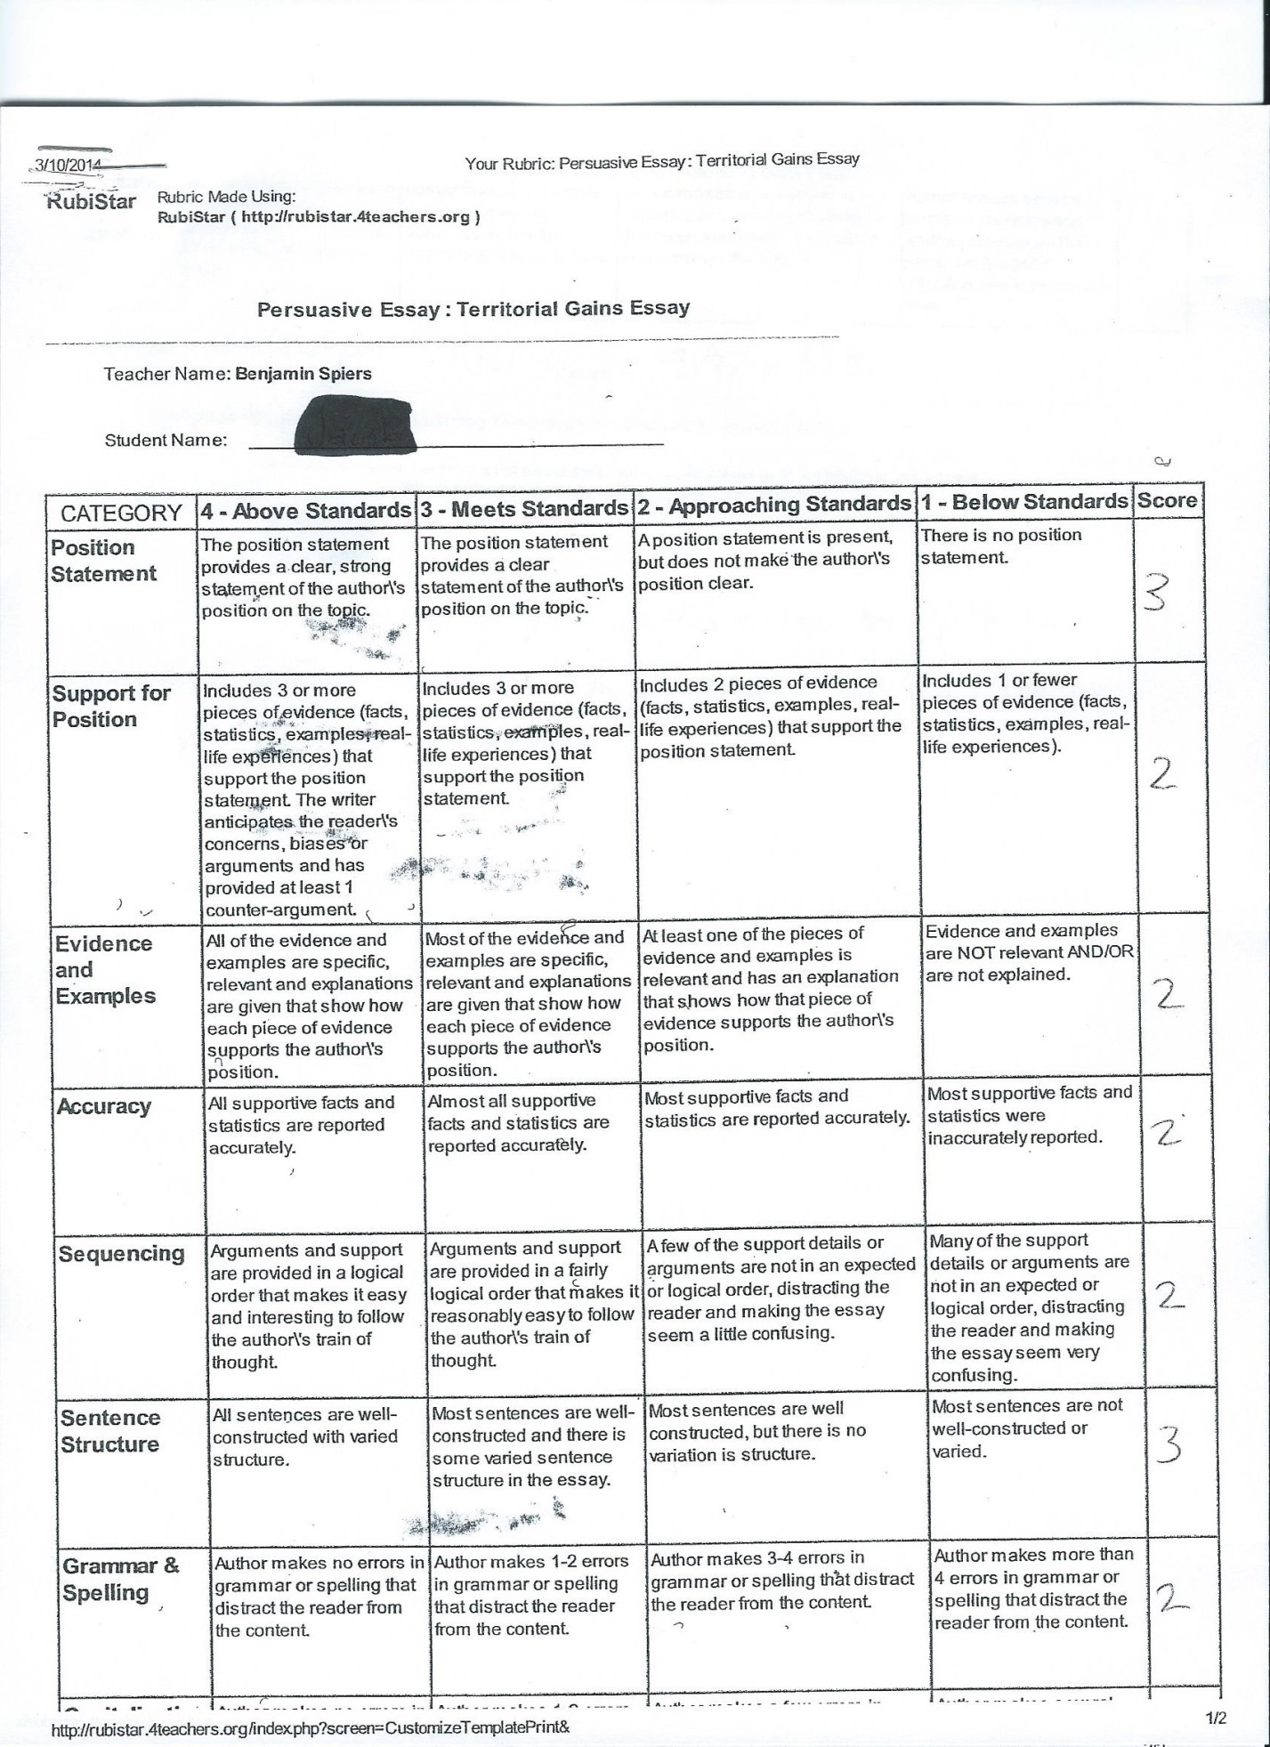
Student A Rubric
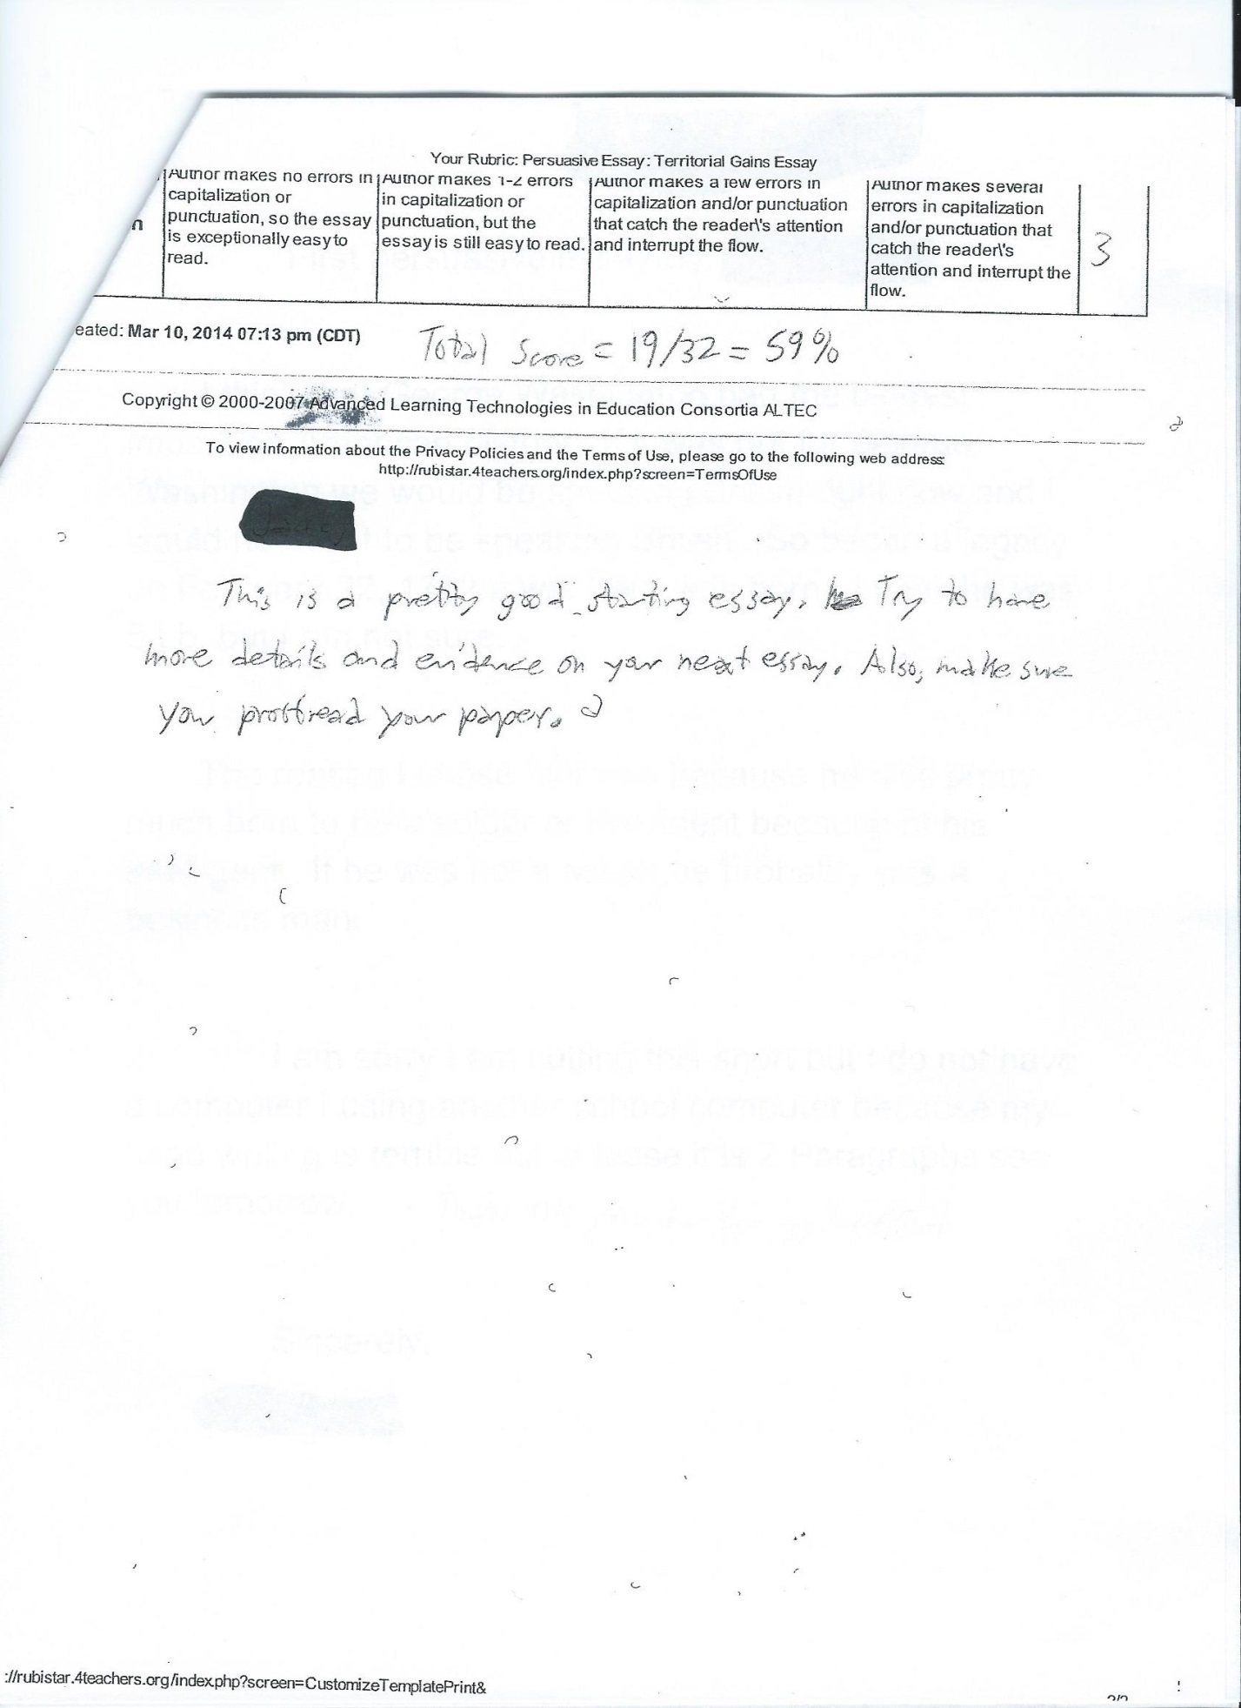
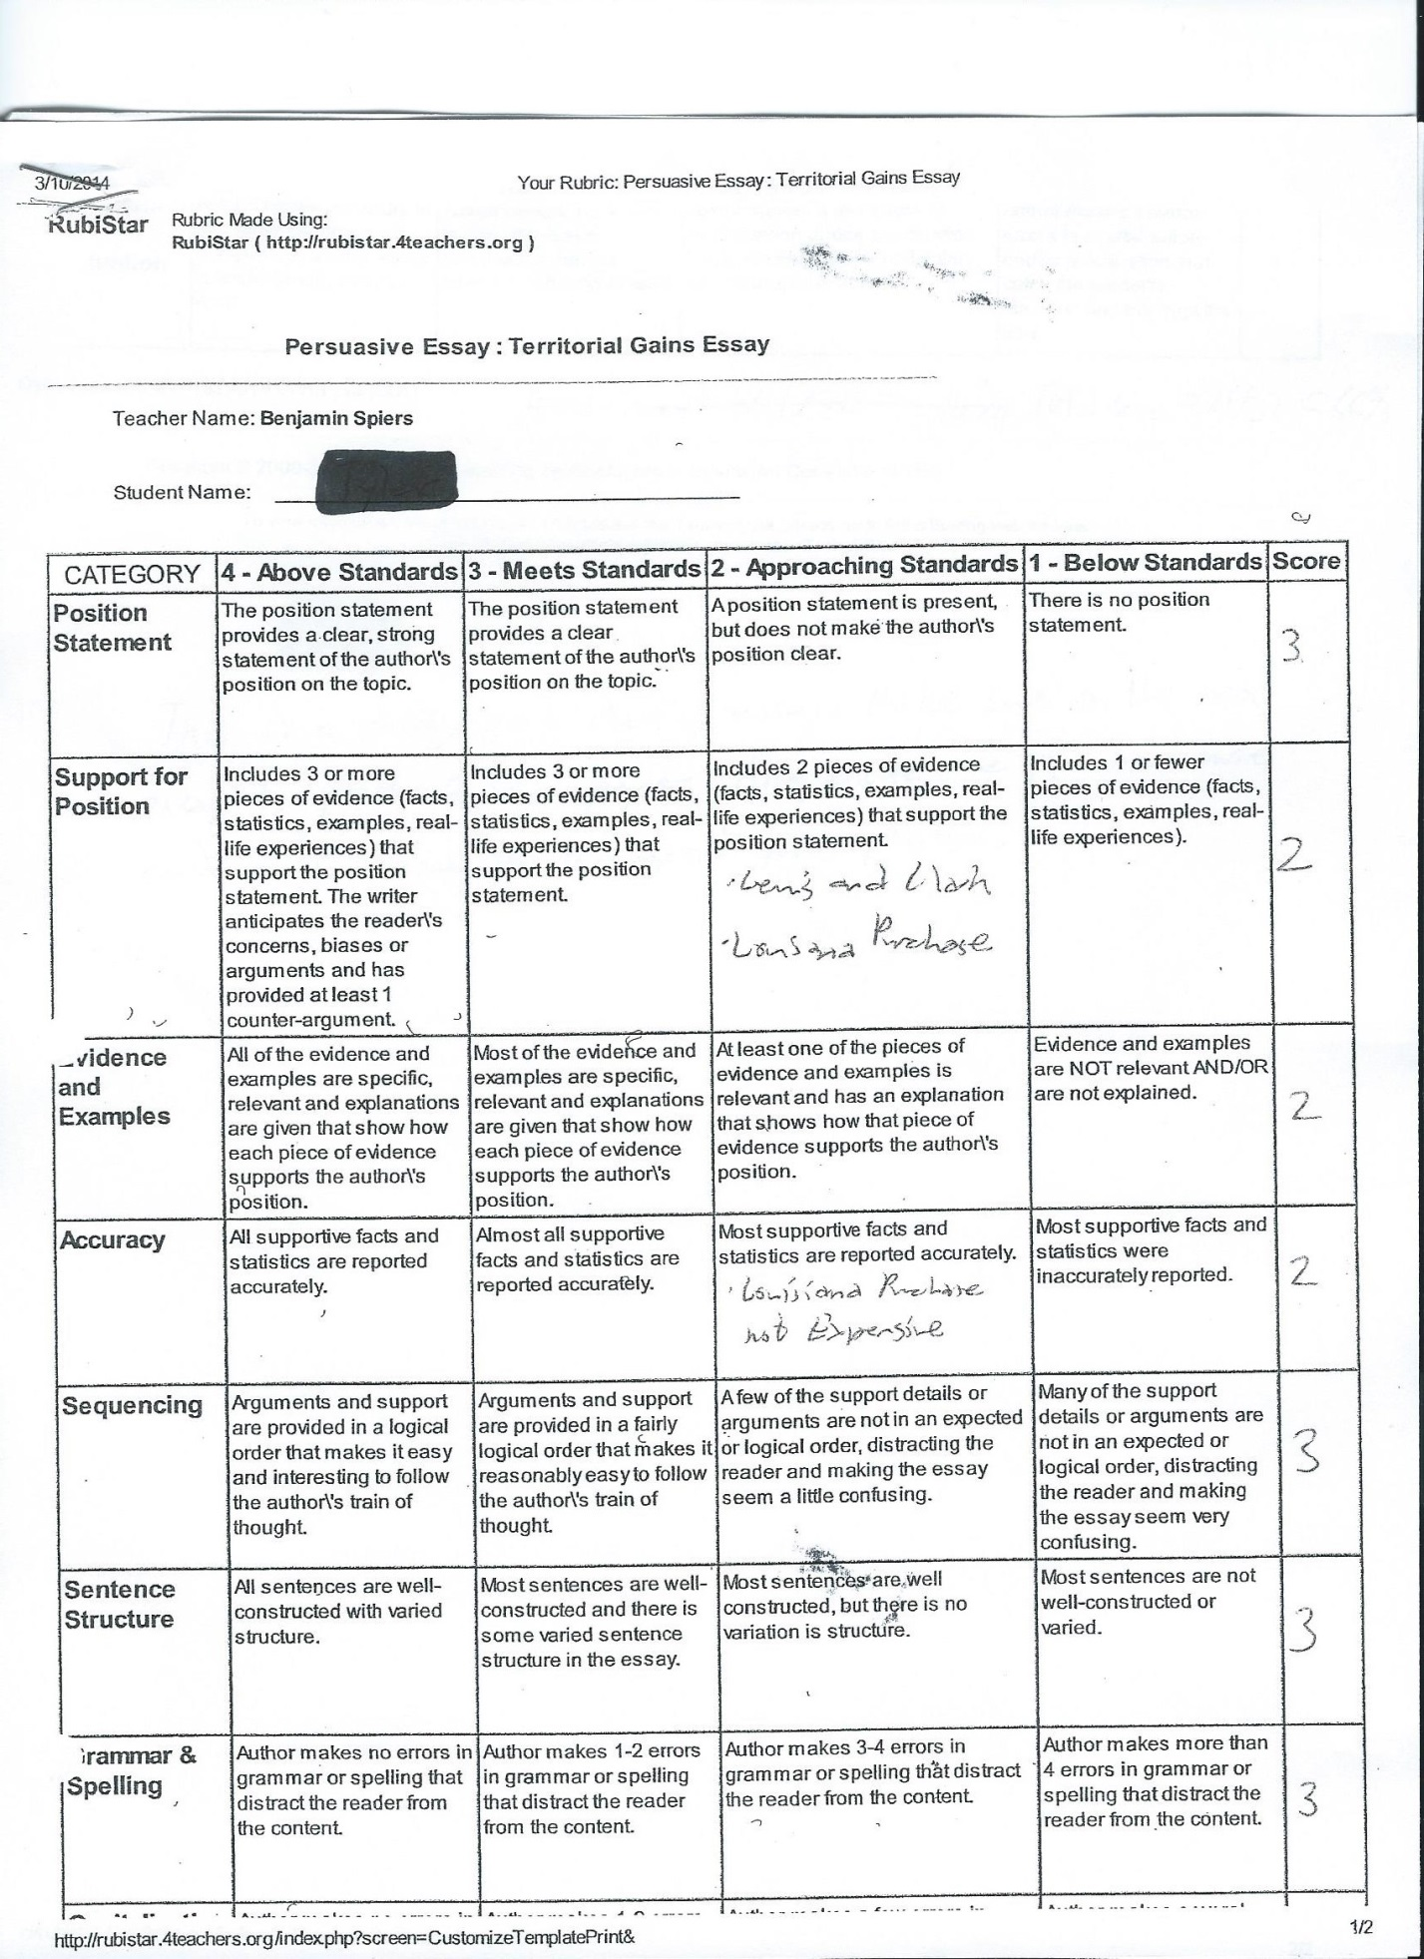
Student B Rubric
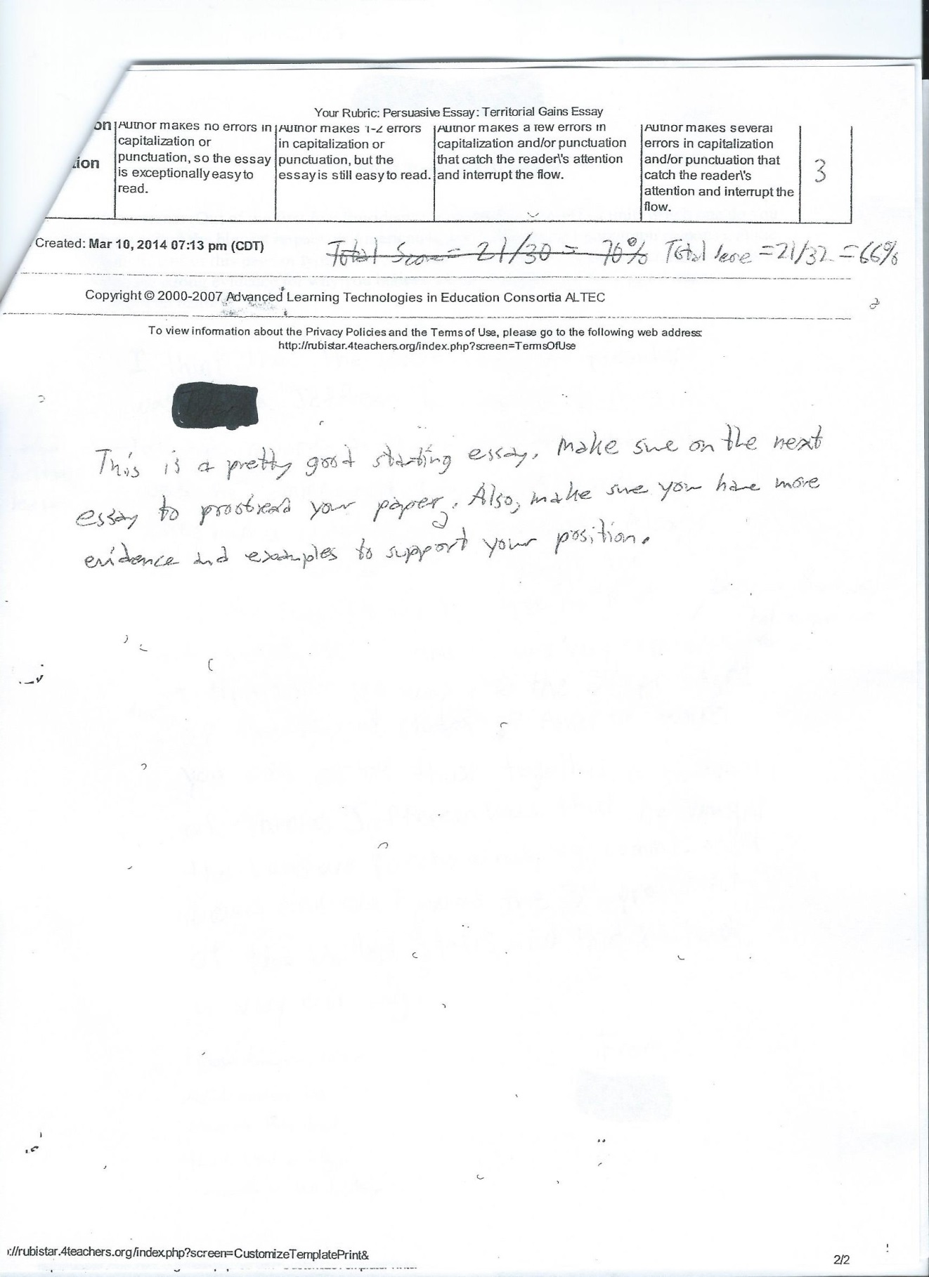

TEACHING REASONING THROUGH WRITING

Copy this cover sheet three times and complete one for each response.
Student Response Cover Sheet

Assignment # 1 , Student A (writing sample on next page)

Attach the following to this Cover Sheet:

Work Sample from a student generated in response to the assignment cited above. Label the work sample with the student’s first name, the Student Identifier (A or B) and the Assignment Number (1, 2, or 3). Delete all other identifying information (e.g. student last name, teacher name, etc.)

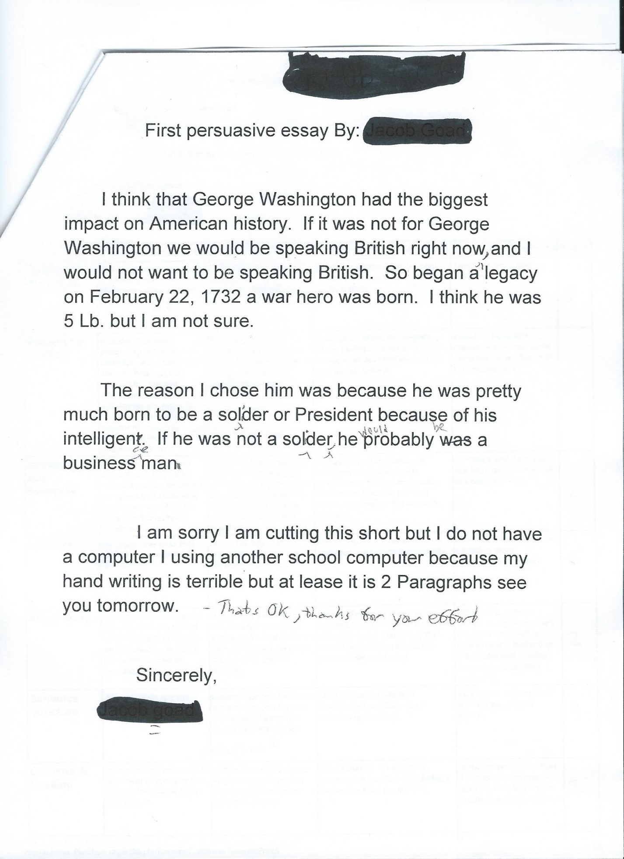
TEACHING REASONING THROUGH WRITING

Copy this cover sheet three times and complete one for each response.
Student Response Cover Sheet

Assignment # 1 , Student B (writing sample on next page)

Attach the following to this Cover Sheet:

Work Sample from a student generated in response to the assignment cited above. Label the work sample with the student’s first name, the Student Identifier (A or B) and the Assignment Number (1, 2, or 3). Delete all other identifying information (e.g. student last name, teacher name, etc.)

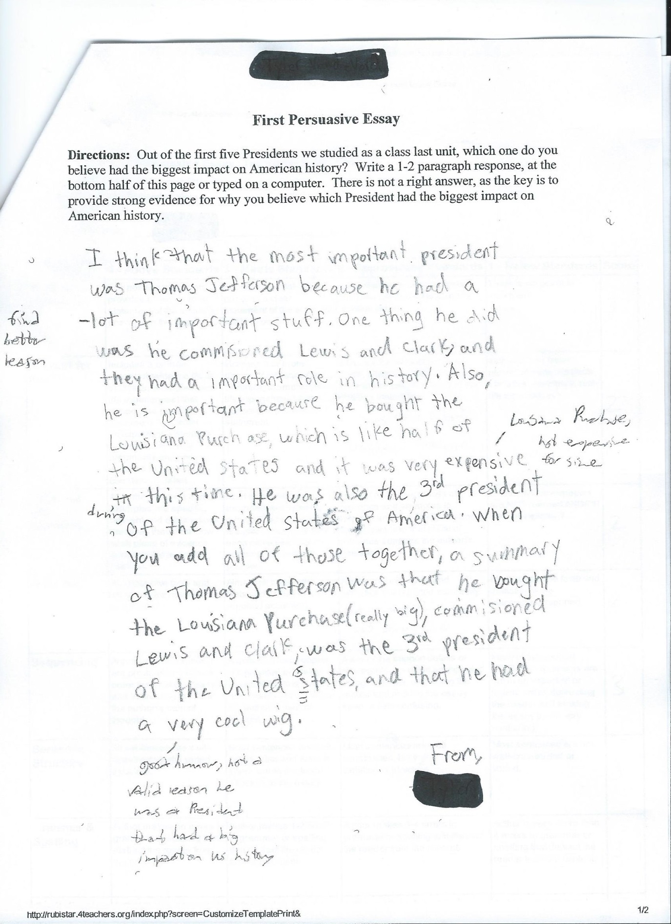

TEACHING REASONING THROUGH WRITING
Copy this cover sheet three times and complete one for each prompt.
Assignment /Prompt # 2 Cover sheet

- Type/write your responses in the space provided.
What were your SMART GOALS for this project

For the next month, 100% of my students will make measurable progress in writing persuasive essays. By late April 2014 every student will increase their overall score by at least one point. By late April 75% percent of my students will have an overall score of at least twenty-four on their persuasive essays.

Briefly describe the nature of this Assignment/Prompt.

For this essay I am having students write a persuasive essay about whether the abolitionist movement or women’s suffrage movement had a more significant impact on US history. I am looking for improvement from the first essay, and they have access to the rubric for this essay.

What specific student understanding and/or skills is this assignment designed to elicit?

Similar to the first essay, I am trying to see if students can use evidence they learned about from the Abolitionist or Women’s Suffrage movements to support their answer. I am also trying to see if they can improve their writing skills through acknowledging the other viewpoint (other movement in this essay), adding more details and evidence from what they learned in class, as well as improvement on proofreading their papers.

B. Attach the following materials to this Cover Sheet:

The Assignment/Prompt and any other relevant Instructional Artifacts. Include completed students rubrics (on following pages) if used in evaluation. If a student’s work is graded, explain criteria for grading.

Assignment/Prompt: In 1-2 Paragraphs, argue whether you believe the abolitionist movement or the women’s suffrage movement had the biggest impact on American history. You can only choose one event you believe to be the most significant and there is not a wrong answer. The key here is to explain why you believe the event you choose is most important and support it with evidence.

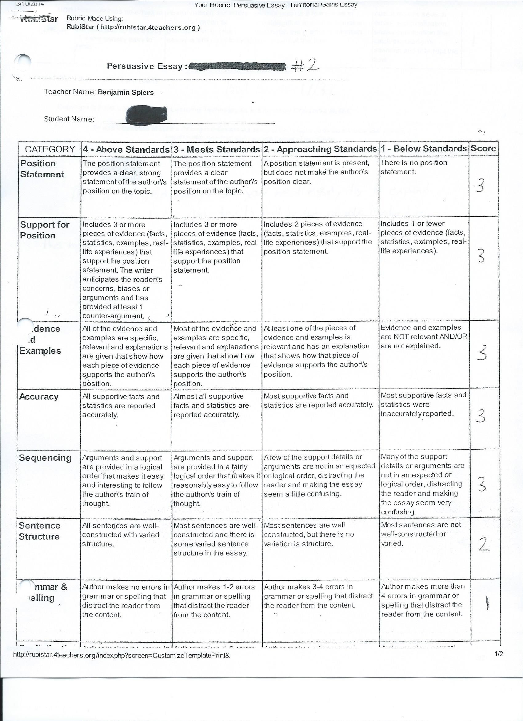
Student A Rubric

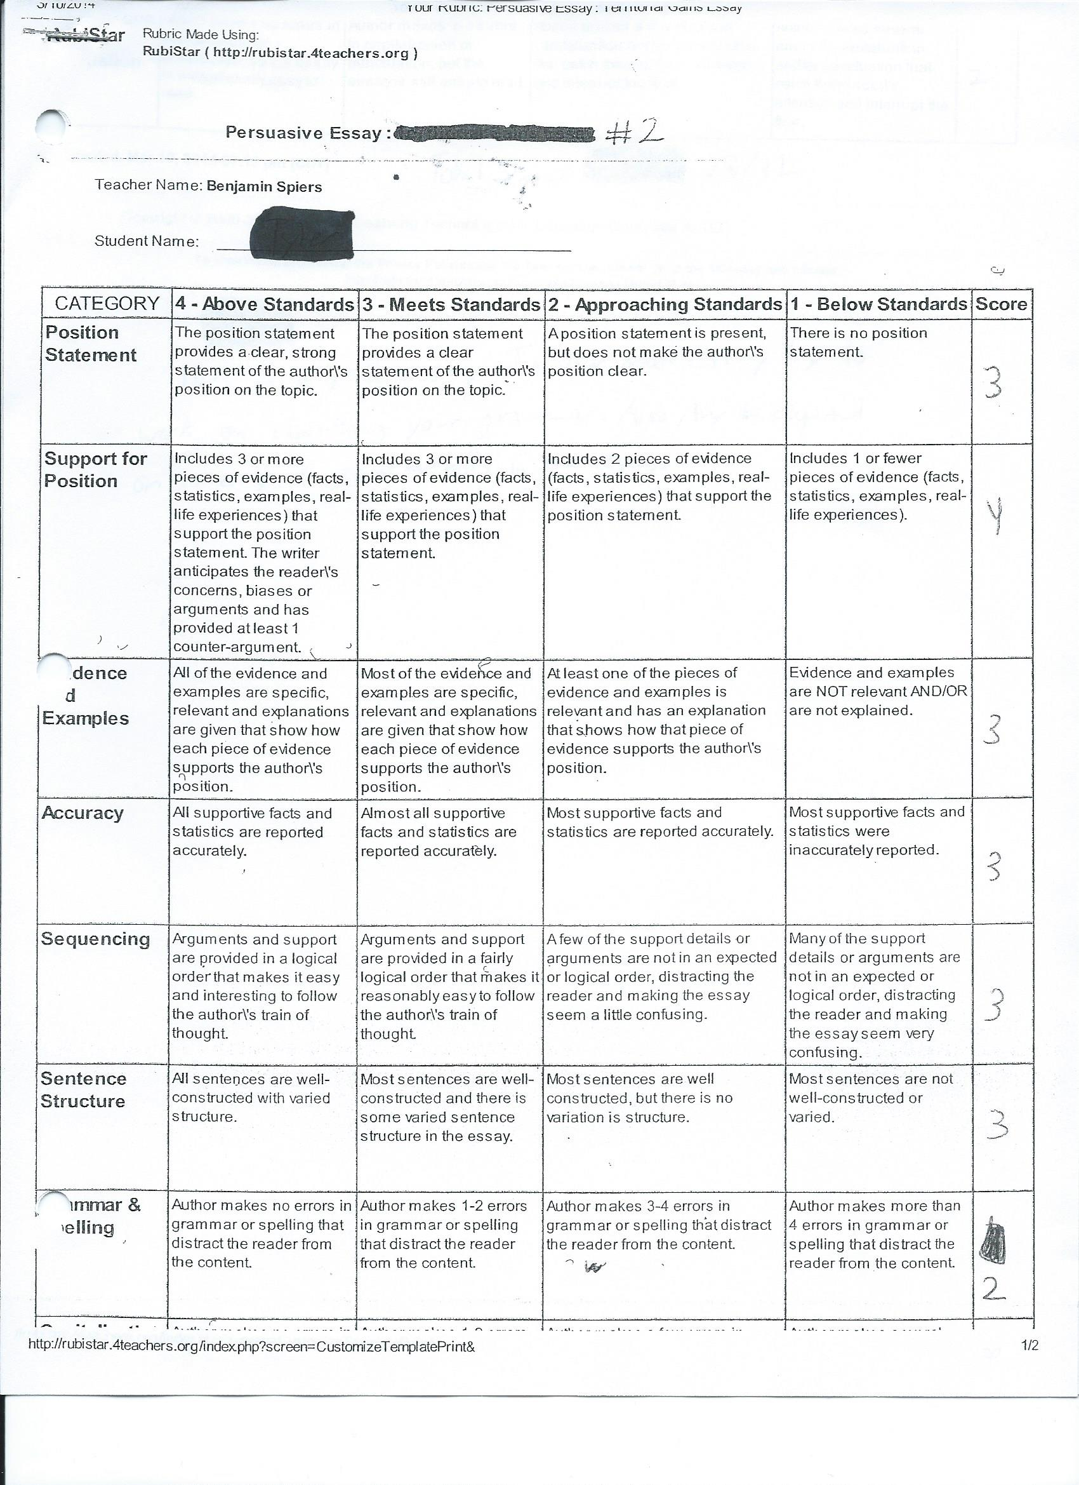
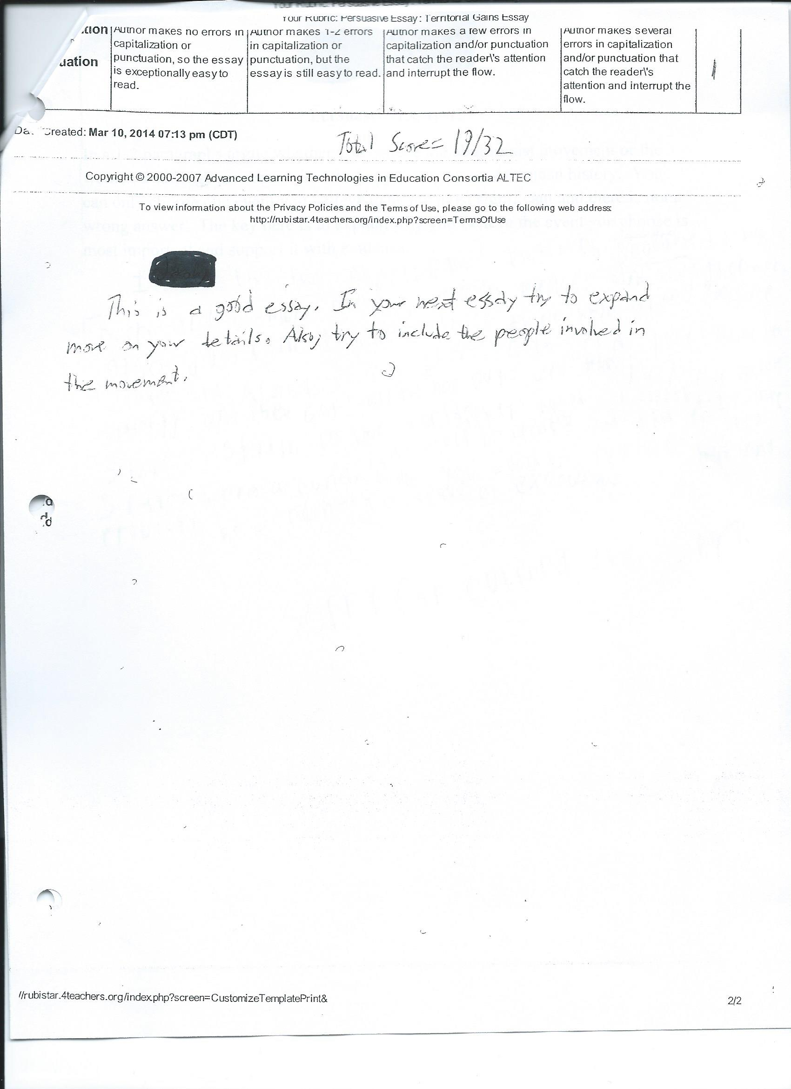 Student B Rubric

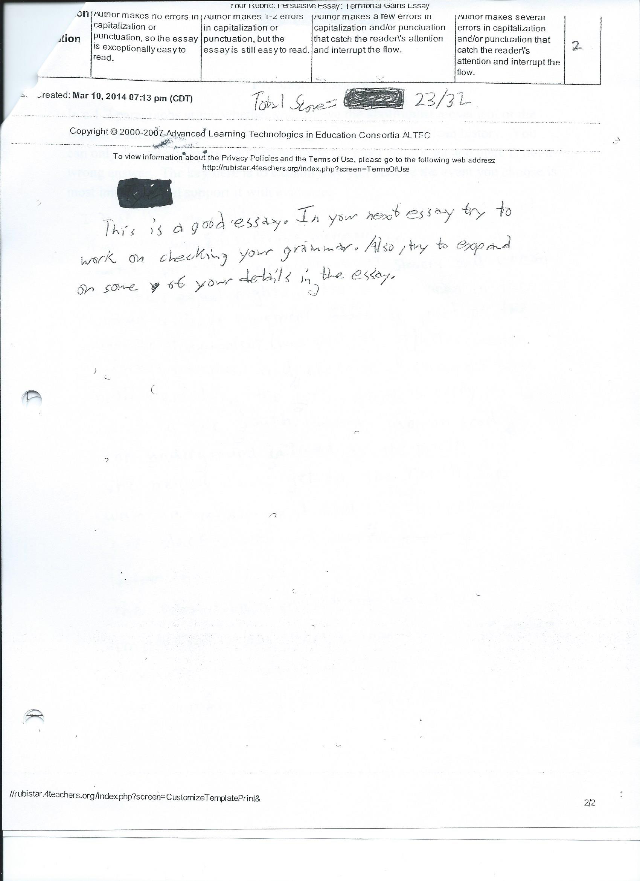

TEACHING REASONING THROUGH WRITING

Copy this cover sheet three times and complete one for each response.
Student Response Cover Sheet

Assignment # 2, Student A (writing sample on next page)

Attach the following to this Cover Sheet:

Work Sample from a student generated in response to the assignment cited above. Label the work sample with the student’s first name, the Student Identifier (A or B) and the Assignment Number (1, 2, or 3). Delete all other identifying information (e.g. student last name, teacher name, etc.)
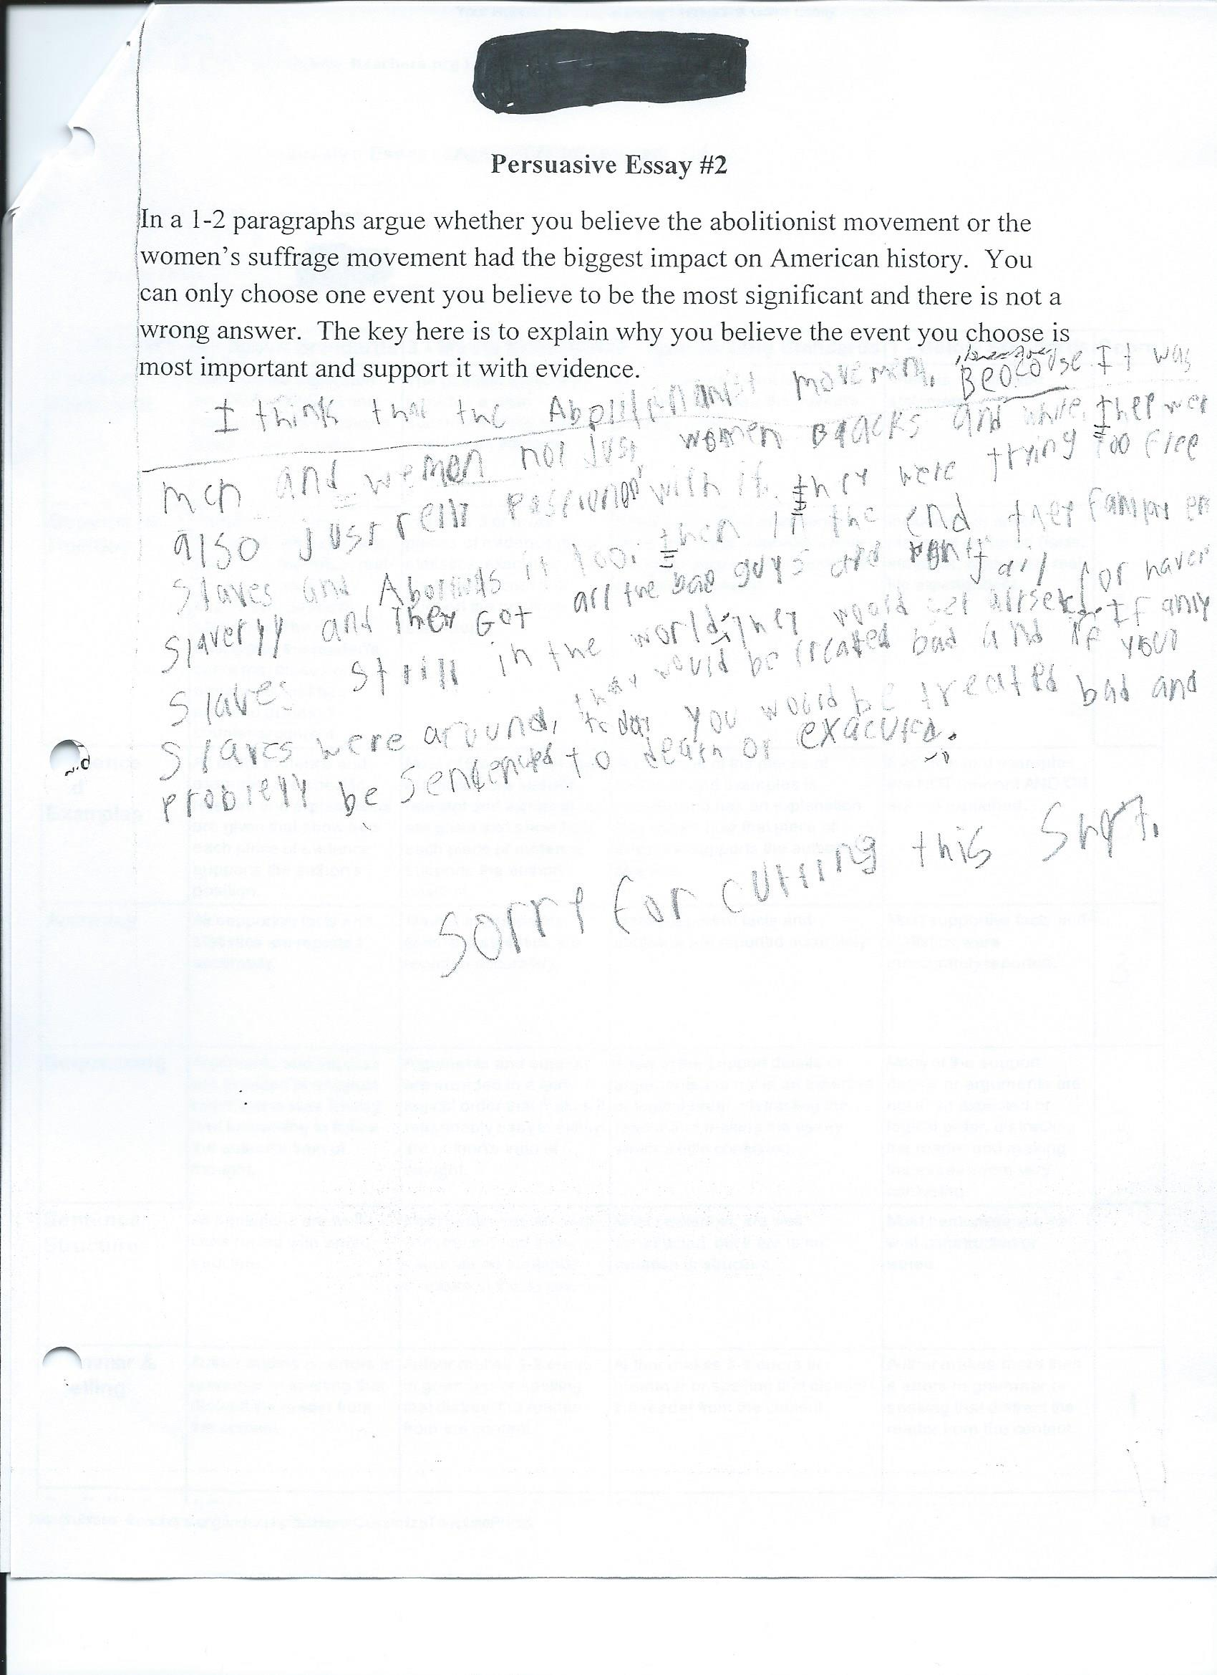

TEACHING REASONING THROUGH WRITING

Copy this cover sheet three times and complete one for each response.
Student Response Cover Sheet

Assignment # 2, Student B (writing sample on next page)

Attach the following to this Cover Sheet:

Work Sample from a student generated in response to the assignment cited above. Label the work sample with the student’s first name, the Student Identifier (A or B) and the Assignment Number (1, 2, or 3). Delete all other identifying information (e.g. student last name, teacher name, etc.)
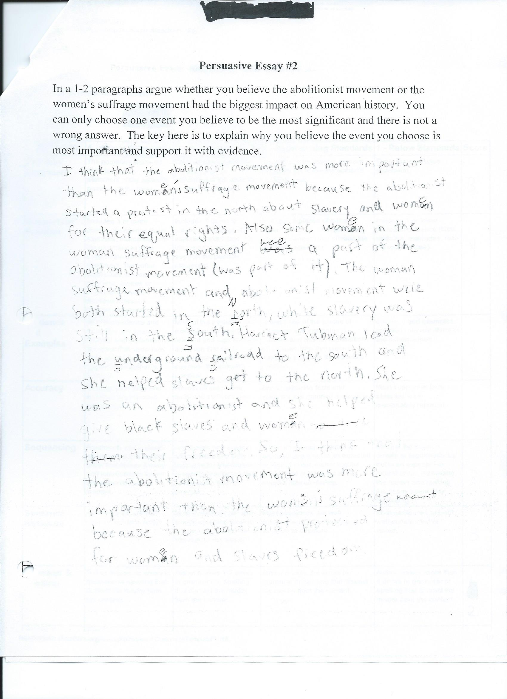

TEACHING REASONING THROUGH WRITING
Copy this cover sheet three times and complete one for each prompt.
Assignment /Prompt # 3 Cover sheet

- Type/write your responses in the space provided.
What were your SMART GOALS for this project

For the next month, 100% of my students will make measurable progress in writing persuasive essays. By late April 2014 every student will increase their overall score by at least one point. By late April 75% percent of my students will have an overall score of at least twenty-four on their persuasive essays.

Briefly describe the nature of this Assignment/Prompt.

For the final essay I am having students write a persuasive essay about what was the most significant invention from the Westward Expansion time period. I am looking for improvement from the first two essays, and they have access to the rubric for this essay as well.

What specific student understanding and/or skills is this assignment designed to elicit?

Similar to the first two essays, I am trying to see if students can use evidence they learned about from the Invention projects to support their answer. I am also trying to see if they can continue to improve on their writing skills through acknowledging the other viewpoint (other movement in this essay), adding more details and evidence from what they learned in class, as well as improvement on proofreading their papers.

B. Attach the following materials to this Cover Sheet:

The Assignment/Prompt and any other relevant Instructional Artifacts.
Include completed students rubrics (on following pages) if used in evaluation. If a student’s work is graded, explain criteria for grading.

Assignment/Prompt: On this sheet of paper or typed up, write a 1-2 paragraph essay on what you believe to be the most significant invention from the Westward Expansion time period. Your choices are the steam locomotive, steamboat, mechanical reaper, or cotton gin. There is not a correct answer, as the key here is to support your answer with evidence.

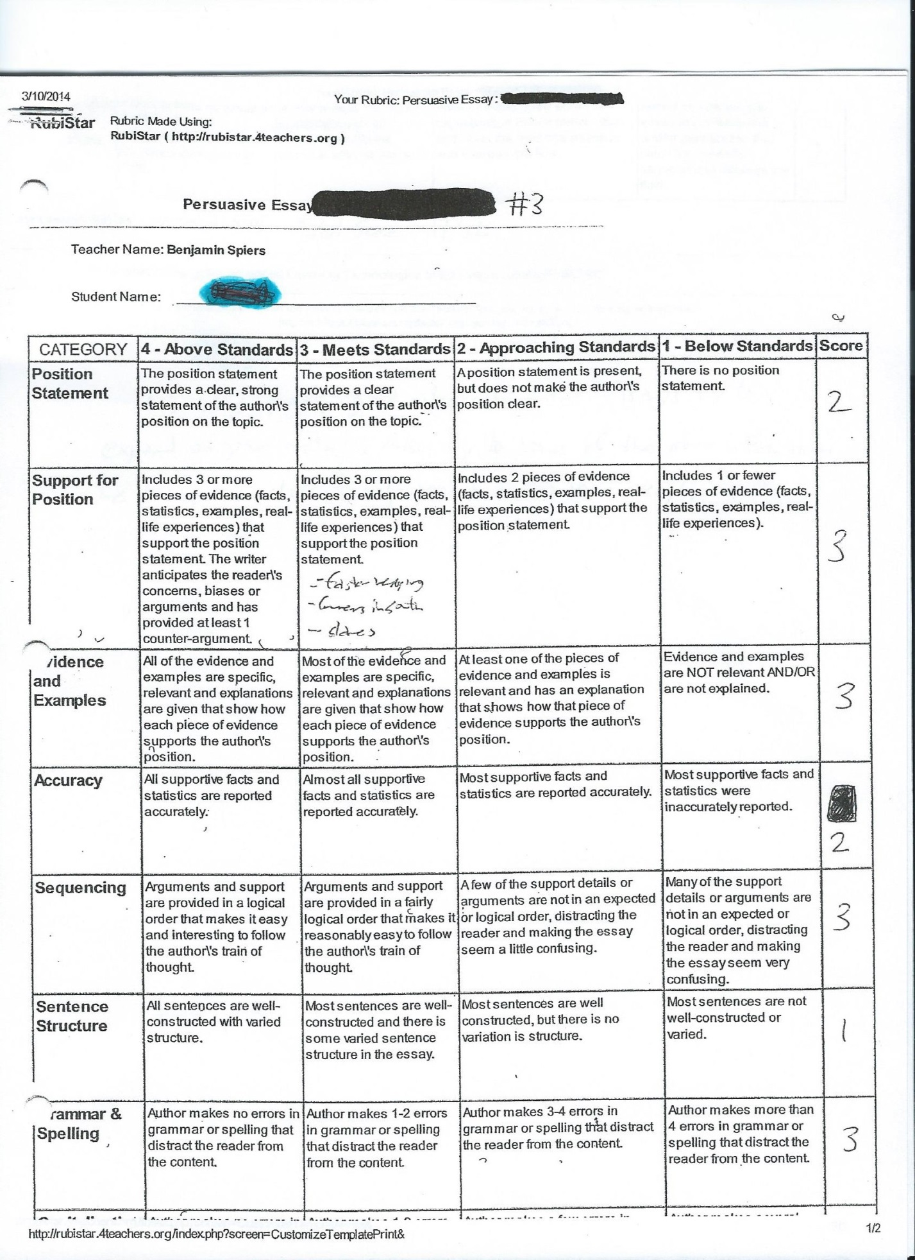
Student A Rubric
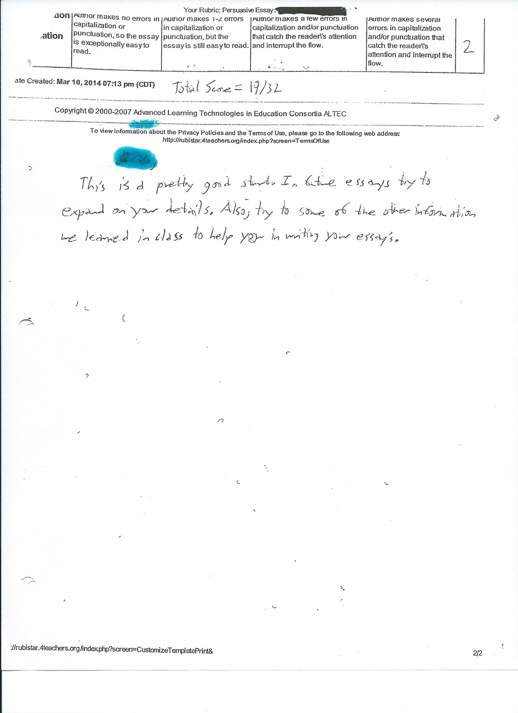

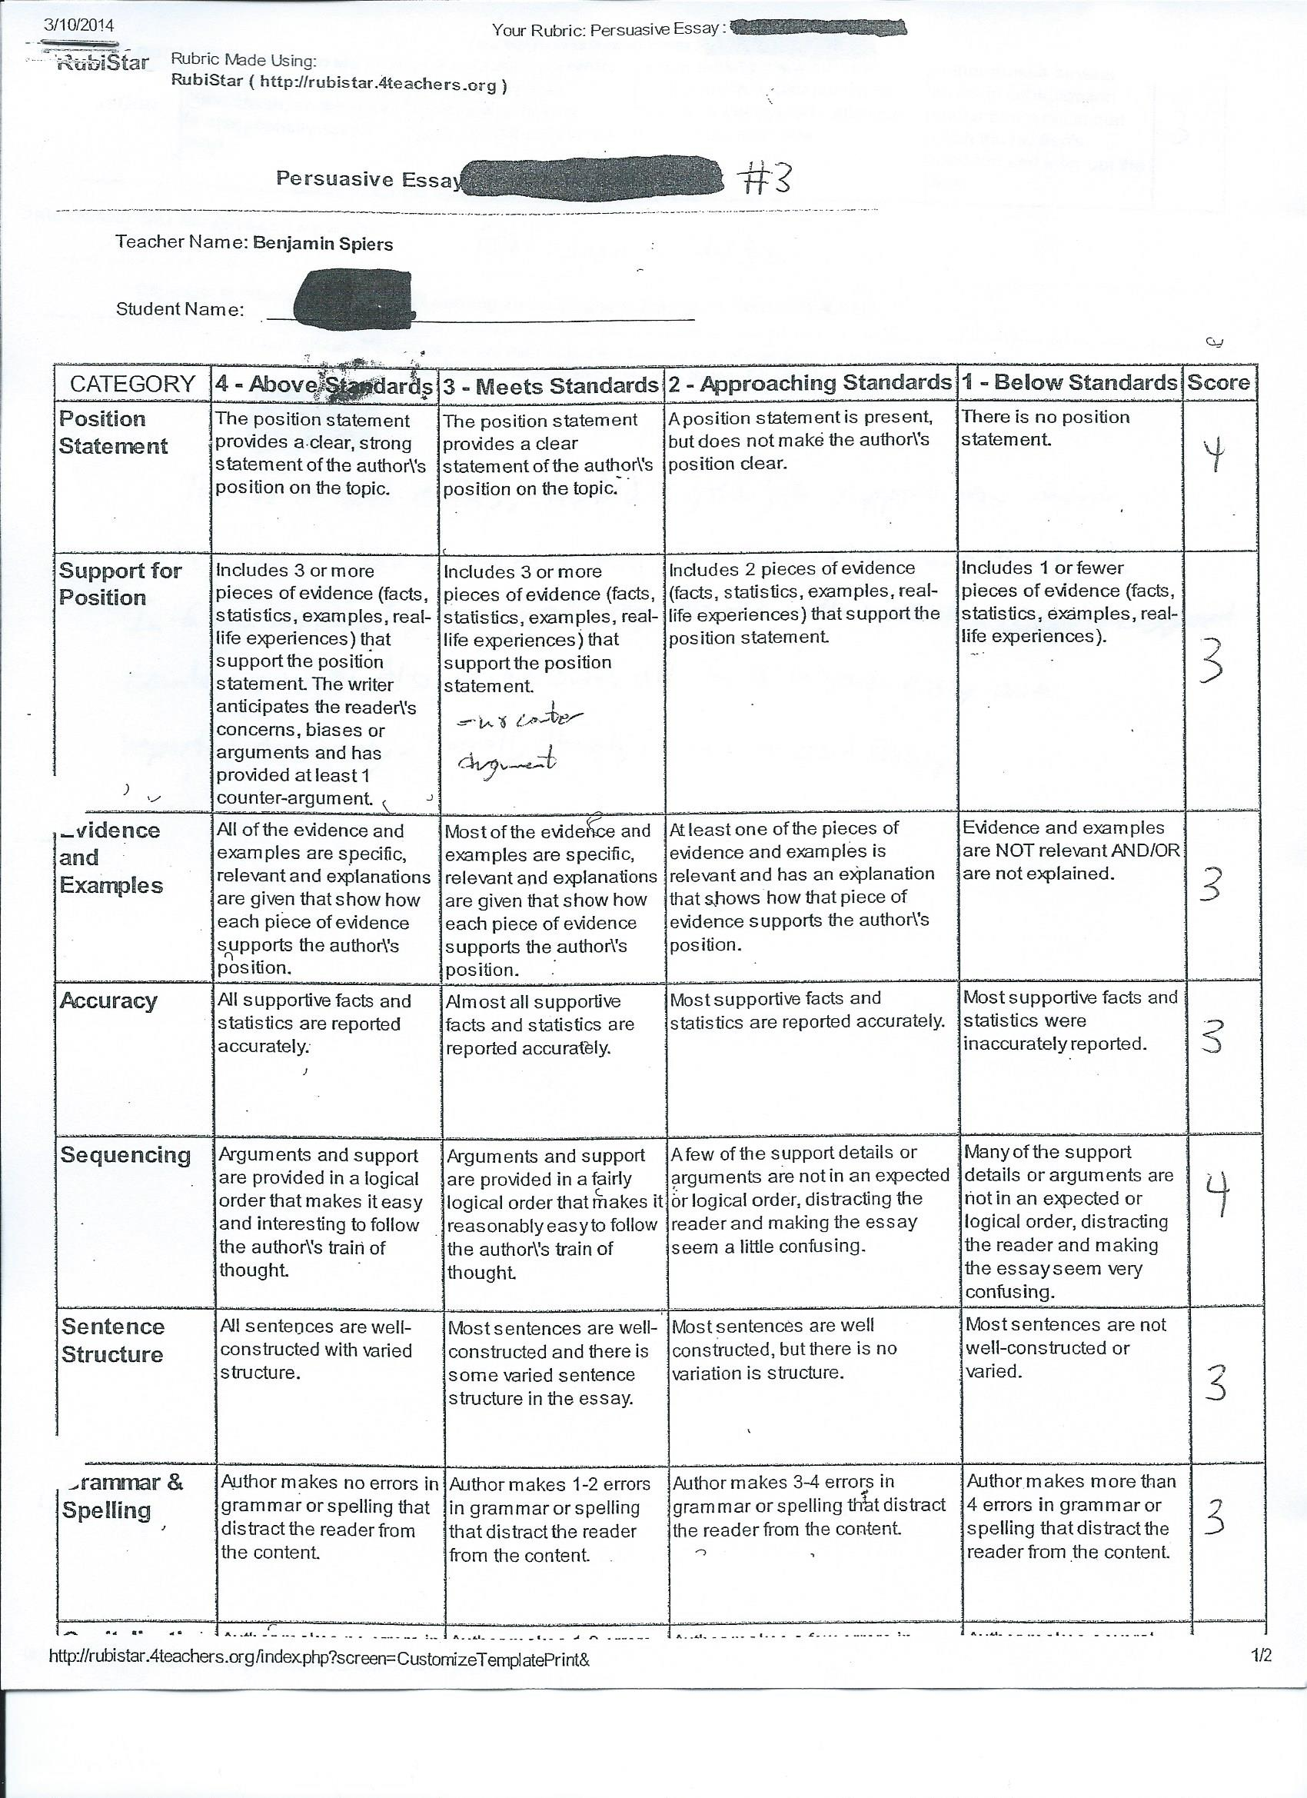
Student B Rubric

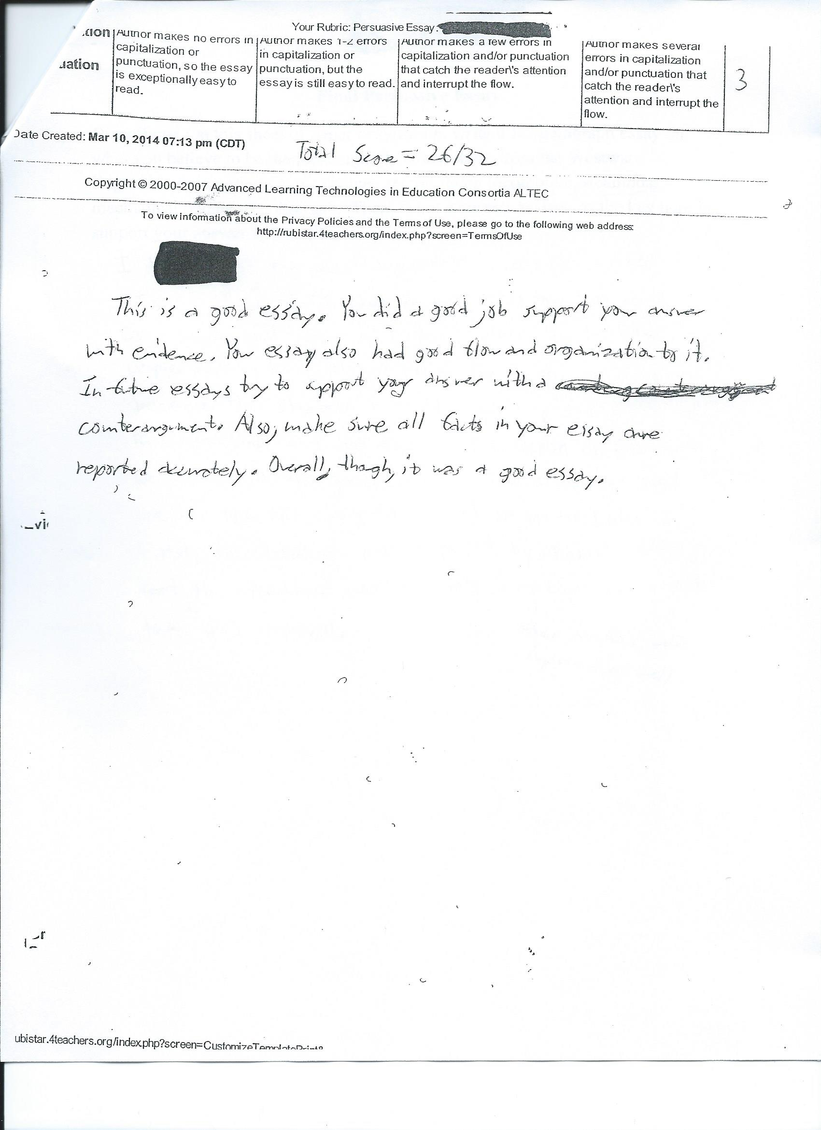

TEACHING REASONING THROUGH WRITING

Copy this cover sheet three times and complete one for each response.
Student Response Cover Sheet

Assignment # 3, Student A (writing sample on next page)

Attach the following to this Cover Sheet:

Work Sample from a student generated in response to the assignment cited above. Label the work sample with the student’s first name, the Student Identifier (A or B) and the Assignment Number (1, 2, or 3). Delete all other identifying information (e.g. student last name, teacher name, etc.)
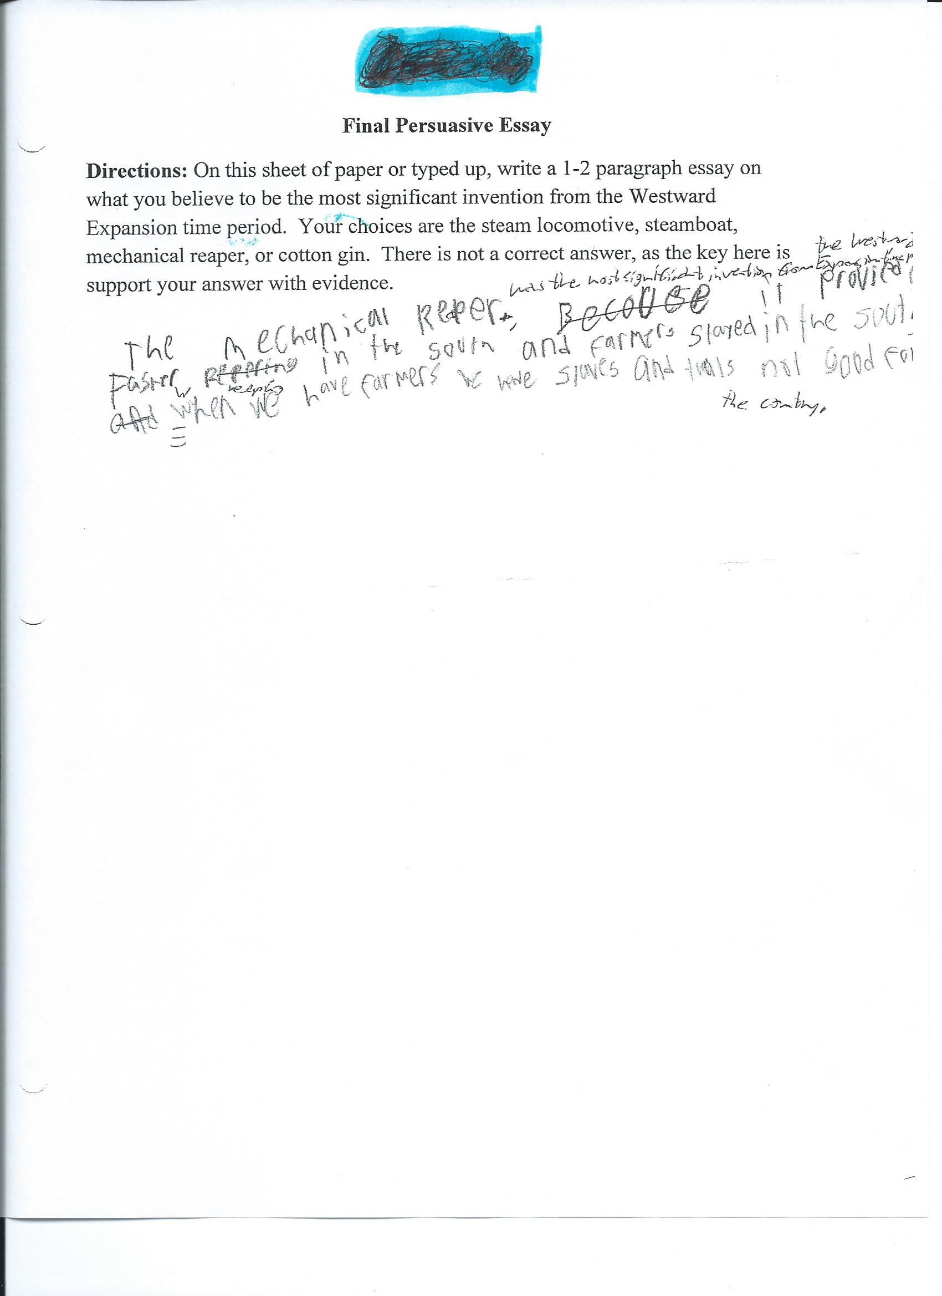

TEACHING REASONING THROUGH WRITING

Copy this cover sheet three times and complete one for each response.
Student Response Cover Sheet

Assignment # 3, Student B (writing sample on next page)

Attach the following to this Cover Sheet:

Work Sample from a student generated in response to the assignment cited above. Label the work sample with the student’s first name, the Student Identifier (A or B) and the Assignment Number (1, 2, or 3). Delete all other identifying information (e.g. student last name, teacher name, etc.)

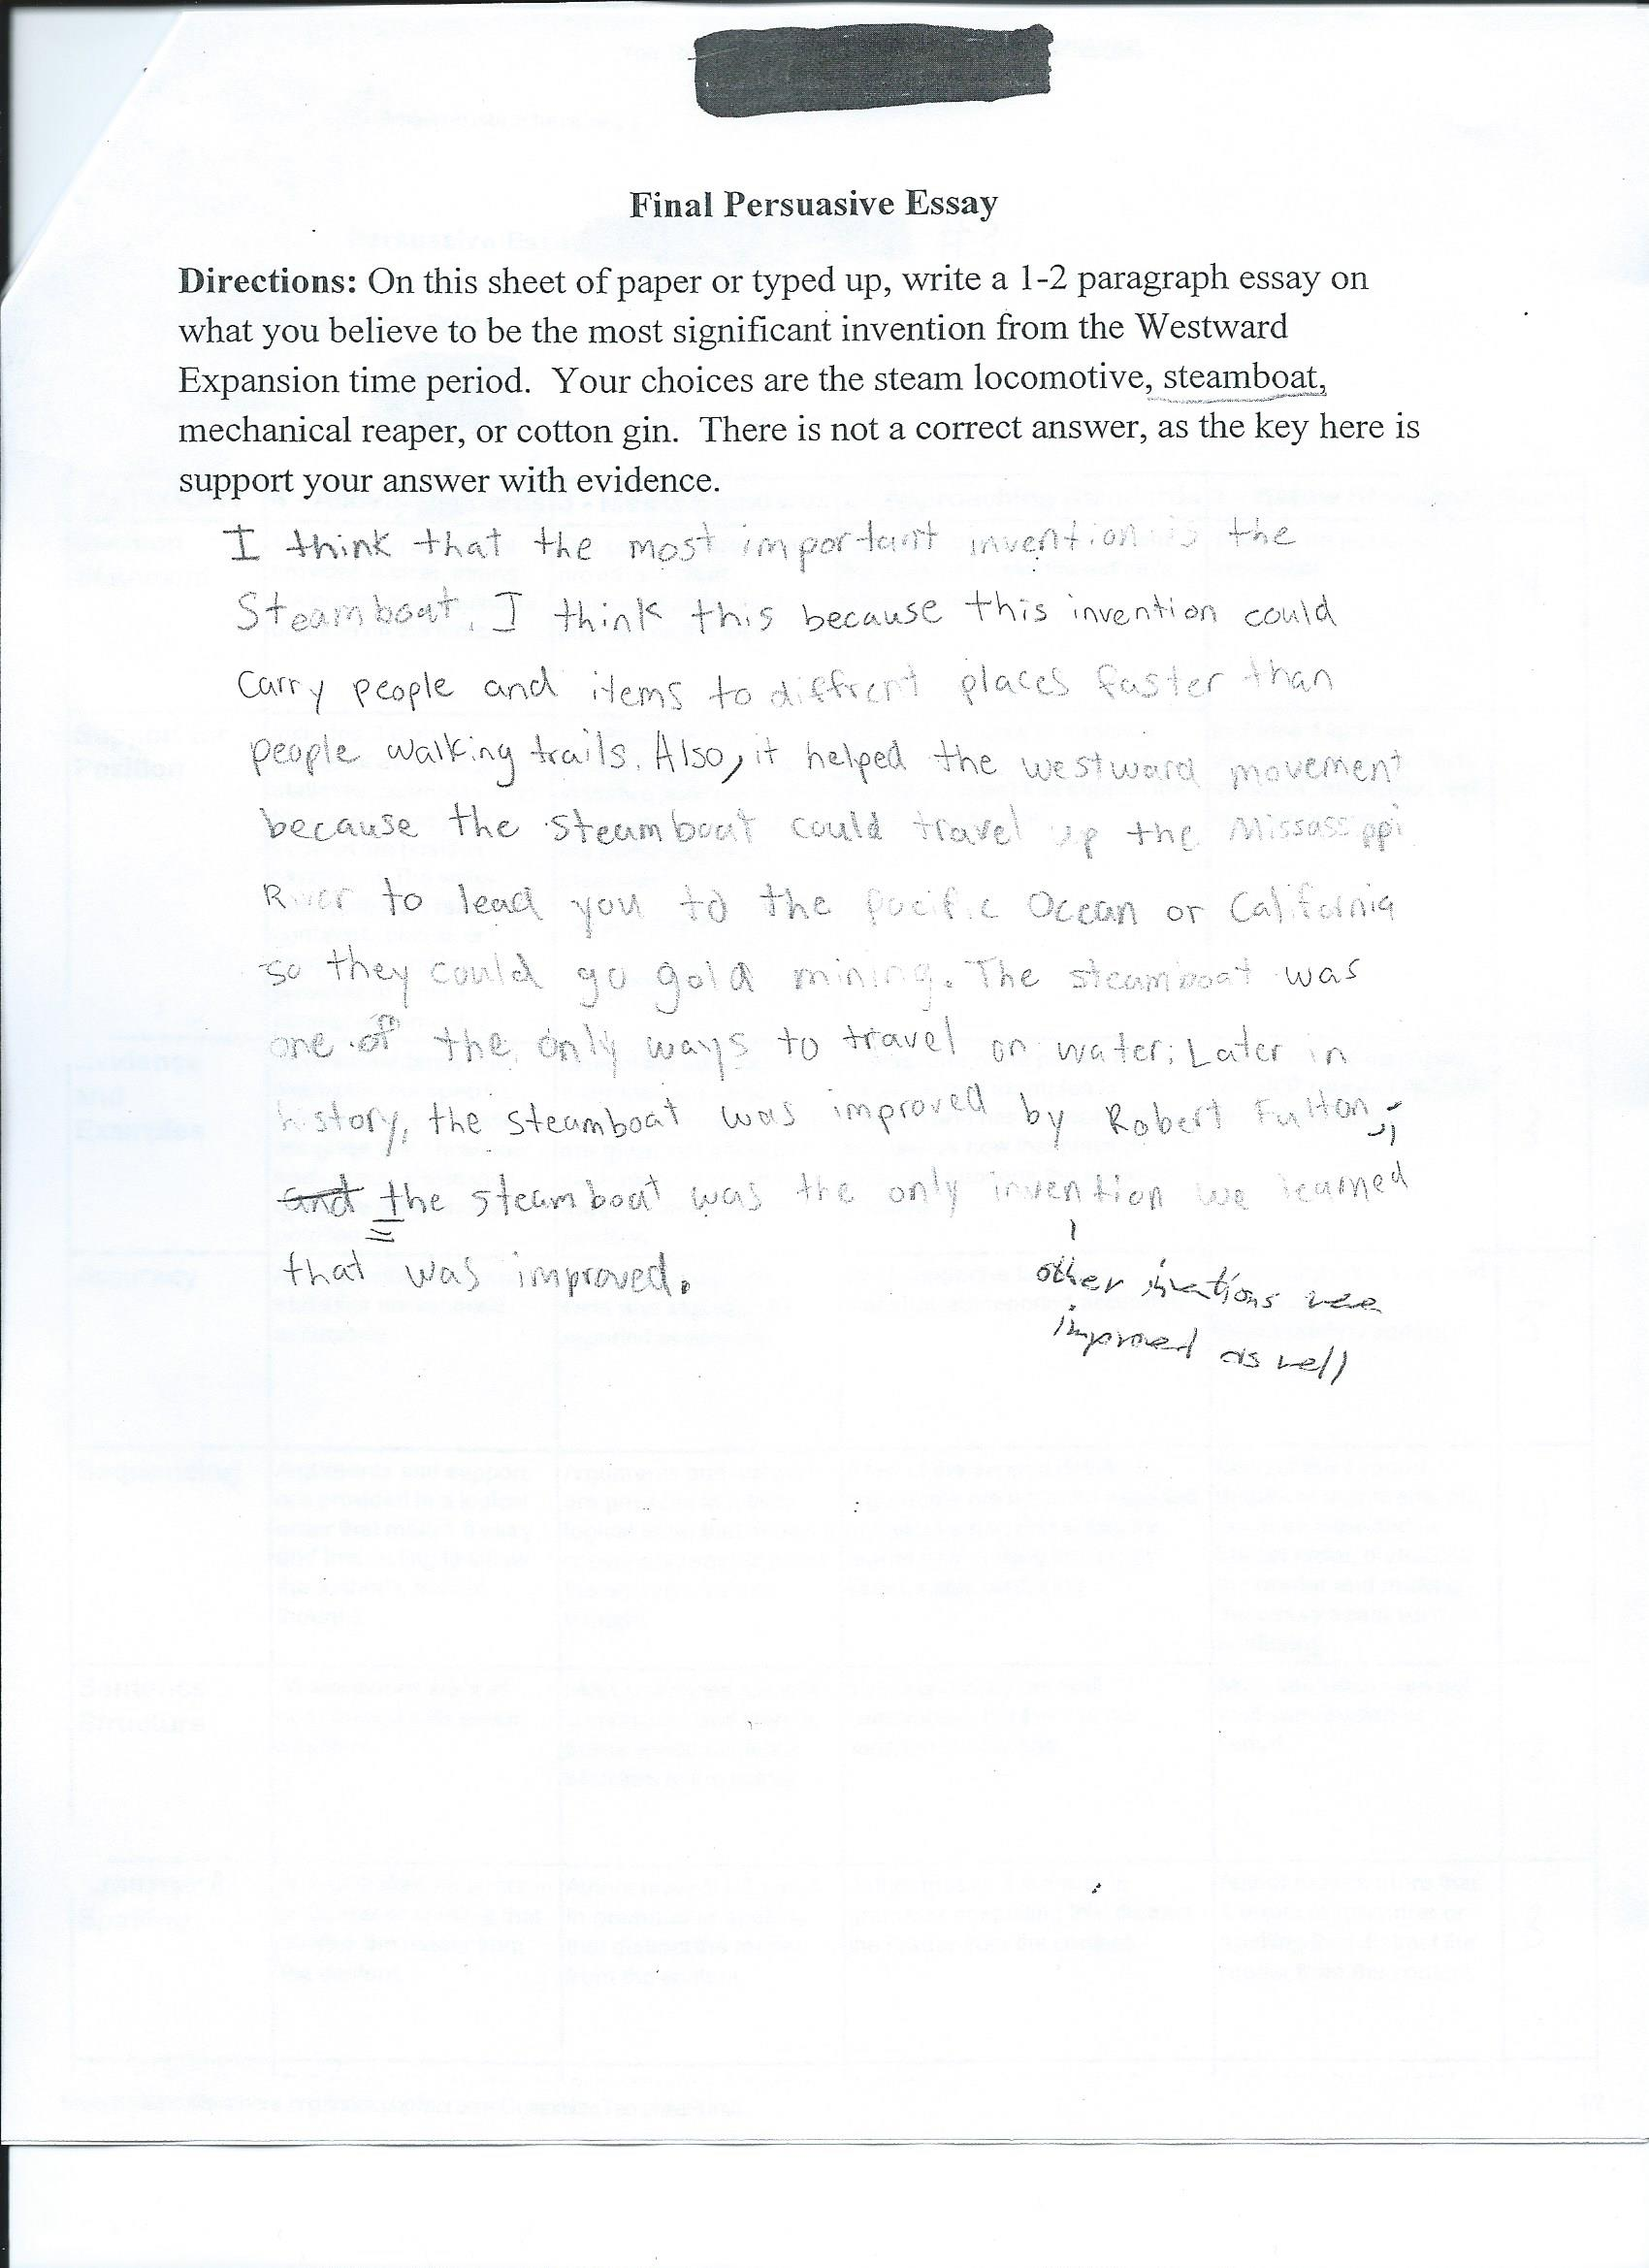

Teaching Reasoning Through Writing Rubric

 | Limited Evidence  (34-38) | Clear Evidence  (39-45) | Clear, Convincing, Consistent Evidence  (46-50) | Score
Alignment with NCSS Standards | The instructional sequence minimally connects to 1 NCSS theme. | The instructional sequence clearly reflects important connections to 1 NCSS theme. | The instructional sequence shows clear and convincing evidence of significant connections to 1 NCSS theme. | 45
Social Studies Content Knowledge | The instructional sequence shows limited evidence of teacher’s knowledge related to facilitating the doing of social studies in alignment with local and national standards and SMART Goals | The instructional sequence shows clear evidence of teacher’s knowledge related to facilitating the doing of social studies in alignment with local and national standards and SMART Goals | The instructional sequence shows clear and convincing evidence of superior content knowledge related to facilitating the doing of social studies in alignment with local and national standards and SMART Goals | 40
Sequence and Assessment Design | The teacher’s instructional decisions, assessments, and feedback provide limited evidence of connections to learning goals/objectives and guiding question. | The teacher’s instructional decisions, assessments, and feedback provide evidence of clear and acceptable connections to learning /objectives and guiding question | The teacher’s instructional decisions, assessments, and feedback provide evidence of consistent and compelling connections to learning goals /objectives and guiding question. | 40
Interpretation of Evidence | The teacher’s feedback to students and written commentary show limited interpretation of student performance and instructional needs. | The teacher’s feedback to students and written commentary show clear and acceptable interpretation of student performance and instructional needs. | The teacher’s feedback to students and written commentary show consistent and convincing interpretations of student performance and instructional needs. | 40
Evidence of Impact on Student Learning | The entries for PART 1 and PART II provide limited details discussing students’ growth with evidence to advance either their analytic, interpretive, and/or persuasive writing skills. | The entries for PART 1 and PART II provide clear and acceptable details discussing students’ growth with evidence to advance either their analytic, interpretive, and/or persuasive writing skills. | The entries for PART 1 and PART II provide consistent and convincing details discussing students’ growth with evidence to advance either their analytic, interpretive, and/or persuasive writing skills. | 40

