**Social Studies Skill Builder Handout**

**Details of Method: Definition**

* Social Studies Skill builders involve students working on activities such as mapping, graphing, and analyzing primary sources (TCI p.38-39).

**Five Steps of Method**

1. The teacher chooses an engaging skill that the students need to have practice on or learn. These skills could include analyzing primary sources like posters, maps, or charts. The skill should also involve students having to use multiple intelligences and building toward having them think about high level questions by the end of the skill activity. The skill could be a prerequisite toward learning another social studies concept (TCI p.39-40).
2. The teacher provides a demonstration of the skill for the students to perform. For example if you wanted students to label the major rivers in Virginia on a map, you would need to physically demonstrate how to label a river on a map. You then could label one or two rivers as examples, and then the students would label the other rivers on the map on their own (TCI p.41).
3. Students will be paired usually in groups of two. This is the recommended grouping, and try to put together students with different skill abilities. Also, encourage students to introduce themselves and consider an ice breaker or short team building activity (TCI p.42).
4. Students perform the skill. It is important to check on students while they are doing their work and provide feedback to help them in completion of the skill (TCI p.43).
5. At the end of the activity the teacher will debrief with the class and work on connecting the skill with other social studies concepts. Key points can be summarized after the activity and answer any questions students have. You can also do short activities like the moral continuum. An example of the moral continuum is if students analyzed war posters, they could during the debriefing session place their posters on a wall in the category ethical, unethical, or in-between. Then the class could have a discussion on why they put their posters on the moral continuum where they did (TCI p.44-45).

**Benefits and Goals of Method**

* Students learn an important skill or skills that may be a prerequisite toward learning another social studies concept.
* Students can use the social studies skills to help them in other social studies concepts.
* Students can apply these social studies skills to real world problems.
* These skills should be fun and engaging for students.
* Students will be able to better use and analyze primary source documents.

**Factors to consider in design, implementation, and assessment of method**

* Give yourself enough time to plan for teaching the skill including: gathering resources, designing charts, maps, etc.
* Make sure the skill is relevant to social studies concepts that students need to learn
* According to TCI provide feedback to students, make sure they individually comprehend the assignment
* Many of these skill builders are good forms of formative assessment

**Notes about Social Studies Skill Builders for teachers**

Venn Diagram

* The Venn Diagram could be used at the start of a lesson or at the end. This activity could also be used to compare and contrast other historical or real life applications.
* You could provide information about the different political systems before the activity and students would have to place the information in the right section of the Venn Diagram.

Cold War Map

* This activity could be used to assess student’s prior knowledge regarding the geographical landscape of the Cold War or as a way to formally or informally assess students’ knowledge regarding Cold War geography.
* The Cold War map can also be further used to assess students’ knowledge world geography in general, with the caveat certain nation-state boundaries have ended since the Cold War.

Timeline

* This activity would be a great starting point or ending point for a unit or lesson on the Cold War.
* The timeline is a good way for students to become familiar with primary sources.
* Timelines can be used for other historical or political events.

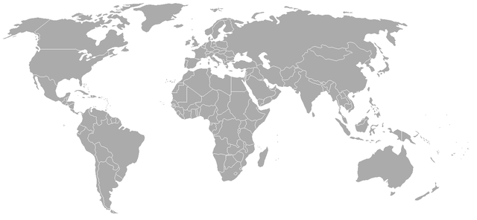**Map of the World During the Cold War**

**Directions:** On the map above identify the location of these countries including the United States, Great Britain, France, Soviet Union, China, East Germany, West Germany, North Korea, South Korea, Cuba, Yugoslavia, and Vietnam.

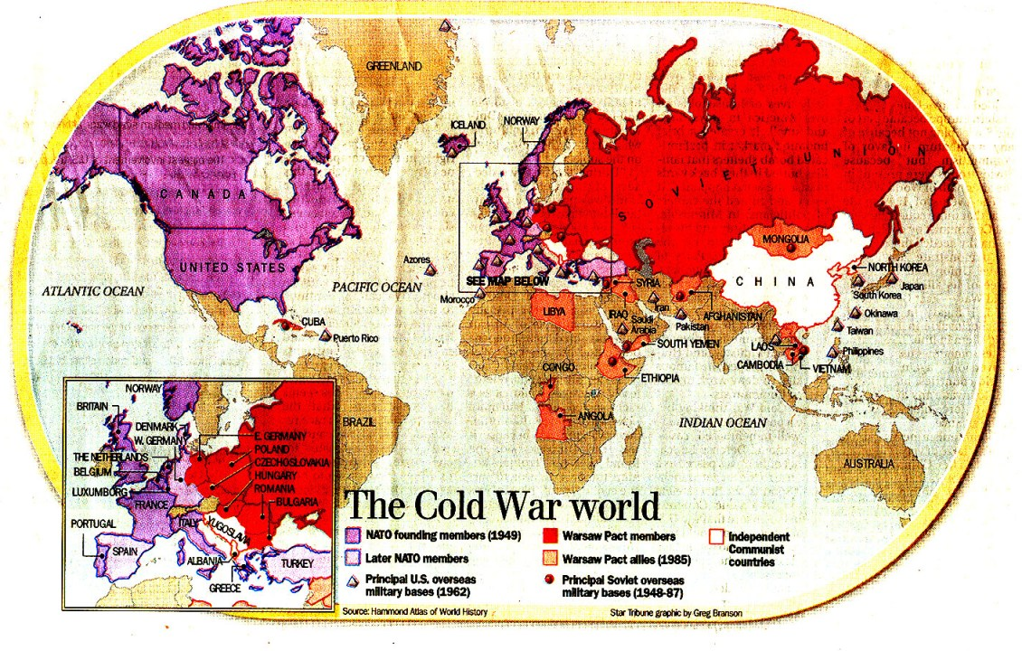**Answer Key**

**Venn Diagram**

**Communism vs. Democracy**

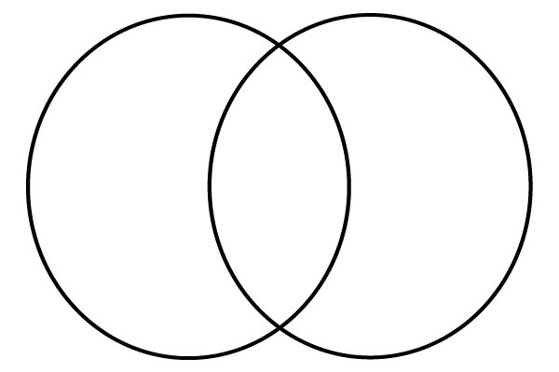 Communism Similarities Democracy

**Directions:** In the Venn Diagram write facts about Communism in the left circle, facts about Democracy in the right circle, and similarities between the two systems in the middle where the two circles converge.

**Sample Answer Key**

**Communism vs. Democracy**

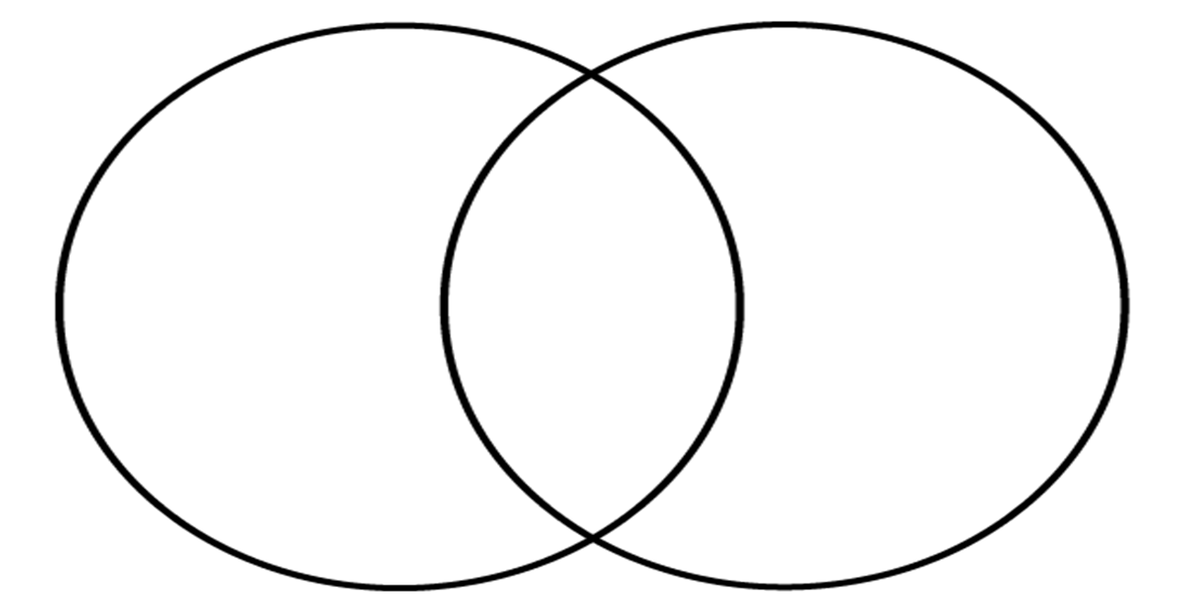

Communism Similarities Democracy

* Opportunity
* Freedom of speech and press
* Elections
* Private Property
* Competition
* Multi-Party
* Propaganda
* Equality
* Bureaucracies
* System based on equal wealth
* Complete government ownership of resources
* Single Party
* Restricted Freedom
* State control of press (censorship)

**Cold War Timeline of Major Events**

**Directions:** Draw timeline similar to the example below. Make sure to have enough room for 15 events. Make sure to label the left side 1945 and the far right 1990. Look at each picture that is provided on the attached handout. Look at the caption underneath the picture. The caption will have the events title/designation. Make sure to look at context clues within the pictures and in the title of the event themselves. Then place each event in linear chronological order from the earliest (1945) to the latest (1990). Make it colorful and fun. Use different colors for different events.

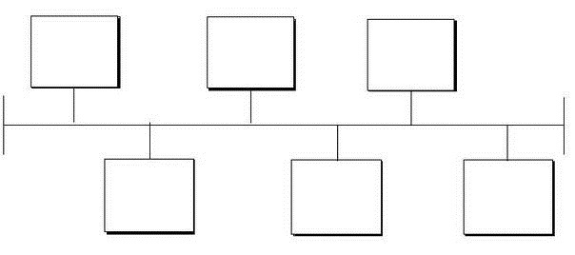

Image Source: <http://blog.reflexsystems.com/>

**Key Events:**

1. Potsdam Conference
2. The Marshall Plan
3. The Truman Doctrine (Containment)
4. Winston Churchill’s Iron Curtain Speech
5. The Berlin Airlift
6. NATO North Atlantic Treaty Organization
7. Warsaw Pact
8. Execution of Suspected Spies Julius and Ethel Rosenberg
9. Prosecution of Alger Hiss Federal Employee
10. The Korean War
11. McCarthyism McCarthy persecuting members of the army for being Communists.
12. The Vietnam War
13. The Cuban Missile Crisis
14. Bay of Pigs Invasion
15. The Fall of the Berlin Wall

**Answer Sheet**

**Event# Earlier to Later**

1. Potsdam Conference July 17th-August 2, 1945
2. Iron Curtain March 5th 1946
3. Marshall Plan June 5th 1947 /Truman Doctrine March 12th 1947
4. Alger Hiss 1948
5. The Berlin Airlift June 24, 1948-May 12th, 1949/NATO April 4, 1949
6. The Korean War 1950-1953 / McCarthyism February 9, 1950-October 1953
7. Julius and Ethel Rosenberg Execution June 19th, 1953
8. Vietnam War 1954-1975
9. Warsaw Pact May 9th, 1955
10. Bay of Pigs April 1961
11. Cuban Missile Crisis October 1962
12. Fall of Berlin Wall November 1989