**Title**: Comparing Christianity, Islam, and Judaism

**Lesson Authors**: Michael Smith and Benjamin Spiers

**Key Words**: Monotheism, Ten Commandments, Torah, Bible, New Testament, Jesus, Muhammad, Quran, Mecca, Medina, Five Pillars of Islam

**Grade Level**: 10th World History Part II

**Time Allotted**: 40 minutes

|  |
| --- |
| **Rationale/ Purpose (so what?)**  Nature and scope of topic. Why is this significant to the mission of educating future citizens? |
| It is important for students to learn about, as well as compare these three religious faiths. These religious faiths are a major element of culture including the U.S., influence foreign policy, and impact student’s personal lives today. It is also important to clear up misconceptions about these faiths and see how many similarities these faiths share to help students promote religious tolerance. |

|  |
| --- |
| **Background/Context:** How does this lesson fit into a unit of study? Looking backwards, looking forwards |
| This lesson would be good to discuss toward the end of a World History II class because these religious faiths play a major role in world affairs and are very relevant to students lives today. |

**Key Concept(s)** include definition: Monotheism- belief in one God or supreme deity that all three faiths share in common, Torah- Jewish holy book, New Testament- Christian holy book, Quran- Islamic holy book, Jesus- Christians believes he is the son of God, Muhammad- Muslims believe he is God’s prophet, Five Pillars of Islam- 1. Shahadah 2. Salat

3. Zakat 4. Sawm 5. Hajj

|  |  |
| --- | --- |
| **NCSS Standard(s)**  **SOL Information**  *As written in the Virginia SOL “Curriculum Framework” for the grade level | |
| **NCSS Theme (s) with indicators**: Culture  **SOL\*** : Word History II 15a, The student will demonstrate knowledge of the influence of Judaism, Christianity, Islam, Buddhism, and Hinduism in the contemporary world by  a) describing their beliefs, sacred writings, traditions, and customs.  Important to note WHII 15a also includes Buddhism and Hinduism; however, due to time constrains those two faiths could be covered in another lesson, as those two faiths share a lot in common with each other. | |
| **Essential Knowledge**  (minimum for SOL Resource Guide)  Judaism  • Monotheism  • Ten Commandments of moral and religious  conduct  • Torah: Written records and beliefs of the Jews    Christianity  • Monotheism  • Jesus as Son of God  • Life after death  • New Testament: Life and teachings of Jesus  • Establishment of Christian doctrines by early  church councils    Islam  • Monotheism  • Muhammad, the prophet  • Qur’an (Koran)  • Five Pillars of Islam  • Mecca and Medina | **Essential Skills**  (minimum for SOL Resource Guide)  Identify, analyze, and interpret  primary and secondary sources to  make generalizations about events  and life in world history |

**Guiding Question(s)**: *MUST BE SHARED WITH STUDENTS AT BEGINNING OF EACH LESSON- Visible in lesson procedure and materials.*

**The day’s big question:** What similarities do these three religious faiths share in common?

**Lesson Objective(s):** clearly emerges from big question and rationale and standards and will align with your assessment in Procedure and Process

**Obj. 1** Students will learn about the major aspects of the three religious faiths through analyzing online secondary document.

**Obj. 2** Students will compare the three religious faiths and discover the similarities that exist between them.

**Obj. 3** Students will explore the major impacts these three faiths have in the modern world and their personal lives.

**Assessment Tool(s) to be used-** Everything above- goes to what you want them to know/understand do- So what assessments are you going to use to help you manage and monitor that they have got it-informal and formal—make one over-riding assessment connect to your closure.

**Assessment 1.** Informal assessment- observe student discussions involving the secondary documents and the answers they come up with on the chart comparing the three religious faiths

**Assessment 2.** Exit Slip- Name one new piece of information you learned about each religious faith. Write two questions you have about today’s lesson including clarifications. Name one modern day conflict these three faiths play a role in and why you believe they play a role in that conflict.

|  |  |  |
| --- | --- | --- |
| **Materials: Historical Source(s):** List here and include copies in materials section below   * None required for lesson. * If desired could bring in Bible, Torah, or Quran if the teacher has a copy. |  | **Additional Materials/Resources:** List here and include copies in materials section- textbooks etc page numbers, websites etc   * Student and teacher access to internet and computer * Student has notebook paper to answer question. * Handout worksheet on comparing three faiths, or have them write it down on Notebook paper. * Exit slip worksheet with questions on Word document. * Access to smart board or regular board. * Youtube video with Steve Carell, Steven Colbert, and Jon Stewart- <http://www.youtube.com/watch?v=ulhWOqiKoNk> * BBC articles   Christianity- <http://www.bbc.co.uk/religion/religions/christianity/>  Islam-  <http://www.bbc.co.uk/religion/religions/islam/>  Judaism-  <http://www.bbc.co.uk/religion/religions/judaism/> |
|  |  |  |

**Procedure/Process:**

**1) JUST DO IT! The “Hook”:** A high-interest activity that introduces new content with connections to students’ prior knowledge. Between 1-5 minutes. You could also introduce the days guiding question- could help with assessment of student needs

the hook

**2) Instructional sequence:**

|  |  |  |
| --- | --- | --- |
| **Obj #**  See above. | **Processing Activity and Procedure** –include directions, question frames, assignment details, to be given to students (these should all be made into explicit materials (e.g. see material A) Do you have opportunities for direct/guided instruction and independent practice/engagement when appropriate and time estimates | **Check for Evidence of Understanding**  -Either Formal or Informal e.g. assessments- question frames, quiz, choice activities, discussion with frame and your THAT’s A WRAP.  (Checks Essential Knowledge and Skills should be in line with assessment tools above) |
| Just do it. | Watch YouTube video and have students answer question while watching video on notebook paper “What similarities and differences did you see between the three faiths in the video?” Write question on board. Discuss answers Est. Time: 10 min | Call on a couple of students to see their thoughts on the question and see if they had any prior knowledge on subject. |
| Transition: | Divide students into three main groups (Christianity, Islam, and Judaism) to focus on learning more about each faith on the BBC website. For larger classes may have to divide intro six main groups with two groups focusing on one religion. Have students get on BBC website. | |
| Objective # 1 | Students will spend time researching information on their religion on the BBC website and discuss among the group. May have students divide researching roles. For example one student in the group may read the Beliefs of Judaism, while another may read the Text section of Judaism on the BBC website. Teacher may need to guide students to look for key words and concepts on website. Est. Time 15 min | Walk around class to check on groups and see if they are discovering key points and major concepts about the faith they are researching. |
| Transition: | Have groups come together to discuss what they learned about their faith. Hand out worksheet or have students get out notebook paper. | |
| Objective # 2 | Have class discussion on what the groups learned about the three faiths. Groups may have a spokesperson. During discussion students will write major concepts on worksheet or notebook paper and discover connections between the three faiths. Est. time 10 min | See what answers students give on the information they learned about the faith they researched, and see if they can make connections between the three faiths. |

**3) Closure-** THAT’S A WRAP that goes to opening question- and also in part to assessment tools –at least one key assessment tool. (Do you need a rubric)

**Exit Slip-** Name one new piece of information you learned about each religious faith. Write two questions you have about today’s lesson including clarifications. Name one modern day conflict these three faiths play a role in and why you believe they play a role in that conflict.

Handout typed sheet to students to complete. Est. time 5 minutes.

**Modifications/Accommodations for Diverse Learners:**

Include reference and acknowledgement of IEP plans for specific students- that is easy. Additionally, highlight how you have designed materials/sequences that pay attention to pre-assessment evidence to address readiness, interest, and learning preference needs, including attention to student groupings, use of time and materials, variance in whole class and small group instruction, varied task complexity. Can you delineate key instructional strategies and scaffolds that are effective for responding to student needs? Do you provide rubrics to explain what good work looks like? Do you provide room for direct instruction/guided instruction (including read alouds and think alouds), independent practice. (Use Cruz and Thornton, and Tomlinson and McTighe).

* Bullet your details and explanations.
* While groups are researching the teacher can check on IEP students for comprehension.
* Teacher could pair an IEP student in a group with a student that could help the IEP student in their learning.
* During discussion observe IEP student, or hand them a copy of the worksheet with answers if necessary.
* Evaluate IEP students Exit Slip.

**Materials** (one resource per page- so it becomes a teacher or student handout, or overhead directions or ppt presentation. Include photocopies if need be. Can you provide elements of choices in materials or enrichment or support/anchor materials for different students?.

* Worksheet comparing the three faiths on Page 8- write on board, also do not write answers beforehand unless for an IEP student, answer list is not exhaustive
* Exit Slip Worksheet- on Page 9, could also have students write it on notebook paper, if that is done write questions on board

**Christianity vs. Islam vs. Judaism**

**Christianity**

* Belief in Jesus as Son of God and his Resurrection
* Only faith to believe in New Testament
* Like Judaism believe in Old Testament as well including Ten Commandments
* Monotheistic

**Judaism**

* Torah is their holy book; however, like Christians they do believe in Old testament
* Ten Commandments
* Monotheistic faith as well

**Islam**

* Muslims believe Muhammad is God’s prophet
* The Quran or Koran is the holy book of Islam.
* Believe in the Five Pillars of Islam

1. Shahadah
2. Salat
3. Zakat
4. Sawm
5. Hajj

* Mecca and Medina are Islamic holy cities
* Monotheistic faith as well

**Exit Slip**

1. Name one new piece of information you learned about each religious faith.
2. Write two questions you have about today’s lesson including clarifications.

1. Name one modern day conflict these three faiths play a role in and why you believe they play a role in that conflict.

**Title**: Absolute Monarchy Intro

**Lesson Author**: Michael Smith and Ben Spiers

**Key Words**: absolute monarchy, constitutional monarchy, France, Russia, Spain, England, Saudi Arabia, Oman, Swaziland

**Grade Level**:10th Grade World History Part II class

**Time Allotted**: 40 min

|  |
| --- |
| **Rationale/ Purpose (so what?)**  Nature and scope of topic. Why is this significant to the mission of educating future citizens? |
| In this lesson we would introduce what an absolute monarchy is, give examples of absolute monarchies back in the 16th-18th centuries, and give examples of absolute monarchies today. Learning about absolute monarchies is important for students because if they do not know what an absolute monarchy is they will not be able to effectively study the absolute monarchies of that time period. Another reason it is important for students to study this topic is that absolute monarchies still exist today. I will also mention what a constitutional monarchy is because England was unique from the other countries in this time period in that it had and still has a constitutional monarchy today. However, constitutional monarchy is not the focus of the lesson, as constitutional monarchy and England would be discussed in further detail later in the unit. It is important to note this lesson is based in part from a lesson plan Ben did for his cooperating teacher to introduce the Monarchy Unit. Ben taught the anticipation guide and frame portion of the lesson to the class, as that went pretty well. |

|  |
| --- |
| **Background/Context:** How does this lesson fit into a unit of study? Looking backwards, looking forwards |
| This lesson fits well into the introduction of a Unit on Absolute Monarchies and Monarchies from around 1500-1800. This lesson would give an introduction to the unit, so some of the people, places, and events would be discussed in further detail later in the unit, as well as the textbook readings. This lesson is a good way to help students be on the lookout for important people, places, and events latter on in the Unit. However, by the end of the lesson students will clearly know what an absolute monarchy is, as it is critical to understand this concept before proceeding further along in the unit. |

**Key Concept(s)** include definition:

* Absolute Monarchy- a king or queen that has total or absolute control over a government without major influence from other leaders like nobles or religious leaders
* Rule by divine right- belief by absolute monarchs that their rule was ordained by God
* Constitutional Monarchy- a monarchy limited by rule of law, in which other people have an important say in how the government is run

|  |  |
| --- | --- |
| **NCSS Standard(s)**  **SOL Information**  *As written in the Virginia SOL “Curriculum Framework” for the grade level | |
| **NCSS Theme (s) with indicators**: Time, Continuity, and Change   * Indicators- differences and similarities in forms of government today from hundreds of years ago, absolute monarchy is still a form of government today   **SOL\*** : related to 10th Grade World History II 6b  The student will demonstrate knowledge of scientific, political, economic, and religious changes during the sixteenth, seventeenth, and eighteenth centuries by  6b describing the Age of Absolutism, including the monarchies of Louis XIV and Peter the Great | |
| **Essential Knowledge**  (minimum for SOL Resource Guide)  Characteristics of absolute  monarchies  • Centralization of power  • Concept of rule by divine right    Absolute monarchs  • Louis XIV of France: Palace of  Versailles as a symbol of royal  power  • Peter the Great of Russia:  Westernization of Russia | **Essential Skills**  (minimum for SOL Resource Guide)  Identify and compare contemporary  political boundaries with the locations of civilizations, empires, and kingdoms. (WHII.1d) |

**Guiding Question(s)**: *MUST BE SHARED WITH STUDENTS AT BEGINNING OF EACH LESSON- Visible in lesson procedure and materials.*

**The day’s big question:** What is an absolute monarchy, what were examples of absolute monarchies back in the 16th-18th century, and are there still absolute monarchies in the world today?

**Lesson Objective(s):** clearly emerges from big question and rationale and standards and will align with your assessment in Procedure and Process

**Obj. 1** Discuss what an absolute monarchy is.

**Obj. 2** Discuss examples of the three major absolute monarchies from the 16th-18th century.

**Obj. 3** Discuss modern day examples of absolute monarchies today.

**Assessment Tool(s) to be used-** Everything above- goes to what you want them to know/understand do- So what assessments are you going to use to help you manage and monitor that they have got it-informal and formal—make one over-riding assessment connect to your closure.

**Assessment 1.** Anticipation Guide- this is a good formative assessment to see what prior knowledge students have of the topic, and at the end to see if they learned the material from the lesson

**Assessment 2.** Map activities- having students locate the European countries involved in the monarchy unit and seeing if they know the location of Saudi Arabia is a good way to formatively assess students’ knowledge of Geography

|  |  |  |
| --- | --- | --- |
| **Materials: Historical Source(s):** List here and include copies in materials section below   * None required for lesson |  | **Additional Materials/Resources:** List here and include copies in materials section- textbooks etc page numbers, websites etc   * Copies of Anticipation guide * Copies of blank frame * Couple of Copies of filled out Frame * A world map in the class to show students where the countries are located * Smart board- optional for map activity * Document camera * Copy of CIA income stats and US Department of Energy world oil production chart to show class * CIA Income stats- <https://www.cia.gov/library/publications/the-world-factbook/rankorder/2004rank.html> * US Department of Energy world oil production chart- <http://www1.eere.energy.gov/vehiclesandfuels/facts/2012_fotw733.html> |
|  |  |  |

**Procedure/Process:**

**1) JUST DO IT! The “Hook”:** A high-interest activity that introduces new content with connections to students’ prior knowledge. Between 1-5 minutes. You could also introduce the days guiding question- could help with assessment of student needs

the hook

**2) Instructional sequence:**

|  |  |  |
| --- | --- | --- |
| **Obj #**  See above. | **Processing Activity and Procedure** –include directions, question frames, assignment details, to be given to students (these should all be made into explicit materials (e.g. see material A) Do you have opportunities for direct/guided instruction and independent practice/engagement when appropriate and time estimates | **Check for Evidence of Understanding**  -Either Formal or Informal e.g. assessments- question frames, quiz, choice activities, discussion with frame and your THAT’s A WRAP.  (Checks Essential Knowledge and Skills should be in line with assessment tools above) |
| Just do it. | Anticipation Guide 5 min- Students will complete the before lesson portion of the anticipation guide. We will go over what they thought the answers were, but will not reveal correct answers until end of class to keep students interest up. | Good way to assess students prior knowledge of topic |
| Transition: | Ask students what they believe an absolute monarchy is? | |
| Objective # 1 and 2 | Frame 15 min- Students will fill out the completed frame that would be placed on the document camera. I would briefly explain the people, places, events, and concepts on frame. I will go over in more detail what an absolute monarchy is. Frame provides good outline of monarchy unit and could be used as a study guide. | Assess students prior knowledge about items on frames by asking questions about it before I explain what that item is. |
| Transition: | Europe map activity 5 min- have students make sure they know where major countries were in Europe during the monarchy time period, countries include Spain, France, Russia, England, and Low Countries (Netherlands, Belgium, and Luxembourg) since they rebelled against Spain, should be good review for students, and I would have students come up to the Smart board to identify those countries | |
| Objective # 3 | Absolute Monarchies today 10 min- ask class if there are absolute monarchies are today, explain that they are three today (Saudi Arabia, Oman, Swaziland), see if students know where Saudi Arabia is on map, show them where Oman and Swaziland are located on map, then ask them why they believe these countries are still absolute monarchies, show them income and oil production charts to show them that Saudi Arabia’s and Oman’s high income due mainly to high oil production may be reasons why absolute monarchs are still in power in those two states. An activity that goes beyond the SOL. | Good way to assess students prior knowledge of Geography and current world politics. |

**3) Closure-** THAT’S A WRAP that goes to opening question- and also in part to assessment tools –at least one key assessment tool. (Do you need a rubric)

Anticipation guide 5 min- students would complete the after lesson portion of the anticipation guide, we would go over the answers to the anticipation guide, I would also take any questions or comments to clarify any issues or misunderstandings

**Modifications/Accommodations for Diverse Learners:**

Include reference and acknowledgement of IEP plans for specific students- that is easy. Additionally, highlight how you have designed materials/sequences that pay attention to pre-assessment evidence to address readiness, interest, and learning preference needs, including attention to student groupings, use of time and materials, variance in whole class and small group instruction, varied task complexity. Can you delineate key instructional strategies and scaffolds that are effective for responding to student needs? Do you provide rubrics to explain what good work looks like? Do you provide room for direct instruction/guided instruction (including read alouds and think alouds), independent practice. (Use Cruz and Thornton, and Tomlinson and McTighe).

* If necessary I could give students a filled out copy of the Frame beforehand
* Also, during the anticipation guide I can help students out if necessary and make sure at the end of class they have the right answers and more importantly understand them

**Materials** (one resource per page- so it becomes a teacher or student handout, or overhead directions or ppt presentation. Include photocopies if need be. Can you provide elements of choices in materials or enrichment or support/anchor materials for different students?.

**Title**: Energy Sources Intro

**Lesson Author**: Michael Smith and Ben Spiers

**Key Words**: energy, fossil fuels, renewable energy, non-renewable energy, pros/cons, pollution, dangers

**Grade Level**:9th Grade World Geography

**Time Allotted**: 40 min

|  |
| --- |
| **Rationale/ Purpose (so what?)**  Nature and scope of topic. Why is this significant to the mission of educating future citizens? |
| In this lesson, we would introduce the concept of energy sources and how they differ in their costs, efficiencies, and outputs (pollution and more). The students will discuss the energy sources themselves (specifically wood, coal, oil, nuclear, and renewable energy) by looking at their impact in history, how they are used today, and how availability affects their cost and implementation. It is important for the students to explore the pros/cons behind energy sources so that they can better understand prices (such as natural gas and petroleum) and the impact that these energy sources have on the environment. As responsible citizens, the students must have a base level of understanding when it comes to energy use, especially the sources that we use today and will use in the future. |

|  |
| --- |
| **Background/Context:** How does this lesson fit into a unit of study? Looking backwards, looking forwards |
| This lesson will be used at the beginning of a unit on natural, human, and capital resources in order to introduce the ways that energy sources can differ and how they have their advantages/disadvantages. The students will all come in with some idea of energy and how it affects them (energy bills, gas prices, etc.) so we will take their prior knowledge and apply it toward any new material they may not know about. By understanding the basic concepts of energy use, energy sources, and human-environment interactions, the students will have a level of understanding that can be applied to the rest of the unit as well as other lessons/topics. |

**Key Concept(s)** include definition:

* Energy sources- fuels or means of obtaining energy that can be used for human purposes.
* Cost- the monetary level of value an energy/source of energy is worth; determined by cost of collection, production, and distribution.
* Pollution- the introduction of harmful substances into the environment, usually from the production or use of something.

|  |  |
| --- | --- |
| **NCSS Standard(s)**  **SOL Information**  *As written in the Virginia SOL “Curriculum Framework” for the grade level | |
| **NCSS Theme (s) with indicators**: People, Places, and Environments  **SOL\*** : related to 9th Grade World Geography 7a  The student will identify types of natural, human, and capital resources and explain their significance by  7a: showing their influence on patterns of economic activity and land use | |
| **Essential Knowledge**  (minimum for SOL Resource Guide)  Changes in use of energy resources and  technology over time  • Wood (deforestation)  • Coal (pollution, mining problems,  competition with oil and gas)  • Petroleum (transportation, environmental  considerations)  • Nuclear (contamination, waste)  • Solar, wind (cost, aesthetics) | **Essential Skills**  (minimum for SOL Resource Guide)  - Gather, classify, and interpret  information.  -Draw conclusions and make  inferences about data.  -Analyze and evaluate information.  -Explain cause-and-effect  relationships. |

**Guiding Question(s)**: *MUST BE SHARED WITH STUDENTS AT BEGINNING OF EACH LESSON- Visible in lesson procedure and materials.*

**The day’s big question:** What energy sources are there and how are they similar/different? Why do some cost more than others? How do they affect the environment?

**Lesson Objective(s):** clearly emerges from big question and rationale and standards and will align with your assessment in Procedure and Process

**Obj. 1** Discuss what energy sources there are and how they are different/similar.

**Obj. 2** Discuss how the energy sources cost more/less depending on need/use/availability.

**Obj. 3** Discuss how different energy sources produce different amounts and forms of pollution.

**Assessment Tool(s) to be used-** Everything above- goes to what you want them to know/understand do- So what assessments are you going to use to help you manage and monitor that they have got it-informal and formal—make one over-riding assessment connect to your closure.

**Assessment 1.** Group work- the students will work in small groups to gather information on one energy source that they will compile and share with the class via Polleverywhere. During the information gathering time allotted, we will monitor the groups to make sure all students are contributing.

**Assessment 2.** Exit slip- this formative assessment will show what information the students are taking away from the lesson and what areas of the lesson we need to focus on more.

|  |  |  |
| --- | --- | --- |
| **Materials: Historical Source(s):** List here and include copies in materials section below   * Energy Comparison stats-<http://www.bbc.co.uk/schools/gcsebitesize/geography/energy_resources/energy_rev1.shtml> |  | **Additional Materials/Resources:** List here and include copies in materials section- textbooks etc page numbers, websites etc   * Laptops (one for every student) * Activ/Smart Board- used to display the Polleverywhere slides * Pen/pencil and paper (for exit slip) |
|  |  |  |

**Procedure/Process:**

**1) JUST DO IT! The “Hook”:** A high-interest activity that introduces new content with connections to students’ prior knowledge. Between 1-5 minutes. You could also introduce the days guiding question- could help with assessment of student needs

**2) Instructional sequence:**

|  |  |  |
| --- | --- | --- |
| **Obj #**  See above. | **Processing Activity and Procedure** –include directions, question frames, assignment details, to be given to students (these should all be made into explicit materials (e.g. see material A) Do you have opportunities for direct/guided instruction and independent practice/engagement when appropriate and time estimates | **Check for Evidence of Understanding**  -Either Formal or Informal e.g. assessments- question frames, quiz, choice activities, discussion with frame and your THAT’s A WRAP.  (Checks Essential Knowledge and Skills should be in line with assessment tools above) |
| Just do it. | Polleverywhere 5 min- Students will respond to 5 questions via Polleverywhere in order to familiarize themselves with the technology and to introduce the concepts of energy sources/uses. | Good way to get the students used to the technology and get the theme of energy sources into the conversation. |
| Transition: | 5 min max- Ask the students what energy sources they use in their daily lives. | |
| Objective # 1 | Discussion 10 min- building off of their list of energy sources they use in their everyday lives, the students will be introduced to the big 5 that will be discussed in this lesson (wood, coal, oil, nuclear, and renewable). We will delegate groups of 3-5 (as needed by class size) to research each energy sources. Specifically they will look at the time in history the source was used most, the costs of the source, and the pros/cons of it, such as pollution or availability. | Building off of prior knowledge the students will develop group cooperation skills by working together to research and “own” their respective energy source. Teacher supervision will be needed to assure that all students are participating and contributing. |
| Transition: | 5 min max- The students will be asked to bullet the information (energy source type, time used, pros/cons like affordability and pollution) and send it to me via Polleverywhere, at which time it will be displayed on the Activboard/Smartboard. | |
| Objectives # 2, 3 | Lecture 10 min- Once the information has been gathered from the groups, we will lead the class in discussion about each source, when it was used, why, and how its costs/availability/pollution/etc. all play a role in its use. Any information the students didn’t gather that is needed for the discussion will be added by me from a previously constructed checklist. | This will be good for highlighting student work and praising the students for completing their work. By having the students own their work they will be more likely to be involved, active learners. |

**3) Closure-** THAT’S A WRAP that goes to opening question- and also in part to assessment tools –at least one key assessment tool. (Do you need a rubric)

Exit Slip 5 min- Students will complete exit slips that asks them for similarities between certain energy sources, what conditions might make certain energy sources cost more, and what forms of pollution are associated with certain energy sources. These will be turned in for assessment.

**Modifications/Accommodations for Diverse Learners:**

* Certain students who need to have specific seating locations will be placed in groups close to the board.
* Hearing impaired students who have electronic aides will have them on the teacher during lecture and at the group when they are doing group work.
* Students with lack of a laptop (if their computer is being repaired or is having problems) can use text messaging to reply to polls.
  + If they do not have a cell phone, we can let them use one of ours.

**Materials** (one resource per page- so it becomes a teacher or student handout, or overhead directions or ppt presentation. Include photocopies if need be. Can you provide elements of choices in materials or enrichment or support/anchor materials for different students?.

**Polleverywhere poll**

**The Warm-Up Poll Collection**

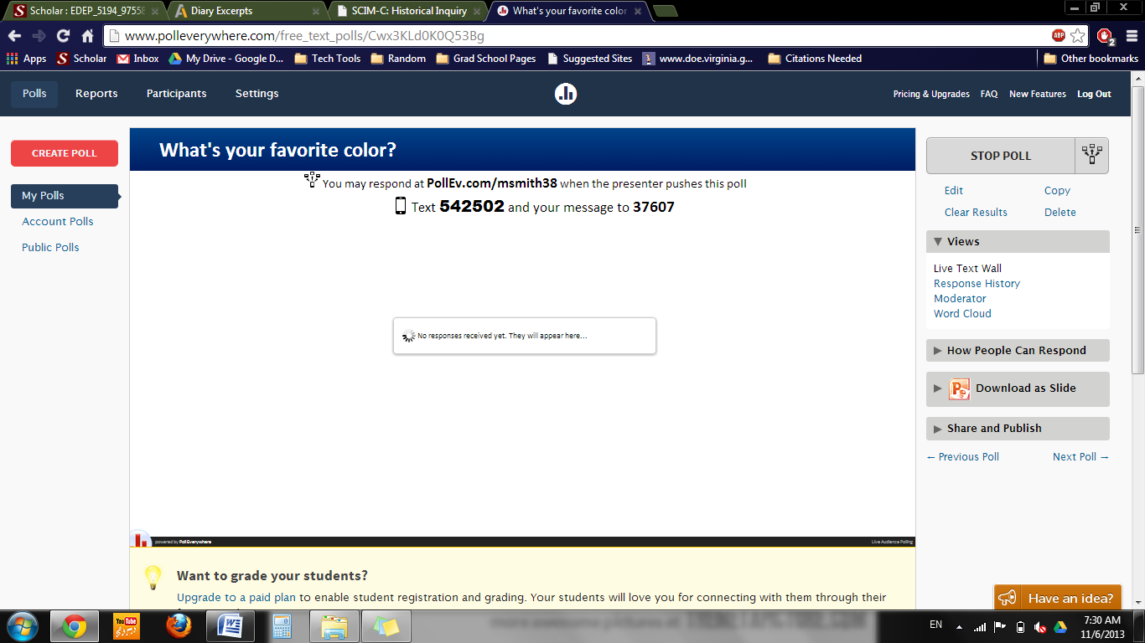

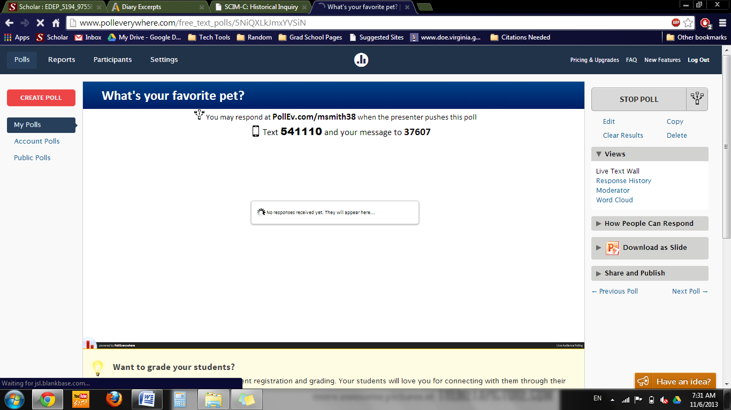

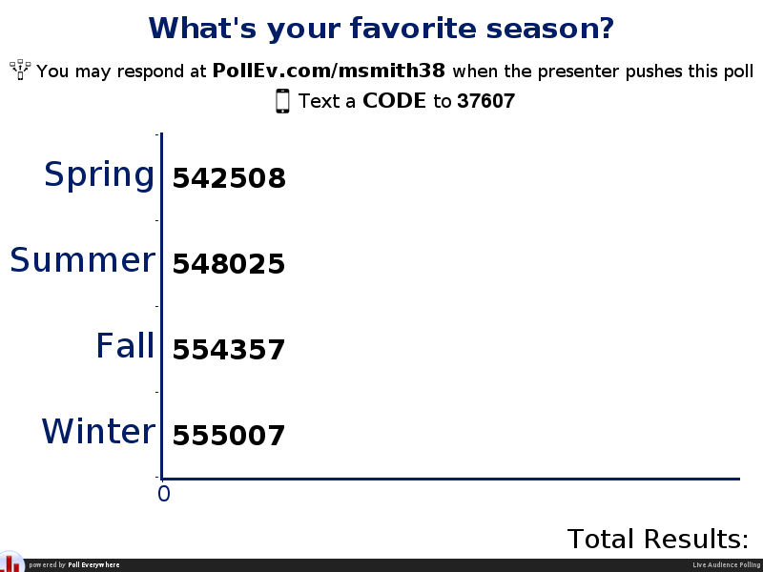

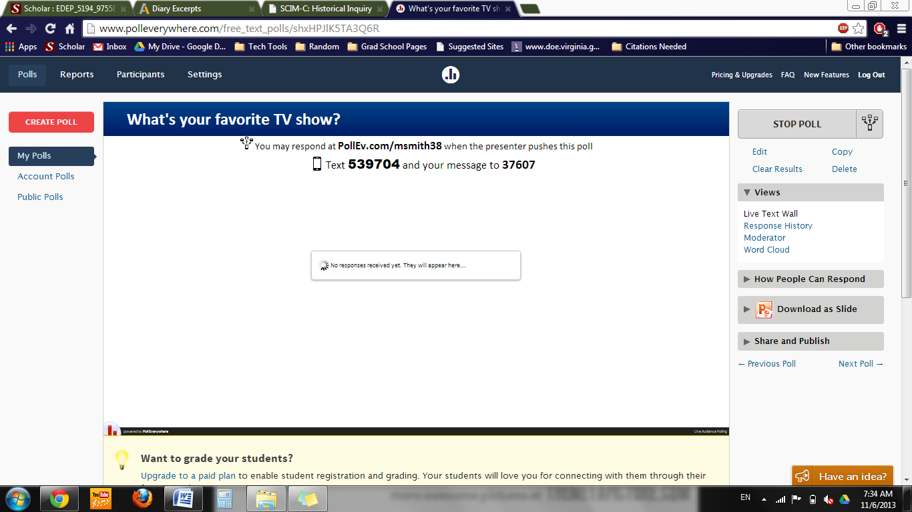

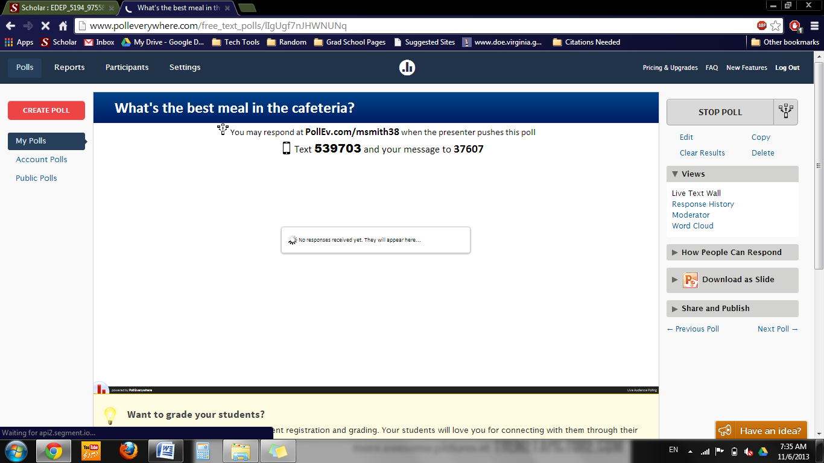

**Title**: Making “Good” Citizens

**Lesson Authors**: Michael Smith and Ben Spiers

**Key Words**: Government, media, war, influence, nationalism, national defense, identity, patriotism

**Grade Level**: 11th Grade

**Time Allotted**: 1 hour

|  |
| --- |
| **Rationale/ Purpose (so what?)**  Nature and scope of topic. Why is this significant to the mission of educating future citizens? |
| By educating students about how the government has played a role in how media was focus uses to affect the population, students will be more able to be critical of how they are influenced today by the government and other authoritative entities. |

|  |
| --- |
| **Background/Context:** How does this lesson fit into a unit of study? Looking backwards, looking forwards |
| Students will have already learned about WWII in other classes and we will have already covered it again in this course before using this lesson. Students will have the conceptual knowledge necessary to understand the context of the lesson (WWII, homefront, etc.) so that we can focus on the roles of the government and media and how they affected public opinion and identity for many Americans. This lesson will aid the students in the coming topics of the Red Scare, communism, and the Cold War by focusing student attention on the federal government and media and how they interacted and cooperated with each other in order to influence the public. |

**Key Concept(s)** include definition:

* **Government use of and influence on media**- During this time in history, the government heavily censored any information regarding the war and how it was going in order to keep public morale up. The government also used the media to put out propaganda which served that same purpose.
* **Exposure**- today we have access to an enormous amount of information via the internet and more traditional means of media such as newspapers, news shows on television, radio, etc., but during the 1940’s, the population had a much more limited range of information to listen to which limited their knowledge and subsequent opinions which were based on the comparatively sparse information.
* **Nationalism**- students must understand that the ultimate goal of all wartime propaganda was to create a citizenship which supported the nation and the government so that the war could be waged with full support. Nationalism, or patriotism, is an important concept to understand because it does not necessarily mean produced critical thinking citizens, but agreeable ones.

|  |  |
| --- | --- |
| **NCSS Standard(s)**  **SOL Information**  *As written in the Virginia SOL “Curriculum Framework” for the grade level | |
| **NCSS Theme (s) with indicators**: Individual development and Identity  **SOL\*** : VUS.12d  **The student will demonstrate knowledge of the effects of World War II on the home front by**  **d) describing the role of media and communications in the war effort.** | |
| **Essential Knowledge**  (minimum for SOL Resource Guide)  - The entertainment industry produced movies, plays, and shows that boosted morale and patriotic support for the war effort as well as portrayed the enemy in stereotypical ways.  - The United States government maintained strict censorship of reporting of the war. | **Essential Skills**  (minimum for SOL Resource Guide)  - Evaluate the authenticity, authority, and credibility of sources. (VUS.1b)  - Develop perspectives of time and place. (VUS.1d) |

**Guiding Question(s)**: *MUST BE SHARED WITH STUDENTS AT BEGINNING OF EACH LESSON- Visible in lesson procedure and materials.*

**The day’s big question:**

* **How did the government and media play a role in how American citizens viewed and reacted to WWII?**

**Lesson Objective(s):** clearly emerges from big question and rationale and standards and will align with your assessment in Procedure and Process

**Obj. 1**

* **Students will be able to evaluate the credibility and authenticity of sources such as propaganda films, news articles, etc.**

**Obj. 2**

* **Students will be able to empathize with the reality that faced many Americans during WWII regarding the range of information they were able to view.**

**Obj. 3**

* **Students will be able to list ways censorships affects individual or group thought during wartime.­**

**Assessment Tool(s) to be used-** Everything above- goes to what you want them to know/understand do- So what assessments are you going to use to help you manage and monitor that they have got it-informal and formal—make one over-riding assessment connect to your closure.

**Assessment 1.**

* **Informal- Observe student involvement during the agree/disagree activity. (Outlined below)**

**Assessment 2.**

* **Formal- Exit Slips- Students will complete 3-2-1 exit slips before leaving class. (Outlined below)**

|  |  |  |
| --- | --- | --- |
| **Materials: Historical Source(s):** List here and include copies in materials section below  -“The Ducktators” Propaganda Film <http://www.youtube.com/watch?v=XKOEMqDupE0> |  | **Additional Materials/Resources:** List here and include copies in materials section- textbooks etc page numbers, websites etc   * **“The Ducktators” Film** |
|  |  | * **FRAME Handouts** * **3-2-1 Handouts** |

**Procedure/Process:**

**1) JUST DO IT! The “Hook”:** A high-interest activity that introduces new content with connections to students’ prior knowledge. Between 1-5 minutes. You could also introduce the days guiding question- could help with assessment of student needs

* Students will answer the big question of the day in a brief 3 minute writing activity. Students we receive a prompt on the PowerPoint (in resources) with the question and directions listed below:
* “How did the government and media play a role in how American citizens viewed and reacted to WWII? Answer in less than 3 sentences.”
* Students will write their answers in their notebooks and we (teacher(s)) will ask a few students to share what they have.

**2) Instructional sequence:**

|  |  |  |
| --- | --- | --- |
| **Obj #**  See above. | **Processing Activity and Procedure** –include directions, question frames, assignment details, to be given to students (these should all be made into explicit materials (e.g. see material A) Do you have opportunities for direct/guided instruction and independent practice/engagement when appropriate and time estimates | **Check for Evidence of Understanding**  -Either Formal or Informal e.g. assessments- question frames, quiz, choice activities, discussion with frame and your THAT’s A WRAP.  (Checks Essential Knowledge and Skills should be in line with assessment tools above) |
| Just do it. | Quick write (See outline above)  3 Min | Informal: We will monitor the students as they write making sure that all are at least attempting to answer the prompt. |
| Transition: | We will ask a few students to share what they wrote in an effort to elicit prior knowledge from the class.  2 Min | |
| Objective # 1 | Students will be able to evaluate the credibility and authenticity of sources such as propaganda films, news articles, etc.  10 min | Informal: We will watch “The Ducktators” propaganda film (resources). Students will be instructed to list down two things that interest them about the film and to answer the questions at the end of the film (on PowerPoint). We will again quietly monitor the students to make sure they are doing what they’re supposed to during and after the film. |
| Transition: | We will put up a slide containing some things we (teachers) found interesting about the film and ask if students found any others.  5 min | |
| Objective # 2 | Students will be able to empathize with the reality that faced many Americans during WWII regarding the range of information they were able to view. 15 min | Informal: Students will take notes (FRAME routine below) based on the slides they will be seeing (PowerPoint) during the short lecture period. Students must take notes so we will check that they are actively filling out the FRAME routine as we speak. |
| Transition: | Students will take part in an agree/disagree activity (agrees stand on one side, disagrees on the other) (PowerPoint Slide). After each question we will discuss why they picked their sides. 10 min | |
| Objective # 3 | Students will be able to list ways censorships affects individual or group thought during wartime.­ 10 min | Building off the agree/disagree activity, students will be called up to fill out a chart about how propaganda changes how someone thinks. |

**3) Closure-** THAT’S A WRAP that goes to opening question- and also in part to assessment tools –at least one key assessment tool. (Do you need a rubric)

* After the last activity, students will complete the 3-2-1 handout (resources) and will turn it in before the end of class.
* 5 min

**Modifications/Accommodations for Diverse Learners:**

* Hearing Impairments- Students with hearing impairments would receive printed transcripts of “The Ducktators”.
* Visual impairments- Students will be given preferencial seating if they need to be closer to the board to view the movie or lecture better.
* ESL- Students can be given a transcribed version of “The Ducktators” as well as notes if we have access to a co-worker who can do so (co-teacher or anyone who speaks the student’s first language)
* IEPs- any student IEPs will be considered and accommodations will be made within our capability. **Materials** (one resource per page- so it becomes a teacher or student handout, or overhead directions or ppt presentation. Include photocopies if need be. Can you provide elements of choices in materials or enrichment or support/anchor materials for different students?.

-See attached PowerPoint file

**FRAME Handout for Class**



3-2-1 Closing Sheet

|  |  |  |
| --- | --- | --- |
| What are 3 things the government did that affected citizens during WWII? | | |
|  |  |  |

|  |  |
| --- | --- |
| What are 2 things people thought when they saw films like the one we did today? | |
|  |  |

|  |
| --- |
| What is 1 opinion you have now? |
|  |

**Title**: Analyzing Anne Frank Excerpts

**Lesson Authors**: Michael Smith and Ben Spiers

**Key Words**: Holocaust, Anne Frank, genocide, race, Germany, Jews

**Grade Level**: 10th Grade (World History 1500-Present)

**Time Allotted**: 50 minutes

|  |
| --- |
| **Rationale/ Purpose (so what?)**  Nature and scope of topic. Why is this significant to the mission of educating future citizens? |
| We will be analyzing excerpts from Anne Frank’s diary. By using the SCIM-C method, students will learn factual knowledge and conceptual knowledge about the Holocaust which will give them perspective that will enable them to understand genocide and how it happens. The concept of ethnocentrism will also be central in this lesson (and unit) which is a vital concept to know in order to be a critical social thinker. |

|  |
| --- |
| **Background/Context:** How does this lesson fit into a unit of study? Looking backwards, looking forwards |
| This lesson will be used as an introduction to the Holocaust unit. It will be used to form a base of knowledge the students can use in any class relating to World War II, the Holocaust, or genocide in general. They will also gain a conceptual understanding of oppression on minority groups that can be transferred to many other topics. |

**Key Concept(s)** include definition:

Genocide- The systematic and purposeful destruction of a racial, political, religious, or cultural group

Bystander effect- the distribution of responsibility across a group of people who don’t act individually due to the scope of the problem/situation and a lack of personal obligation

|  |  |
| --- | --- |
| **NCSS Standard(s)**  **SOL Information**  *As written in the Virginia SOL “Curriculum Framework” for the grade level | |
| **NCSS Theme (s) with indicators**: Individuals, Groups, and Institutions  **SOL\*** : **WHII.12b**  **The student will demonstrate knowledge of the worldwide impact of World War II by**  **b) examining the Holocaust and other examples of genocide in the twentieth century.** | |
| **Essential Knowledge**  (minimum for SOL Resource Guide)  **Terms to know**  • genocide: The systematic and  purposeful destruction of a racial,  political, religious, or cultural group  **Elements leading to the Holocaust**  • Hitler’s belief in the master race  • Final solution: Extermination camps,  gas chambers | **Essential Skills**  (minimum for SOL Resource Guide)  -Identify, analyze, and interpret primary  and secondary sources to make  generalizations about events and life in  world history.  -Analyze trends in human migration and  cultural interaction. (WHII.1e) |

**Guiding Question(s)**: *MUST BE SHARED WITH STUDENTS AT BEGINNING OF EACH LESSON- Visible in lesson procedure and materials.*

**The day’s big question:**

Who was Anne Frank?

**Lesson Objective(s):** clearly emerges from big question and rationale and standards and will align with your assessment in Procedure and Process

**Obj. 1**

* Students will gain understanding in how the Germans implemented civil rule/law.

**Obj. 2**

* Students will empathize with those who were the minority in a repressive population

**Obj. 3**

* Understand the goals of the Holocaust and genocide in general

**Assessment Tool(s) to be used-** Everything above- goes to what you want them to know/understand do- So what assessments are you going to use to help you manage and monitor that they have got it-informal and formal—make one over-riding assessment connect to your closure.

**Assessment 1.**

* Observation of group work while they are doing SCIM-C. This is informal, but if the students are actively doing the activity by finding out things such as who wrote the diary entries, why, when, etc. then we can safely assume that they are actively involved in the lesson.

**Assessment 2.**

* 3-2-1 Activity- Students will list three things they have learned, two questions they still have, and one opinion they now have.

|  |  |  |
| --- | --- | --- |
| **Materials: Historical Source(s):**  <http://annefrank.com/about-anne-frank/diary-excerpts/>  <http://www.npr.org/books/titles/138709907/anne-frank-the-diary-of-a-young-girl#excerpt> |  | **Additional Materials/Resources:**   * Laptops * Pencil/Paper * Excerpt SCIM-C handouts * Overhead projector |
|  |  |  |

**Procedure/Process:**

1. **JUST DO IT! The “Hook”:** A high-interest activity that introduces new content with connections to students’ prior knowledge. Between 1-5 minutes. You could also introduce the days guiding question- could help with assessment of student needs

**2) Instructional sequence:**

|  |  |  |
| --- | --- | --- |
| **Obj #**  See above. | **Processing Activity and Procedure** –include directions, question frames, assignment details, to be given to students (these should all be made into explicit materials (e.g. see material A) Do you have opportunities for direct/guided instruction and independent practice/engagement when appropriate and time estimates | **Check for Evidence of Understanding**  -Either Formal or Informal e.g. assessments- question frames, quiz, choice activities, discussion with frame and your THAT’s A WRAP.  (Checks Essential Knowledge and Skills should be in line with assessment tools above) |
| Just do it. | Quick Write 5 min- “What do you know about Anne Frank? Who was she? When was she alive? What happened to her? Why is she known today?” | Informal assessment- Walk around making sure that all students are actively listing things they know about Anne Frank. |
| Transition: | Brief Class Discussion 5 min max- Collect class input on who Anne Frank is. Include any important background information they failed to bring up. | |
| Objectives # 1, 2, 3 | SCIM-C 20 min- The teacher will lead the students in analyzing an excerpt from Anne Frank’s diary using SCIM-C. Once we have completed it, the class will be split up into 4 groups who will then analyze a respective excerpt using SCIM-C. | Informal assessment- Briefly stopping and talking to each group to see how their analysis is going. We will also monitor so as to keep students from monopolizing the work. |
| Transition: | Finalization of SCIM-C information 5 min- Have each group collect their information into a condensed form and appoint one member of the group to present the information. | |
| Objectives # 1, 2, 3 | Class discussion 10 min- Have each group present their respective analysis. We will have a specific list of things we want them to bring up and if they fail to do so we’ll bring them up after they conclude their analysis so as to highlight SOL information and key concepts. | Informal assessment- Building off of what we saw while walking around, we will informally assess what information the students gathered and how much effort they put into the work. We will give a small participation grade to all students who did the minimum contribution. |

**3) Closure-** THAT’S A WRAP that goes to opening question- and also in part to assessment tools –at least one key assessment tool. (Do you need a rubric)

**3-2-1 Activity 5 min**- students will complete this before the end of class which asks them to write three things they have learned, two questions they still have, and one opinion they now have. They will turn them in for assessment.

**Modifications/Accommodations for Diverse Learners:**

* Students with hearing impairments will be given preferential seating and their electronic aides will be worn by whoever is speaking during class discussion sessions.
* Certain students who need to have specific seating locations will be placed in groups close to the board.
* Pay close attention to any students who may have cultural/ethnic sensitivity to the issues discussed during this class.
  + A brief preface before class begins may be advisable.

**Materials** (one resource per page- so it becomes a teacher or student handout, or overhead directions or ppt presentation. Include photocopies if need be. Can you provide elements of choices in materials or enrichment or support/anchor materials for different students?.

**Analyze the quote below using the SCIM-C method:**

"Our many Jewish friends and acquaintances are being taken away in droves. The Gestapo is treating them very roughly and transporting them in cattle cars to Westerbork, the big camp in Drenthe to which they're sending all the Jews....If it's that bad in Holland, what must it be like in those faraway and uncivilized places where the Germans are sending them? We assume that most of them are being murdered. The English radio says they're being gassed."

Summarizing-

Contextualizing-

Inferring-

Monitoring-

Corroborating- (Do this section after you’ve heard every groups SCIM)

**Analyze the quote below using the SCIM-C method:**

"All college students are being asked to sign an official statement to the effect that they 'sympathize with the Germans and approve of the New Order." Eighty percent have decided to obey the dictates of their conscience, but the penalty will be severe. Any student refusing to sign will be sent to a German labor camp."

Summarizing-

Contextualizing-

Inferring-

Monitoring-

Corroborating- (Do this section after you’ve heard every groups SCIM)

**Analyze the quote below using the SCIM-C method:**

“Our lives were not without anxiety, since our relatives in Germany were suffering under Hitler's anti-Jewish laws. After the pogroms in 1938 my two uncles (my mother's brothers) fled Germany, finding safe refuge in North America. My elderly grandmother came to live with us. She was seventy-three years old at the time.”

Summarizing-

Contextualizing-

Inferring-

Monitoring-

Corroborating- (Do this section after you’ve heard every groups SCIM)

**Analyze the quote below using the SCIM-C method:**

“After May 1940 the good times were few and far between: first there was the war, then the capitulation and then the arrival of the Germans, which is when the trouble started for the Jews. Our freedom was severely restricted by a series of anti-Jewish decrees: Jews were required to wear a yellow star; Jews were required to turn in their bicycles; Jews were forbidden to use streetcars; Jews were forbidden to ride in cars, even their own; Jews were required to do their shopping between 3 and 5 p.m.; Jews were required to frequent only Jewish-owned barbershops and beauty parlors; Jews were forbidden to be out on the streets between 8 p.m. and 6 a.m.; Jews were forbidden to go to theaters, movies or any other forms of entertainment; Jews were forbidden to use swimming pools, tennis courts, hockey fields or any other athletic fields; Jews were forbidden to go rowing; Jews were forbidden to take part in any athletic activity in public; Jews were forbidden to sit in their gardens or those of their friends after 8 p.m.; Jews were forbidden to visit Christians in their homes; Jews were required to attend Jewish schools, etc. You couldn't do this and you couldn't do that, but life went on. Jacque always said to me, "I don't dare do anything anymore, 'cause I'm afraid it's not allowed."”

Summarizing-

Contextualizing-

Inferring-

Monitoring-

Corroborating- (Do this section after you’ve heard every groups SCIM)

**Title**: What is a Republic?

**Lesson Author**: Michael Smith and Ben Spiers

**Key Words**: republic, democracy, representative democracy, Constitution, Greece, Rome, U.S.

**Grade Level**: 12th Grade

**Time Allotted**: 40 min

|  |
| --- |
| **Rationale/ Purpose (so what?)**  Nature and scope of topic. Why is this significant to the mission of educating future citizens? |
| In this lesson we will discuss what a republic is. There are many misconceptions about the difference between a republic and a democracy. This topic is important because although the U.S. has aspects of a democracy, the U.S. is a republic. |

|  |
| --- |
| **Background/Context:** How does this lesson fit into a unit of study? Looking backwards, looking forwards |
| This lesson is designed for a 12th Virginia and U.S. Government class. It would probably be taught toward the beginning of a unit and the semester. Due to times constraints a separate lesson would have to be done before this one on what a democracy is, and the aspects of democracy that are in U.S. government today. It is also possible to do a concept mastery routine in that lesson on what is a democracy. |

**Key Concept(s)** include definition:

* Republic- form of government in which the power of government is limited by rule of law that protects the rights of its citizens
* Democracy- form of government in which citizens directly elect their representatives and the majority always rules
* Representative Democracy- aspect of a republic in which citizens elect a person to represent their interests in government

|  |  |
| --- | --- |
| **NCSS Standard(s)**  **SOL Information**  *As written in the Virginia SOL “Curriculum Framework” for the grade level | |
| **NCSS Theme (s) with indicators**: Power, Authority, and Governance   * Indicators- learning about the role of citizens in a republic, learning about the history of the U.S. being a republic   **SOL\*** : related to 12th Grade Virginia and U.S. Government 2a  The student will demonstrate knowledge of the political philosophies that shaped the development of Virginia and United States constitutional government by  a) describing the development of Athenian democracy and  the Roman republic. | |
| **Essential Knowledge**  (minimum for SOL Resource Guide)  Democratic elements of the United  States constitutional system borrowed  from Athens and Rome  • Athens: Direct democracy  • Rome: Indirect (representative)  democracy, republic | **Essential Skills**  (minimum for SOL Resource Guide)  Create and interpret diagrams, tables,  and charts. (GOVT.1b)    Distinguish between relevant and  irrelevant information. (GOVT.1d)    Identify a problem, weigh the expected costs and benefits and possible consequences of proposed solutions, and recommend solutions, using a decision-making model. (GOVT.1f) |

**Guiding Question(s)**: *MUST BE SHARED WITH STUDENTS AT BEGINNING OF EACH LESSON- Visible in lesson procedure and materials.*

**The day’s big question:** What is a republic and is the U.S. a republic?

**Lesson Objective(s):** clearly emerges from big question and rationale and standards and will align with your assessment in Procedure and Process

**Obj. 1** Students will learn that the U.S. is not a pure democracy, but is instead a republic.

**Obj. 2** Students will learn about the characteristics of a Republic, as well as examples of Republics in history and the present day.

**Assessment Tool(s) to be used-** Everything above- goes to what you want them to know/understand do- So what assessments are you going to use to help you manage and monitor that they have got it-informal and formal—make one over-riding assessment connect to your closure.

**Assessment 1.** Video worksheet- worksheet will help us see what students learn about the video, what a republic is, and whether the U.S. is a republic or not

**Assessment 2.** Exit Slip- exit slip will also help us see what the students learned about a republic and what further questions they have about the topic

|  |  |  |
| --- | --- | --- |
| **Materials: Historical Source(s):** List here and include copies in materials section below   * None required for lesson |  | **Additional Materials/Resources:** List here and include copies in materials section- textbooks etc page numbers, websites etc   * Access to internet and smart board screen or other video projection screen * Copies of blank concept diagrams for class * A couple of copies of a filled out concept diagram * Copies of video worksheet for class * Copies of Exit Slip * Bills of Rights Institute Video “Constitutional Principles: Representative Government”   <http://www.youtube.com/watch?v=bVD0bZ5H4MY>  or can be accessed from <http://billofrightsinstitute.org/resources/student-resources/videos/> |
|  |  |  |

**Procedure/Process:**

**1) JUST DO IT! The “Hook”:** A high-interest activity that introduces new content with connections to students’ prior knowledge. Between 1-5 minutes. You could also introduce the days guiding question- could help with assessment of student needs

the hook

**2) Instructional sequence:**

|  |  |  |
| --- | --- | --- |
| **Obj #**  See above. | **Processing Activity and Procedure** –include directions, question frames, assignment details, to be given to students (these should all be made into explicit materials (e.g. see material A) Do you have opportunities for direct/guided instruction and independent practice/engagement when appropriate and time estimates | **Check for Evidence of Understanding**  -Either Formal or Informal e.g. assessments- question frames, quiz, choice activities, discussion with frame and your THAT’s A WRAP.  (Checks Essential Knowledge and Skills should be in line with assessment tools above) |
| Just do it. | Video Worksheet 5 min- students answer before you watch portion of video worksheet, let a couple of students share their answers | Can assess student’s prior knowledge and views on topic. |
| Transition: | Watch Bills of Rights Institute Video “Constitutional Principles: Representative Government”-5 min | |
| Objective # 1 | Students complete after you watch portion of worksheet, discuss answers-10 min | Can assess student comprehension and views of video as well as republic through their answers on worksheet |
| Objective #2 | Complete concept diagram of Republic 15 min- students will get a blank copy of the concept diagram and fill it out | Ask students questions about the concept diagram. Can ask them if they know examples and non-examples of a republic. |

**3) Closure-** THAT’S A WRAP that goes to opening question- and also in part to assessment tools –at least one key assessment tool. (Do you need a rubric)

Exit Slip 5 min- students will complete the Exit Slip, students can also ask questions or make comments to clear up any misunderstandings from the lesson

**Modifications/Accommodations for Diverse Learners:**

Include reference and acknowledgement of IEP plans for specific students- that is easy. Additionally, highlight how you have designed materials/sequences that pay attention to pre-assessment evidence to address readiness, interest, and learning preference needs, including attention to student groupings, use of time and materials, variance in whole class and small group instruction, varied task complexity. Can you delineate key instructional strategies and scaffolds that are effective for responding to student needs? Do you provide rubrics to explain what good work looks like? Do you provide room for direct instruction/guided instruction (including read alouds and think alouds), independent practice. (Use Cruz and Thornton, and Tomlinson and McTighe).

* A filled out copy of the concept diagram could be handed out to students if necessary
* Pay extra attention to make sure IEP and special accommodations students comprehend the material.

**Materials** (one resource per page- so it becomes a teacher or student handout, or overhead directions or ppt presentation. Include photocopies if need be. Can you provide elements of choices in materials or enrichment or support/anchor materials for different students?.

**Exit Slip**

1. List three things you learned about a Republic today?
2. Write down two questions you have about today’s lesson?
3. After today’s lesson do you believe the U.S. is in some way’s a democracy?

**Title**: Globalization and Its Effects Today

**Lesson Authors**: Ben Spiers and Michael Smith

**Key Words**: Globalization, economy, international, goods, consumption

**Grade Level**: 6th grade

**Time Allotted**: 80 min (90 min period, with extra time due to lots of activities)

|  |
| --- |
| **Rationale/ Purpose (so what?)**  Nature and scope of topic. Why is this significant to the mission of educating future citizens? |
| This lesson will help students understand how our economic system affects not only us, but everyone around the globe. By understanding how goods are usually no longer created solely in the nation where they are bought and how the economic chain crosses many international borders; the students will be better able to understand how the goods they buy are part of a large complex system they has varied effects on many people. |

|  |
| --- |
| **Background/Context:** How does this lesson fit into a unit of study? Looking backwards, looking forwards |
| This lesson will be towards the end of the semester, after the majority of Cold War topics have been covered. The material covered in this lesson will give students authentic learning skills which will help them better understand the world around them and will contain material that will be valuable if transferred into future classes on economics, modern politics, etc. |

**Key Concept(s)** include definition:

- Production: (in this context) the recent economic trend where goods are produced in foreign countries (usually developing) due to the low costs and are transported across international boundaries to be sold/consumed in a more developed country where citizens can afford them.

- Globalization: the trend that business has taken in the last half a century where goods/services are produced/done where they are cheapest due to advents such as modern transportation and telecommunications.

- Quality of life: things such as access to basic needs like food, water, shelter, etc., but also enjoyment of life in ways such as entertainment (tv, radio, etc.), activities (shopping, going to movies, etc.), and more all determine one’s quality of life.

|  |  |
| --- | --- |
| **NCSS Standard(s)**  **SOL Information**  *As written in the Virginia SOL “Curriculum Framework” for the grade level | |
| **NCSS Theme (s) with indicators**:   * Production, Distribution, and Consumption   **SOL\*** :   * USII.8e * The student will demonstrate knowledge of the economic, social, and political transformation of the United States and the world between the end of World War II and the present by: e) describing how international trade and globalization have impacted American life. | |
| **Essential Knowledge**  (minimum for SOL Resource Guide)  Globalization is the linking of nations  through trade, information,  technologies, and communication.  Globalization involves increased  integration of different societies.  Impact of globalization on American  life:  • Availability of a wide variety of  foreign-made goods and services | **Essential Skills**  (minimum for SOL Resource Guide)  - Identify the costs and benefits of  specific choices made, including the  consequences, both intended and  unintended, of the decisions and how  people and nations responded to  positive and negative incentives. |

**Guiding Question(s)**: *MUST BE SHARED WITH STUDENTS AT BEGINNING OF EACH LESSON- Visible in lesson procedure and materials.*

**The day’s big question:**

* **What is globalization and how does it affect our lives as well as others around the world?**

**Lesson Objective(s):** clearly emerges from big question and rationale and standards and will align with your assessment in Procedure and Process

**Obj. 1**

* **Students will be able to demonstrate an understanding of how goods are produced in an international market.**

**Obj. 2**

* **Students will be able to identify what factors affect how business occurs between nations, specifically trade barriers, trade agreements, and physical barriers.**

**Obj. 3**

* **Students will be able to empathize will people in developing countries who experience a lower quality of life, specifically how production and the wages they earn influence it.**

**Assessment Tool(s) to be used-** Everything above- goes to what you want them to know/understand do- So what assessments are you going to use to help you manage and monitor that they have got it-informal and formal—make one over-riding assessment connect to your closure.

**Assessment 1.**

* **Informal: observation of student involvement in the globalization activity (group work for obj. 1)**

**Assessment 2.**

* **Formal: students must complete a brief worksheet as an exit slip (outlined below)**

|  |  |  |
| --- | --- | --- |
| **Materials: Historical Source(s):** List here and include copies in materials section below |  | **Additional Materials/Resources:** List here and include copies in materials section- textbooks etc page numbers, websites etc  **Warm-up Worksheet**  **Exit Slip** |
|  |  | **http://www.cbsnews.com/videos/working-conditions-at-apples-chinese-factories-under-fire/** |

**Procedure/Process:**

**1) JUST DO IT! The “Hook”:** A high-interest activity that introduces new content with connections to students’ prior knowledge. Between 1-5 minutes. You could also introduce the days guiding question- could help with assessment of student needs

- The students will fill out an anticipatory worksheet (resources) that will elicit any prior knowledge and will introduce some key concepts of the lesson.

**2) Instructional sequence:**

|  |  |  |
| --- | --- | --- |
| **Obj #**  See above. | **Processing Activity and Procedure** –include directions, question frames, assignment details, to be given to students (these should all be made into explicit materials (e.g. see material A) Do you have opportunities for direct/guided instruction and independent practice/engagement when appropriate and time estimates | **Check for Evidence of Understanding**  -Either Formal or Informal e.g. assessments- question frames, quiz, choice activities, discussion with frame and your THAT’s A WRAP.  (Checks Essential Knowledge and Skills should be in line with assessment tools above) |
| Just do it. | Complete the activity written above.  5 min | Informal: We will collect the warm-up sheets for a participatory grade. |
| Transition: | We will discuss volunteers’ answers and correct any misconceptions before we begin.  5 min | |
| Objective # 1 | Students will be broken up into 3 groups. Each group will be asked a question (PowerPoint) which they will answer about 3 goods they’ll see. Students will need to designate someone as the spokesperson for their group. After each product is revealed the groups will have 3 minutes to find out the answer to their respective question. (The answers don’t have to be perfect and the students can use whatever websites they like. This is just to introduce the concept)  15 min | Informal: The students will be quietly observed while they work on each prompt in order to keep them on track. Each group must produce an answer to their question. |
| Transition: | Students will be asked what trends they see developing across these products. (Ex: consumed by developed countries mostly)  5 min | |
| Objective # 2 | Students will be able to identify what factors affect how business occurs between nations, specifically trade barriers, trade agreements, and physical barriers.  20 min | Informal: Students will take part in a Jigsaw activity. The things students will cover will be in the PowerPoint. |
| Transition: | Students will be asked to go back to their “hook” activity sheets and correct any misconceptions they had.  5 min | |
| Objective # 3 | Students will be able to empathize will people in developing countries who experience a lower quality of life, specifically how production and the wages they earn influence it.  Students will watch a short video depicting labor conditions in a Chinese Foxconn production plant (resources)  20 min | Informal: Students will all have one playing card given to them during the clip and at the end must give one impression/understanding they have about the quality of life people in developing countries have. |

**3) Closure-** THAT’S A WRAP that goes to opening question- and also in part to assessment tools –at least one key assessment tool. (Do you need a rubric)

**Exit Slip (Resources)**

**5 min**

**Modifications/Accommodations for Diverse Learners:**

Hearing Impairments- If students have hearing impairments then we (teachers) can wear a personal auditory device (school supplied) and will have students use them during class discussion.

Visual Impairments- students with visual impairments will be given preferential seating close to the board or can be given larger text sized worksheets.

ESL- translations of all the material will be made if it is within our power and any bilingual students will be grouped with single language students so as to facilitate discussion.

IEPs- any IEP will be considered and accommodations will be made, including extra time or paper copies of notes if need be.

**Materials** (one resource per page- so it becomes a teacher or student handout, or overhead directions or ppt presentation. Include photocopies if need be. Can you provide elements of choices in materials or enrichment or support/anchor materials for different students?.

See the PowerPoint attached.

**Warm-Up**

* Answer the following questions:

1. What do you think globalization is? What factors does it deal with? How are we affected?
2. How do you think our “quality of life” is in America? What about other developed nations? Developing nations?
3. What is a “trade barrier”? What do you think it does and who is it supposed to help?

**Exit Slip**

**Circle the correct choice:**

1. Trade barriers make it more difficult for goods to go INTO/OUT OF a country.
2. Trade agreements LESSEN/INCREASE trade barriers between member nations.
3. Physical barriers usually DECREASE/INCREASE the cost of goods.
4. Developed countries usually have FEWER/MORE labor unions.

**Title**: Technological Innovations in the U.S. (early 20th century)

**Lesson Authors**: Michael Smith and Ben Spiers

**Key Words**: Technology, jobs, transportation, innovation, production

**Grade Level**: 6th Grade

**Time Allotted**: 75 minutes

|  |
| --- |
| **Rationale/ Purpose (so what?)**  Nature and scope of topic. Why is this significant to the mission of educating future citizens? |
| Students today understand technology better than many, but they need to understand how the implementation of technology, especially in the early 1900’s in the U.S., led to massive social and economical changes. By understanding how technology can inspire/drive change, the students will be better prepared to deal with tech in the future and can better use it to better themselves and the world around them. |

|  |
| --- |
| **Background/Context:** How does this lesson fit into a unit of study? Looking backwards, looking forwards |
| This portion of the semester will be finishing up Reconstruction and the post Civil War United States. The students will use the information gained in this portion of the semester to better prepare them for the entirety of the rest of the unit (as technology becomes more prevalent) and especially for the upcoming portion of the class dealing with the era from the Roaring Twenties to World War II. |

**Key Concept(s)** include definition:

- Mass Production: the concept of producing a product in large quantities with identical outcomes each time (ex: all cars produced are the same type with same measurements and specifications)

- “Shrinking World”: the idea that time and space are shortened because of the improvements in transportation (ex: Places which were days away previously can be reached in several hours)

- Continuing Importance: this concept is about how these nearly century old innovations still impact us today due to the “game changing” nature they possessed (ex: we can fly across the continent in a matter of hours, something unthinkable in all senses before the Wright Brothers invented the airplane)

|  |  |
| --- | --- |
| **NCSS Standard(s)**  **SOL Information**  *As written in the Virginia SOL “Curriculum Framework” for the grade level | |
| **NCSS Theme (s) with indicators**:  Science, Technology, and Society  **SOL\*** :  **USII.6a: The student will demonstrate knowledge of the social, economic, and technological changes of the early twentieth century by:**  **a) explaining how developments in factory and labor productivity, transportation (including the use of the automobile), communication, and rural electrification changed American life and standard of living.** | |
| **Essential Knowledge**  (minimum for SOL Resource Guide)  **Results of improved transportation**  **brought about by affordable**  **automobiles**  • Greater mobility  • Creation of jobs  • Growth of transportation-related  industries (road construction, oil,  steel, automobile)  • **Invention of the airplane**  • The Wright brothers  **Use of the assembly line**  • Henry Ford, automobile  • Rise of mechanization | **Essential Skills**  (minimum for SOL Resource Guide)  - Make connections between the past and  the present. (USII.1b)  - Interpret ideas and events. (USII.1d) |

**Guiding Question(s)**: *MUST BE SHARED WITH STUDENTS AT BEGINNING OF EACH LESSON- Visible in lesson procedure and materials.*

**The day’s big question:**

**How did the technological innovations of the early 20th century affect life for those who lived during that time and how do the innovations continue to affect us today?**

**Lesson Objective(s):** clearly emerges from big question and rationale and standards and will align with your assessment in Procedure and Process

**Obj. 1**

* **Students will be able to express why the assembly line was such an important concept.**

**Obj. 2**

* **Students will be able to demonstrate mathematically how improvements in transportation drastically reduced transit times from place to place.**

**Obj. 3**

* **Students will be able to discuss what innovations created during this time period still affect us greatly today.**

**Assessment Tool(s) to be used-** Everything above- goes to what you want them to know/understand do- So what assessments are you going to use to help you manage and monitor that they have got it-informal and formal—make one over-riding assessment connect to your closure.

**Assessment 1.**

* **Formal: Students must complete the travel time reduction handout.**

**Assessment 2.**

* **Formal: Students will complete the matching activity on the exit slip.**

|  |  |  |
| --- | --- | --- |
| **Materials: Historical Source(s):** List here and include copies in materials section below |  | **Additional Materials/Resources:** List here and include copies in materials section- textbooks etc page numbers, websites etc |
|  |  | Assembly Line Video-<http://www.youtube.com/watch?v=c-OkmRcyMfg>  Distance Calculator-(I used this to figure out the distance for the worksheet)  <http://www.infoplease.com/atlas/calculate-distance.html>  Wright Bros Flight Video-  <http://www.youtube.com/watch?v=Wfyvspnko04>  Travel Time Worksheet  Exit Slip (Matching)  All images on the PowerPoint were taken from Google Images |

**Procedure/Process:**

**1) JUST DO IT! The “Hook”:** A high-interest activity that introduces new content with connections to students’ prior knowledge. Between 1-5 minutes. You could also introduce the days guiding question- could help with assessment of student needs

Students will take part in an assembly line activity (outlined in PowerPoint).

**2) Instructional sequence:**

|  |  |  |
| --- | --- | --- |
| **Obj #**  See above. | **Processing Activity and Procedure** –include directions, question frames, assignment details, to be given to students (these should all be made into explicit materials (e.g. see material A) Do you have opportunities for direct/guided instruction and independent practice/engagement when appropriate and time estimates | **Check for Evidence of Understanding**  -Either Formal or Informal e.g. assessments- question frames, quiz, choice activities, discussion with frame and your THAT’s A WRAP.  (Checks Essential Knowledge and Skills should be in line with assessment tools above) |
| Just do it. | Hook activity (above)  5 min | Informal- We will check to make sure all students are actively participating. |
| Transition: | We will have a class discussion going over why the groups who followed the assembly line model were more efficient and how that was a representation of Henry Ford’s vision of how to mass produce a vehicle (directly going into the clip we’re about to watch).  5 min | |
| Objective # 1 | Students will do a Jigsaw activity (outlined in PowerPoint) which goes over Henry Ford, the assembly line, the creation of jobs, and the creation of industries related to transportation. (PowerPoint)  20 min | Informal- Each student must be able to take the knowledge gathered in their original group and express it to the mixed group they transfer into. |
| Transition: | Brief class discussion where we ask, “What did it all do?”. We will talk about all the things the students bring up, but we will make sure they mention both the rise in the mobility of people and the rise of mechanization.  5 min | |
| Objective # 2 | Students will fill out a worksheet (resources) which shows the increase in travel times between the past and modern day.  10 min | Informal- Students will have their answers graded (not strictly on mathematical correctness, but understanding the trend that traveling took less time than before. They must have answered all of the questions on the worksheet to get full credit. |
| Transition: | After students complete the worksheet, we’ll ask which method of transportation was the fastest (the plane). We will then ask students what they know about the plane, such as “Who invented it”, “Where was it invented”, “When was it invented”.  5 min | |
| Objective # 3 | Working off the transition, we will do a short lecture about the Wright Brothers and their creation of the first plane (PowerPoint). We will focus on how the plane has transformed from what the Wrights created to the modern planes we have today. We will then have a class discussion about what other inventions during this time period evolved over the years into influential things we see today (cars, mechanization, trains, efficiency, etc.)  20 min | No assessment for this portion. |

**3) Closure-**

Formal- Students will complete a brief matching worksheet as their exit slip (resources)

5 min

**Modifications/Accommodations for Diverse Learners:**

Hearing Impairments- If students have hearing impairments then we (teachers) can wear a personal auditory device (school supplied) and will have students use them during class discussion.

Visual Impairments- students with visual impairments will be given preferential seating close to the board or can be given larger text sized worksheets.

ESL- translations of all the material will be made if it is within our power and any bilingual students will be grouped with single language students so as to facilitate discussion.

IEPs- any IEP will be considered and accommodations will be made, including extra time or paper copies of notes if need be.

**Materials** (one resource per page- so it becomes a teacher or student handout, or overhead directions or ppt presentation. Include photocopies if need be. Can you provide elements of choices in materials or enrichment or support/anchor materials for different students?.

See attached PowerPoint

Calculate how long it would take to make these trips if you used different modes of transportation. Assume that the person traveling never eats, sleeps, or gets tired.

* Hint: Divide the total miles by the mph of the mode of transportation you’re using.

|  |  |
| --- | --- |
| **Method of Transportation** | **Speed** |
| Walking | 4 mph |
| Horse drawn carriage | 5 mph |
| Car (Early 1900’s) | 15 mph |
| Train (Early 1900’s) | 20 mph |
| Modern Car | 70 mph |
| Modern Passenger Train | 100 mph |
| Modern Passenger Jet | 500 mph |

1. If you traveled from Washington D.C. to Miami, FL (922 miles) by walking non-stop, how long would it take? What if you went by early car?
2. Richmond, VA to Los Angeles, CA (2285 miles) by early train? What about by modern train?
3. New York City to Chicago, IL (1745 miles) by horse drawn carriage? What about by early train?
4. Baltimore, MD to Austin, TX (2320 miles) by modern car? What about by passenger jet?

**Exit Slip**

Match the terms/people with the corresponding items we discussed in class today

Henry Ford Airplane

Wright Brothers Greater mobility of people

Rise of mechanization More jobs and supporting industry

Improved travel methods Assembly Line

**Title**: The Columbian Exchange

**Lesson Author**: Michael Smith and Ben Spiers

**Key Words**: Columbian Exchange, tobacco, peanuts, diseases, smallpox, horses, corn, coffee, bananas, chocolate

**Grade Level**: 10th Grade World History II

**Time Allotted**: 40 min

|  |
| --- |
| **Rationale/ Purpose (so what?)**  Nature and scope of topic. Why is this significant to the mission of educating future citizens? |
| The Columbian Exchange is an important topic to discuss, as the exchange of items resulting from it had major effects on the world that are still being felt today. Many of the major items we eat, use, or ride comes from the Columbian Exchange. One major downside of the Columbian Exchange is that it resulted in the spread of diseases that decimated Native Americans populations. Ben did the Columbian Exchange PowerPoint activity during his observation and it went well. |

|  |
| --- |
| **Background/Context:** How does this lesson fit into a unit of study? Looking backwards, looking forwards |
| This lesson would probably fit in around the time of discussing the Explorers and the New World. |

**Key Concept(s)** include definition: Columbian Exchange- the exchange of plants, animals, and goods from Europe/Africa to the Americas or the Americas to Europe/Africa

|  |  |
| --- | --- |
| **NCSS Standard(s)**  **SOL Information**  *As written in the Virginia SOL “Curriculum Framework” for the grade level | |
| **NCSS Theme (s) with indicators**: Global Connections   * The Columbian Exchange resulted in global connections that had different impacts on individuals, animals, and the environment of multiple Continents.   **SOL\*** : WHII 4d The student will demonstrate knowledge of the impact of the European Age of Discovery and expansion into the Americas, Africa,  and Asia by  d) describing the Columbian Exchange, including its impact on native populations. | |
| **Essential Knowledge**  (minimum for SOL Resource Guide)  Columbian Exchange  • Western Hemisphere agricultural  products, such as corn, potatoes, and  tobacco, changed European lifestyles.  • European horses and cattle changed  the lifestyles of American Indians.  • European diseases, such as smallpox,  killed many American Indians.    Impact of the Columbian Exchange  • Shortage of labor to grow cash crops  led to the use of African slaves.  • Slavery was based on race.  • European plantation system in the  Caribbean and the Americas destroyed  indigenous economics and damaged  the environment. | **Essential Skills**  (minimum for SOL Resource Guide)  Use maps, globes, artifacts, and  pictures to analyze the physical and  cultural landscapes of the world and to  interpret the past. (WHII.1b) |

**Guiding Question(s)**: *MUST BE SHARED WITH STUDENTS AT BEGINNING OF EACH LESSON- Visible in lesson procedure and materials.*

**The day’s big question:** What is the Columbian Exchange, and what are its impacts on the World.

**Lesson Objective(s):** clearly emerges from big question and rationale and standards and will align with your assessment in Procedure and Process

**Obj. 1** Students will learn what the Columbian Exchange is, what items were involved in it, and how it relates to today.

**Obj. 2** Students will determine what they think is the most important item in the Columbian Exchange through Significance Cards.

**Assessment Tool(s) to be used-** Everything above- goes to what you want them to know/understand do- So what assessments are you going to use to help you manage and monitor that they have got it-informal and formal—make one over-riding assessment connect to your closure.

**Assessment 1.** Formative assessment of student’s prior knowledge on the Anticipation Guide and Columbian Exchange PowerPoint Activity.

**Assessment 2.** Formative assessment of student responses on their Significance Cards.

|  |  |  |
| --- | --- | --- |
| **Materials: Historical Source(s):** List here and include copies in materials section below   * Some historical photos in PowerPoint |  | **Additional Materials/Resources:** List here and include copies in materials section- textbooks etc page numbers, websites etc   * Anticipation Guide * Access to PowerPoint for Columbian Exchange activity * Access to board for writing the chart down * Note Cards for students to write what they think is the most important item of the Columbian Exchange * Tape, clothespin, or other item for students to put up the Note Cards on the board * Access to internet to show Columbian Exchange chart via <http://dmshistory8.weebly.com/the-columbian-exchange.html> |
|  |  |  |

**Procedure/Process:**

**1) JUST DO IT! The “Hook”:** A high-interest activity that introduces new content with connections to students’ prior knowledge. Between 1-5 minutes. You could also introduce the days guiding question- could help with assessment of student needs

the hook

**2) Instructional sequence:**

|  |  |  |
| --- | --- | --- |
| **Obj #**  See above. | **Processing Activity and Procedure** –include directions, question frames, assignment details, to be given to students (these should all be made into explicit materials (e.g. see material A) Do you have opportunities for direct/guided instruction and independent practice/engagement when appropriate and time estimates | **Check for Evidence of Understanding**  -Either Formal or Informal e.g. assessments- question frames, quiz, choice activities, discussion with frame and your THAT’s A WRAP.  (Checks Essential Knowledge and Skills should be in line with assessment tools above) |
| Just do it. | 5 min- Students complete Before Lesson portion of Anticipation Guide, and we go over student responses. Don’t reveal answers. | Informal- see how students answer the questions to the Anticipation Guide |
| Transition: | Tell students we will be doing the Columbian Exchange PowerPoint Activity, and briefly tell them what the Columbian Exchange is. | |
| Objective # 1 | 10 min- Complete Columbian Exchange PowerPoint activity. We will write on the board the chart for them to copy down on a piece of paper. On the left side of the chart will be Europe to Americas and on the right side of the chart will be Americas to Europe. We will go through the ten pictures on the PowerPoint. Half of them will be Europe to Americas, and vice versa. We will do a class vote by raising hands to see where they think item, good, etc. should go on the chart. Then we will say the correct answer and write it on the board for them to copy down. We will elaborate on some of the pictures and concepts where time permits. We will also have an extra picture of Virginia to show them where Tobacco and Peanuts are grown in the state. We think this is a good way for to them to relate the Columbian Exchange to today. | Informal- see how students think where the item originated from through them raising their hands, also looking to see if students are putting the Columbian Exchange Item in the right spot on the chart. |
| Transition: | Show them the Columbian Exchange chart from <http://dmshistory8.weebly.com/the-columbian-exchange.html>, can leave it up during Significance Card activity | |
| Objective # 2 | 20 min- Students will do Significance Cards. On a note card we hand out they will write on the Note Card what they think is the most significant item resulting from the Columbian Exchange. After that all the students will post their cards on the board. There will be two sections for items coming from Americas to Europe/Africa and Europe/Africa to Americas. Students can help each other post their responses in the right section. Students will then take a seat and we will take a minute to look at the responses at the board. Then we will ask students to verbally elaborate on why they chose what they did for their note card. | Informal- see what students put on their note cards, see if they arrange their answers in the right section on the board, and see what their explanations for their answers are when we ask questions |

**3) Closure-** THAT’S A WRAP that goes to opening question- and also in part to assessment tools –at least one key assessment tool. (Do you need a rubric)

5 min- Students will complete After Lesson portion of Anticipation Guide. We will then go over answers to the guide. Informal assessment of how students answered the After Lesson portion of the Anticipation Guide.

**Modifications/Accommodations for Diverse Learners:**

Include reference and acknowledgement of IEP plans for specific students- that is easy. Additionally, highlight how you have designed materials/sequences that pay attention to pre-assessment evidence to address readiness, interest, and learning preference needs, including attention to student groupings, use of time and materials, variance in whole class and small group instruction, varied task complexity. Can you delineate key instructional strategies and scaffolds that are effective for responding to student needs? Do you provide rubrics to explain what good work looks like? Do you provide room for direct instruction/guided instruction (including read alouds and think alouds), independent practice. (Use Cruz and Thornton, and Tomlinson and McTighe).

* May need to provide IEP or other special needs students copies of chart from PowerPoint activity and Columbian Exchange chart from <http://dmshistory8.weebly.com/the-columbian-exchange.html>
* Provide additional assistance to students on Significance Card activity in coming up with a responses and putting it on the board in the right spot

**Materials** (one resource per page- so it becomes a teacher or student handout, or overhead directions or ppt presentation. Include photocopies if need be. Can you provide elements of choices in materials or enrichment or support/anchor materials for different students?.

**Columbian Exchange Anticipation Guide**

Directions: For the Before Lesson portion circle whether you believe the statement to the left is True (T) or False (F). Do not complete the After Lesson portion of the guide until at the end of class.

|  |  |  |
| --- | --- | --- |
|  | Before Lesson | After Lesson |
| 1. The Greeks and Romans were using Tobacco products thousands of years ago. | T F | T F |
| 1. Native Americans were growing Corn before the Europeans arrived. | T F | T F |
| 1. The potato originated in Ireland. | T F | T F |
| 1. Native Americans were riding horses before Europeans arrived. | T F | T F |
| 1. The Columbian Exchange had devastating impacts on Native Americans due to diseases like smallpox. | T F | T F |

**Sample chart students would complete during PowerPoint Activity**

SOL Requirements are in bold

Europe to Americas Americas to Europe

**Horses** **Corn**

**Cattle** **Potatoes**

Coffee **Tobacco**

**Smallpox**  Peanuts

Flu Turkey

**Columbian Exchange chart to be shown to class after PowerPoint Activity**

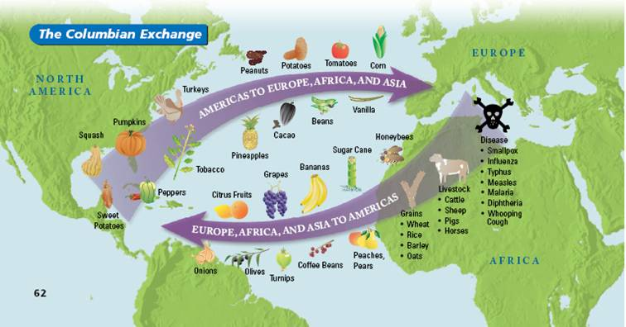

Picture accessed from: <http://dmshistory8.weebly.com/the-columbian-exchange.html>

**Sample Significance Card Activity Answers on Board**

Europe/Africa to Americas Americas to Europe/Africa

Turkey

Smallpox

Tobacco

Corn

Bananas

Cattle

**Title**: Voter ID Laws: What do you think?

**Lesson Author**: Michael Smith and Ben Spiers

**Key Words**: Democrat, Republican, Legislation, Voting, Elections, Voter Fraud, Voting Restrictions

**Grade Level**: 12th Grade VA and US Government Class

**Time Allotted**: 40 min

|  |
| --- |
| **Rationale/ Purpose (so what?)**  Nature and scope of topic. Why is this significant to the mission of educating future citizens? |
| Vote ID laws have been in the news a lot lately. It is a topic that is very relevant to today and it is something that should interest students. Voter ID laws affect voter participation and can certainly effect elections. It is highly debated whether or not Voter ID laws restrict voting or protect the voting process from fraud. |

|  |
| --- |
| **Background/Context:** How does this lesson fit into a unit of study? Looking backwards, looking forwards |
| This lesson could fit well in a unit on voting and/or elections. It could also be a current event issue since Voter ID laws have been in the news lately. This lesson in particular has a level of flexibility in where it could fit in a unit. |

**Key Concept(s)** include definition: Voter ID Laws- laws that several states have enacted that require an government photo ID like a driver’s license in order to vote, some Vote ID laws still allow a provisional ballot to be cast without a photo ID

|  |  |
| --- | --- |
| **NCSS Standard(s)**  **SOL Information**  *As written in the Virginia SOL “Curriculum Framework” for the grade level | |
| **NCSS Theme (s) with indicators**: Civic Ideals and Practices  **SOL\*** : GOVT 6g The student will demonstrate knowledge of local, state, and national elections by  g) analyzing voter turnout. | |
| **Essential Knowledge**  (minimum for SOL Resource Guide)  Influences on voter turnout  • Campaign issues  • Candidates  • Voter attitudes toward government  • Voter loyalty to political parties  • Competitive and noncompetitive  races    Education, age, and income are  important factors in predicting which  citizens will vote.    More citizens vote in presidential  elections than in other national, state,  and local contests, but the percentage of  Americans voting in presidential  elections was on the decline until the  2008 election.    A voter’s belief that he/she has little  impact on the outcome of an election  tends to discourage voter turnout.    Voter apathy, dissatisfaction, and failure  to meet voting requirements can  contribute to decline in voting. | **Essential Skills**  (minimum for SOL Resource Guide)  Create and interpret diagrams, tables,  charts, and spreadsheet. (GOVT.1b)    Analyze political cartoons, political  advertisements, pictures, and other  graphic media. (GOVT.1c)    Identify a problem, weigh the expected  costs and benefits and possible  consequences of proposed solutions,  and recommend solutions, using a  decision-making model. (GOVT.1f) |

**Guiding Question(s)**: *MUST BE SHARED WITH STUDENTS AT BEGINNING OF EACH LESSON- Visible in lesson procedure and materials.*

**The day’s big question:** What are the effects of Voter ID laws and are they needed to prevent voter fraud, or do they restrict voting rights?

**Lesson Objective(s):** clearly emerges from big question and rationale and standards and will align with your assessment in Procedure and Process

**Obj. 1** Students will become aquatinted with a view of Voter ID Laws through reading an article on the subject.

**Obj. 2** Students will argue for the position taken on the laws in the article they read in a class debate.

**Obj. 3** Students will express their own opinion on Voter ID Laws through answering the closing question.

**Assessment Tool(s) to be used-** Everything above- goes to what you want them to know/understand do- So what assessments are you going to use to help you manage and monitor that they have got it-informal and formal—make one over-riding assessment connect to your closure.

**Assessment 1.** Formative assessment of student’s prior knowledge about Voter ID laws through responses to opening question.

**Assessment 2.** Formative assessment of student responses during the structured academic controversy and the closing question.

|  |  |  |
| --- | --- | --- |
| **Materials: Historical Source(s):** List here and include copies in materials section below   * None required for lesson |  | **Additional Materials/Resources:** List here and include copies in materials section- textbooks etc page numbers, websites etc   * Board for writing opening and closing question on * Several copies of both articles for and against Voter ID Laws * Martin Knight article for voter ID laws on “Why Democrats Really Oppose Voter ID…” link: <http://www.redstate.com/martin_a_knight/2013/08/17/why-democrats-oppose-voter-id/> * Voting Rights Institute article against Voting ID Laws on “The Real Cost Of Photo ID: An Unnecessary, Expensive, And Intrusive Voter Restriction In a Time of Fiscal Crisis” link: <http://assets.democrats.org/pdfs/photoid/Dems-report-real_cost_of_voting_ID.pdf> |
|  |  |  |

**Procedure/Process:**

**1) JUST DO IT! The “Hook”:** A high-interest activity that introduces new content with connections to students’ prior knowledge. Between 1-5 minutes. You could also introduce the days guiding question- could help with assessment of student needs

the hook

**2) Instructional sequence:**

|  |  |  |
| --- | --- | --- |
| **Obj #**  See above. | **Processing Activity and Procedure** –include directions, question frames, assignment details, to be given to students (these should all be made into explicit materials (e.g. see material A) Do you have opportunities for direct/guided instruction and independent practice/engagement when appropriate and time estimates | **Check for Evidence of Understanding**  -Either Formal or Informal e.g. assessments- question frames, quiz, choice activities, discussion with frame and your THAT’s A WRAP.  (Checks Essential Knowledge and Skills should be in line with assessment tools above) |
| Just do it. | 5 min-Students upon entering the classroom will answer the opening question on the board “What do you know about Voter ID Laws?” We will then go over student responses, and we will very briefly mention what a Voter ID Law is. | Informal- see student’s prior knowledge about Voter ID Law’s through their responses to the opening question. |
| Transition: | Tell students that we are going to do a structures academic controversy or debate on Voter ID Laws. One side will argue for them, while the other side will argue against it. Class will count 1,2 to determine what position they will have to argue during the debate. Ones will be handed the article that’s argues for the laws, while two’s will be handed the article that argues against the law (see page 4). | |
| Objective # 1 | 10 min- Students will read the article they are going to have to argue for in the debate. | Informal- walk around the classroom to make sure students are reading the article |
| Transition: | Divide the classroom by having ones go to one side of the classroom, while two’s will go to the other side of the classroom. | |
| Objective # 2 | 20 min- A class debate will be held on the Voter ID law, as each side will go back and forth arguing their position. Students can work together in the group. Due to time constraints the structured academic controversy will end at this stage. | Informal- see what evidence and responses students come up with during the debate |

**3) Closure-** THAT’S A WRAP that goes to opening question- and also in part to assessment tools –at least one key assessment tool. (Do you need a rubric)

5 min- Students will answer the closing question on the board, “Do you support Voter ID Laws or believe they unnecessarily restrict voting rights? If time permits we will go over student answers, and we can formatively assess students through their responses to the question. This way students can express their personal opinions on the matter.

**Modifications/Accommodations for Diverse Learners:**

Include reference and acknowledgement of IEP plans for specific students- that is easy. Additionally, highlight how you have designed materials/sequences that pay attention to pre-assessment evidence to address readiness, interest, and learning preference needs, including attention to student groupings, use of time and materials, variance in whole class and small group instruction, varied task complexity. Can you delineate key instructional strategies and scaffolds that are effective for responding to student needs? Do you provide rubrics to explain what good work looks like? Do you provide room for direct instruction/guided instruction (including read alouds and think alouds), independent practice. (Use Cruz and Thornton, and Tomlinson and McTighe).

* IEP and other special needs students will be watched closely during the debate. Each group will have students that IEP students can work with during the debate.