**5 Just Do Its and 5 That’s a Wrap**

Note: All opening and closing activities should take around five minutes.

**1A. Civil War Lesson Opening- Anticipation Guide:** I think an anticipation guide can be a good way to introduce and prepare students for almost any type of lesson in a variety of social studies classes. Specifically this anticipation guide would be for the beginning of a lesson on the American Civil War. This anticipation guide, the lesson following it, and the closing question would be based off of VA and US History SOL Standard 7a-b.

SOL Objectives: The student will demonstrate knowledge of the Civil War and Reconstruction Era and their importance as major turning points in American history by

1. evaluating the multiple causes of the Civil War, including the role of the institution of slavery as a principal cause of the conflict.
2. identifying the major events and the roles of key leaders of the Civil War Era, with emphasis on Abraham Lincoln, Jefferson Davis, Ulysses S. Grant, Robert E. Lee, and Frederick Douglass.

The Civil War would probably take multiple days to cover so the anticipation guide would be designed for the causes, beginning, and major actors in the Civil War. This anticipation guide will help a teacher see a student’s prior knowledge on the subject, and help students be on the lookout for important events during the lesson. The anticipation guide could also be used as a study guide for a later quiz or test.

Anticipation Guide Procedure:

* As students come into in the classroom, hand them the anticipation guide worksheet for them to complete.
* Give students a couple of minutes to complete the guide.
* Go over the students responses to the anticipation guide, but do not reveal the answers. (Students can fill in the answers to the anticipation guide during the lesson or the teacher can go over the answers at the end of class once the lesson is completed.)
* Move on to the next part of the Civil War lesson.

**American Civil War Anticipation Guide**

Directions: Complete the Before Lesson portion of the anticipation guide by circling True (T) or False (F) to for the statement to the left. The During Lesson portion will be completed later on in the lesson at the direction of the teacher.

|  |  |  |
| --- | --- | --- |
|  | Before Lesson | During Lesson |
| 1. Slavery was a major cause of the Civil War. | T F | T F |
| 2. The Marbury vs. Madison Supreme Court decision was a major cause of the Civil War. | T F | T F |
| 3. Several states in the South succeeded before Fort Sumter. | T F | T F |
| 4. The U.S. was blessed with great Presidents during the 1850’s. | T F | T F |
| 5. Robert E. Lee was a Union general during the Civil War. | T F | T F |
| 6. Jefferson Davis was the President of the Confederacy during the Civil War. | T F | T F |

**1B.** **Civil War Lesson Closure- Closing Question:** A closing question can be a simple and great way to see what students have learned from a lesson, as well as make connections from the lesson to today. It can also be a way for students to express their opinions on the lesson.

**Closing Question-** Other than Slavery, what do you think is another important factor in causing the Civil War? Why?

I think this closing question helps students to express their opinions about what they think are important factors other than slavery in causing the Civil War. Students would learn about the other factors (like state’s rights, tariffs, agriculture, weak President’s, etc.) involved in causing the Civil War during the lesson. While slavery is a major cause of the Civil War, it is important for students to look into the other factors that caused this conflict. This question does not necessarily have a right or wrong answer, as long as students support their opinion with evidence.

Civil War Closing Question Procedure:

* At the end of the lesson direct students to take a few minutes to the answer the closing question on the board in a short paragraph on a piece of paper.
* If time permits, go over student responses. If a teacher so chooses students can hand in their responses to the closing question as they walk out the door.

**2A. Opening Question: U.S. Constitution-** An opening question to start the day is a simple and effective way to activate student’s prior knowledge and get them thinking about what will be covered in today’s lesson. The opening question can also be a review of a lesson from the prior day, or a check to see if students did their homework reading the previous night. This specific opening question and opinionare closing will relate to Civics and Economics SOL Standard 2b-c.

SOL Objectives:The student will demonstrate knowledge of the foundations of American constitutional government by

b) explaining the significance of the charters of the Virginia Company of London, the Virginia Declaration of Rights, the Declaration of Independence, the Articles of Confederation, the Virginia Statute for Religious Freedom, and the Constitution of the United States, including

the Bill of Rights.

c) identifying the purposes for the Constitution of the United States as stated in its Preamble.

The Opening Question could be used before any lesson on the Constitution in a Civics class, as well as other government or history classes related to the Constitution. This question will get students thinking about why the Constitution was written.

**Opening Question:** Why do you think the U.S. Constitution was written?

Opening Question Procedure:

* Write the opening question on the board.
* As students come in, tell them to answer the question on the board in a short paragraph. Tell them they have a couple of minutes to complete it.
* Have a couple of students share their responses.
* Move on to the next part of the U.S. Constitution lesson.

**2B. Opinionare Closing:** An opinionare can be a great way for students to express their thoughts on what they learned during the lesson in a variety of Social Studies classes. It can be used to help connect historical topics to today. It could also be used at the beginning of a class as well. It is important to note with an opinionare that there are not necessarily right or wrong answers, as long as students use evidence and reasoning to support their answer. In this specific opinionare students are asked to express their opinions on modern issues related to what they learned on the U.S. Constitution in class. This opinionare will help students make connections with the lesson to issues today.

Opinionare Closing Procedure:

* At the end of a lesson have students take a couple of minutes to complete the opinionare.
* If times permits, go over student responses. If desired, teachers could have the students hand in the opinionares as they walk out the door.

**Constitution Opinionare**

Directions: For each statement circle whether you agree or disagree with the statement. Then below that explain your reasoning for your answer. There are no wrong answers.

1. According to the Constitution, the Federal government is currently too powerful.

Agree Disagree

Reasoning:

1. School policies involving searches and seizures violate the Constitution.

Agree Disagree

Reasoning:

1. In the Constitution, small states like Delaware have too much power in the Senate since all states have equal representation despite their population.

Agree Disagree

Reasoning:

1. The process of amending the Constitution is too difficult, and needs to be changed.

Agree Disagree

Reasoning:

**3A. Opening Article: Mt. St. Helens 1980 Eruption-** An opening article related to the lesson is a good way for students to become interested prepared for the day’s lesson. You could have a couple of questions for students to answer about the article or just discuss the article after students have read it. This opening article and picture closing will be specifically related to World Geography SOL Standard 2b.

SOL Objective: The student will analyze how selected physical and ecological processes shape

the Earth’s surface by

b) describing how humans influence the environment and are influenced by it.

The opening article is on the May 1980 eruption of Mt. Saint Helens. Students will be introduced to the eruption, how volcanoes work, as well as important terms like pyroclastic flows and lahars. The article will provide a good introduction into a lesson on volcanoes and earthquakes related to the SOL standard above.

Article link: <http://volcanoes.usgs.gov/volcanoes/st_helens/st_helens_geo_hist_99.html>

Opening Article Procedure:

* Hand students the article as they come into class, and tell them to take a couple of minutes to read it.
* After students have finished reading the article, ask students for their thoughts on the article and ask them a couple of questions about the article.
* Move on to the Volcanoes and Earthquakes lesson

**3B. Closing Picture:** A picture can be used at the end of a lesson to see if students can use what they learned from the lesson and apply it to figure out what is going on in the picture. A closing picture can be an interesting and thought provoking activity for student to do at the end of a class. This picture is of students on top of a school flooded by lahar after the eruption of Mt. Pinatubo in 1991. This picture helps students make connections from what they learned in the lesson about the effects of volcanoes.

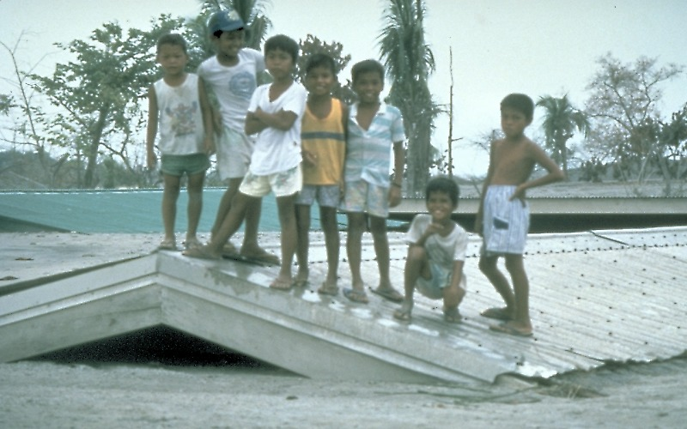

Picture accessed from: <http://volcanoes.usgs.gov/Imgs/Jpg/Pinatubo/30410135_097_large.jpg>

Closing Picture Procedure:

* At the end of the lesson give students a couple of minutes to study the picture and see what is going on in the picture. Students can also look for time period and location of picture. Students can work in small groups of 2-3 to study the picture.
* The teacher will ask for student thoughts on the picture, as well as ask questions to help students figure out what and where the picture is.

**4A. Current Event-** A current event is a good way to start off a class to make social studies lessons relevant to today. They can be used in a variety of social studies classrooms. A current event can also prepare and interest students in the upcoming lesson. This specific current event and exit slip closing is related to World History II SOL Standard 14b.

SOL Objective: The student will demonstrate knowledge of political, economic, social, and cultural aspects of independence movements and development efforts by

b) describing Africa’s achievement of independence, including Jomo Kenyatta’s leadership of Kenya and Nelson Mandela’s role in South Africa.

Since Nelson Mandela recently passed away, it would be an important current event to bring up in any Social Studies classroom, especially World History. Students should have also heard about Mandela’s passing on the news and what he meant to freedom in South Africa and across the world. This current event can also help students learn more about Apartheid.

Article link: <http://www.cnn.com/2013/12/06/world/africa/nelson-mandela-main/>

Current Event Procedure:

* Hand students current event article on Mandela as they walk in class, and have them read the article for a few minutes.
* After students have read the article, ask for students thoughts on the article and ask them a couple of questions about the article.
* Move on to the planned lesson for the day. Since Post-Colonial Africa may not be taught until later in the semester, tell students that Mandela, South Africa, and Apartheid will be covered in more detail later in the semester.

**4B- Post-Colonial Africa Exit Slip Closing:** An Exit Slip is a simple and great way to assess what students have learned, what questions they have, or misunderstandings they have in any Social Studies classroom. Exit Slips’ can help teachers plan future instruction or re-teach concepts students had trouble comprehending before. The Post-Colonial Africa Exit Slip will be used to see what students learned from the Post-Colonial Africa lesson, questions they have about the lessons, and more information they want to know.

Post-Colonial Africa Exit Slip Procedure:

* At the end of the lesson, hand students the Exit Slip and tell them to take a couple of minutes to complete it.
* Collect the Exit Slips as students leave the class, or if extra time permits go over the Exit Slip with students, then collect them as students leave the class
* During planning or after school read the students Exit Slips to see what they learned about the lesson and see if any issues need to be addressed during the next class.

**Post-Colonial Africa Exit Slip**

1. What three things did you learn today about Post-Colonial Africa?
2. What two questions do you have about Post-Colonial Africa?
3. What is one thing you want to learn more about Post-Colonial Africa?

**5A. Opening picture: Cuban Missile Crisis-** An opening picture can be a good way to interest, prepare, and introduce students for an upcoming lesson. An opening picture can also help teachers assess students’ prior knowledge on the subject. This specific opening picture and current event closing is related to VA and US History SOL Standard 13b.

SOL Objective: The student will demonstrate knowledge of United States foreign policy since World War II by

b) explaining the origins of the Cold War, and describing the Truman Doctrine and the policy of containment of communism, the American role of wars in Korea and Vietnam, and the role of the North Atlantic Treaty Organization (NATO) in Europe.

The opening picture is related the range of Soviet Missiles from Cuba, as students may recognize what the picture is about if they know about the Cuban Missile Crisis. The picture will be a good intro into a lesson on the Cuban Missile Crisis and help students understands why the U.S. did not want nuclear missiles in Cuba that could hit major U.S. cities like DC and Dallas.

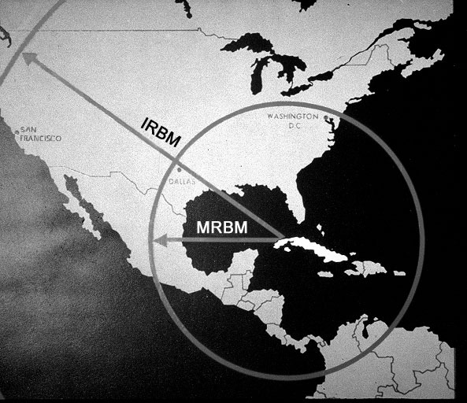

Picture accessed from: <https://www.cia.gov/library/center-for-the-study-of-intelligence/csi-publications/csi-studies/studies/vol46no1/CubaMap1b_w.jpg/image.jpg>

Opening Picture Procedure:

* Have the picture projected on a Smartboard or overhead projector as students come into the classroom. Tell them to take a couple of minutes to study the picture.
* Once the students have studied the picture ask students their thoughts on the picture and ask them a couple of questions the photo.
* Move on to a lesson on the Cuban Missile Crisis or the Cold War in general

**5B- North Korea Current Event Closing:** A current event can also be used to close a class. After a lesson a student may be able to understand a current event better and make connections from the lesson to today. This current event of North Korea potentially having a missile capable of reaching the U.S. is similar to the Soviets having a missile capable of reaching the U.S. from Cuba.

Article accessed from: <http://www.presstv.com/detail/2013/11/06/333302/north-korea-missile-hitting-america-alerts-us/>

Current Event Closing Procedure:

* At the end of the lesson, have students read the current event article for a couple of minutes.
* Once students have read the article, take a couple of minutes to have students express their views on the article, and see if there are any similarities from the article to the Cuban Missile Crisis.