**SIM Routines Used During**

**Spring 2014 Student Teaching**

**Ben Spiers**

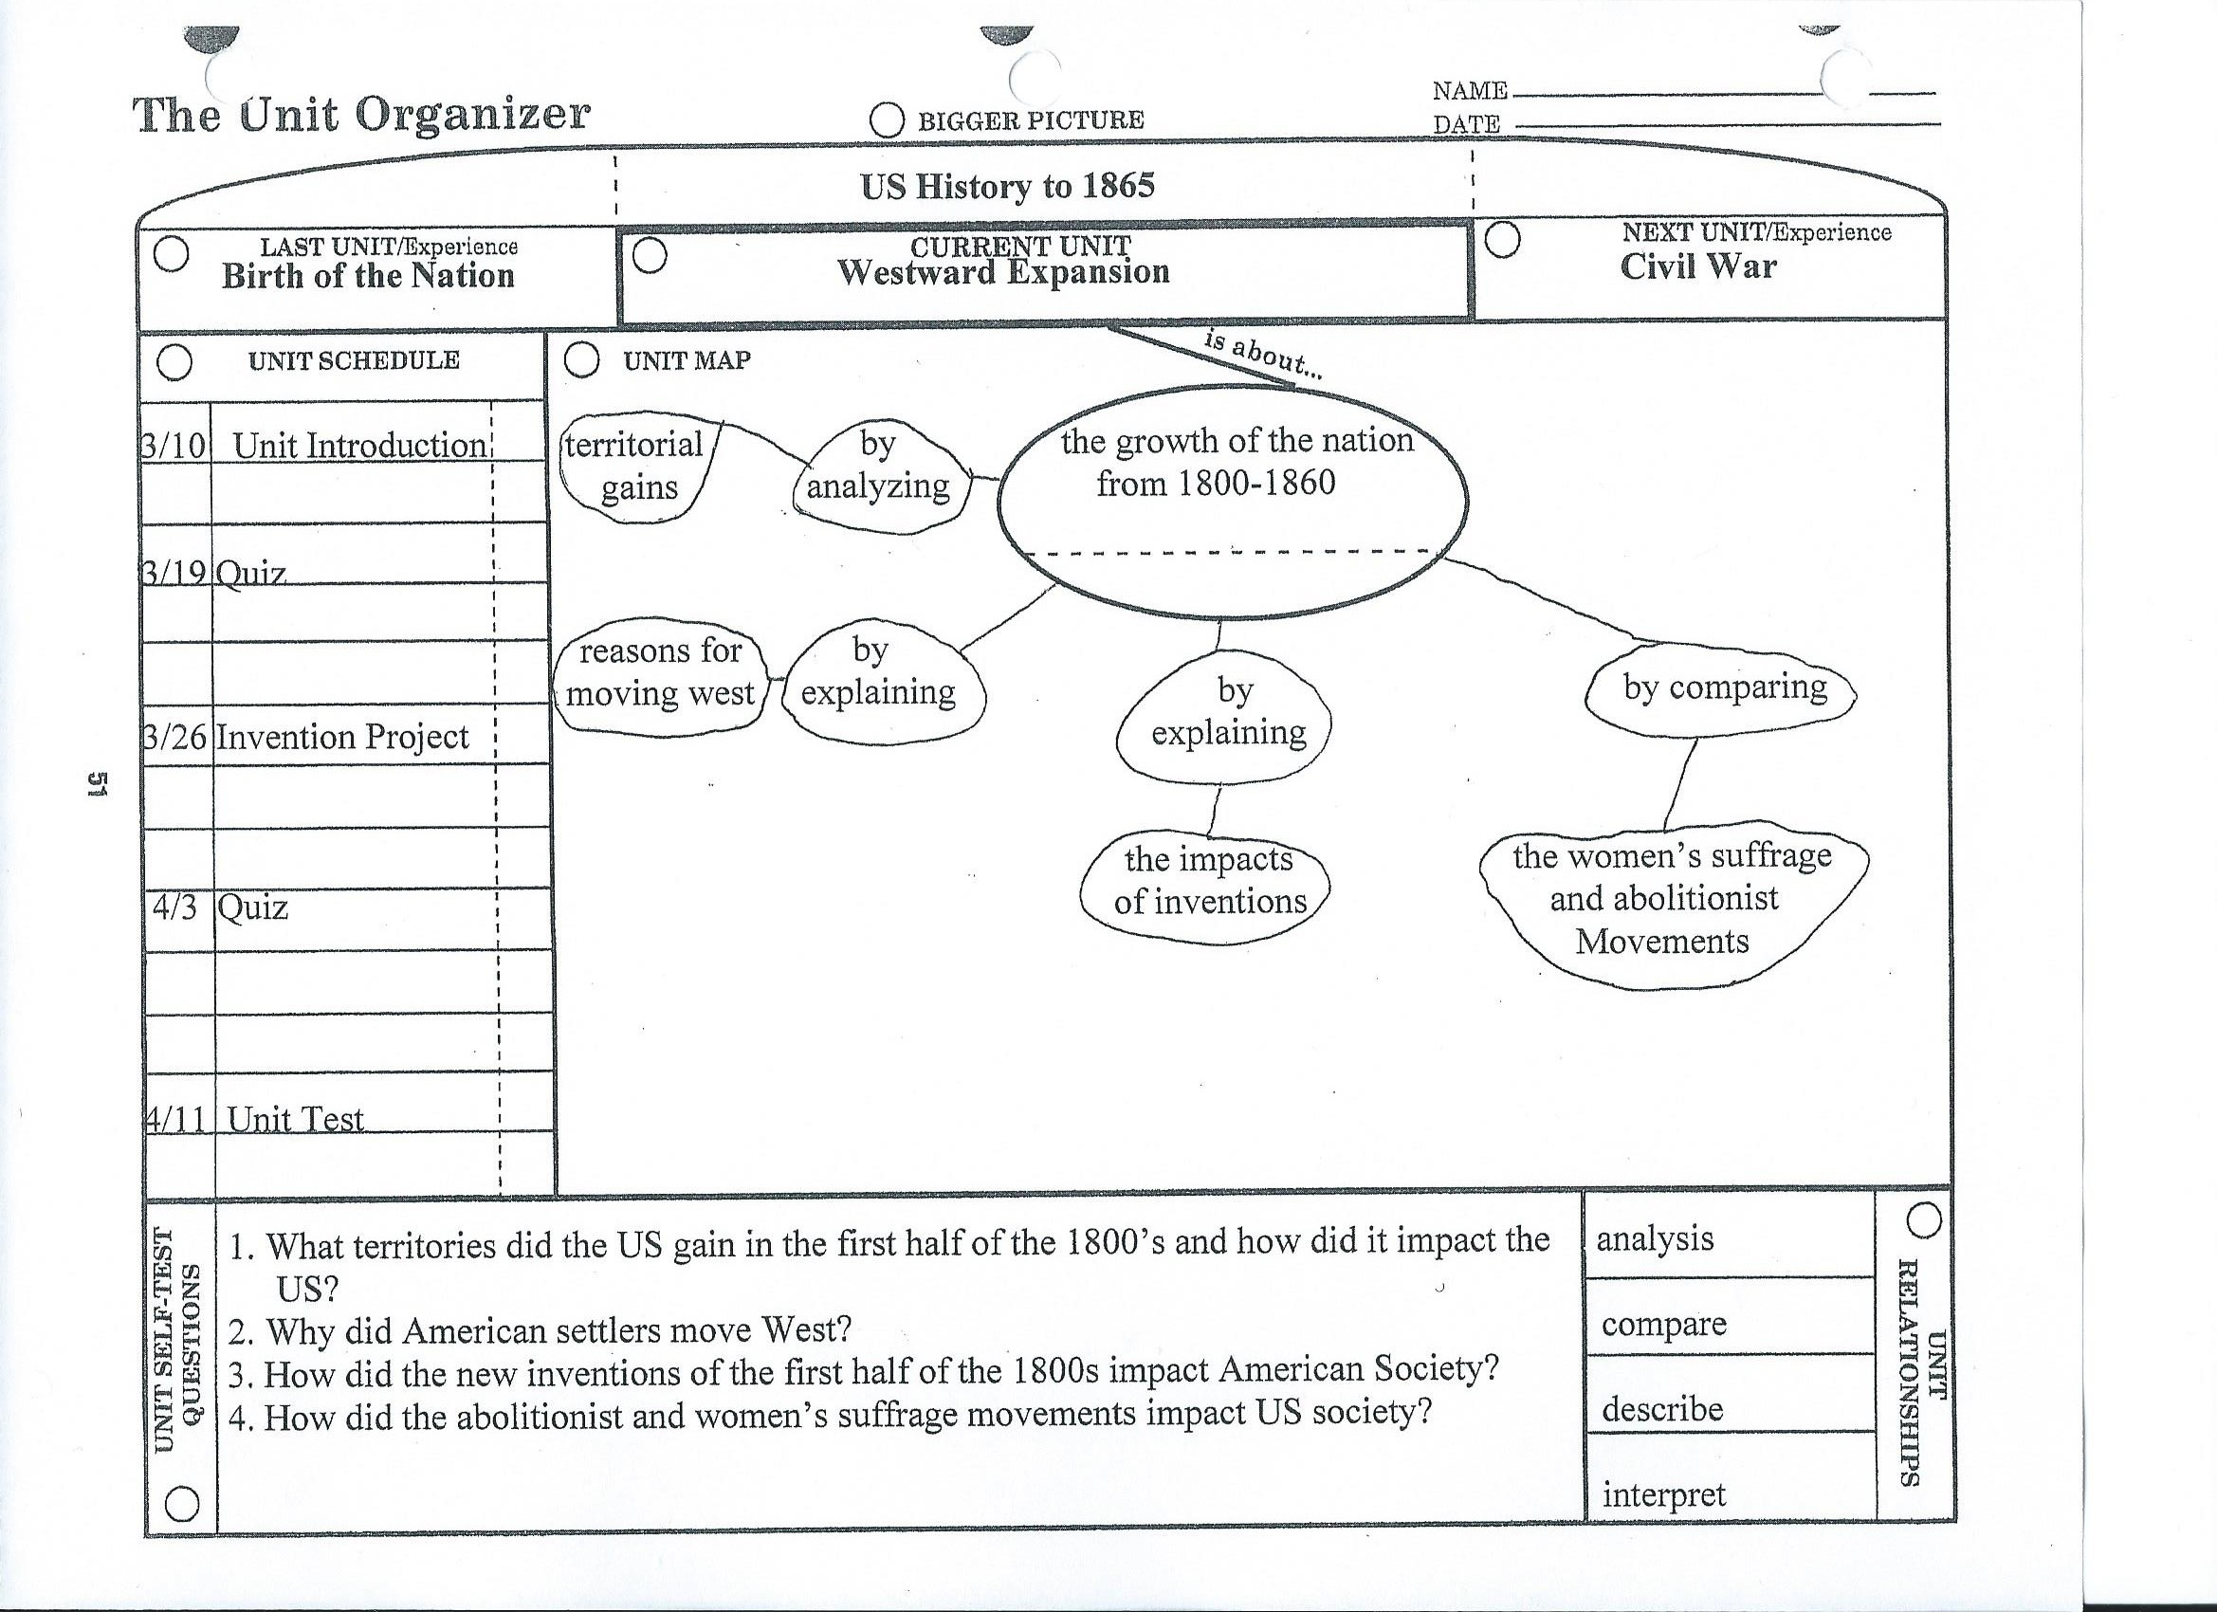

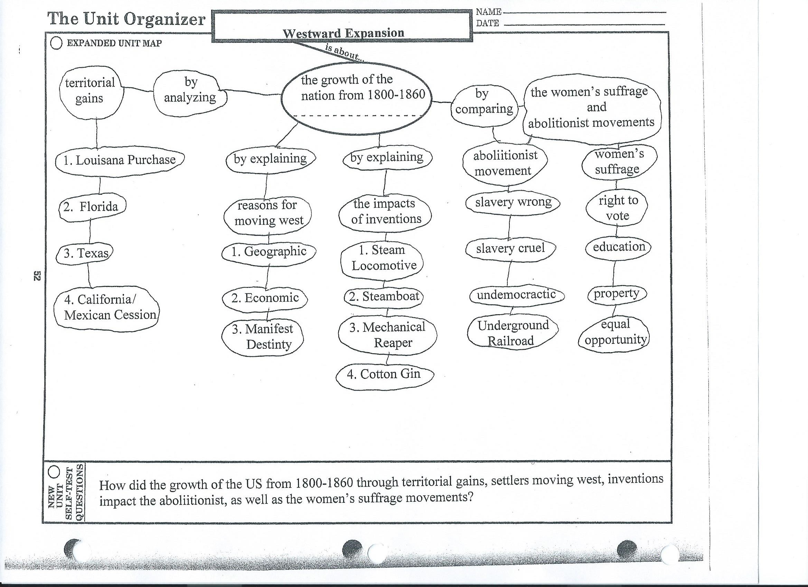

**Westward Expansion Unit Organizer:** I taught this unit organizer that I created for the Westward Expansion Unit on March 10th. This was the first of the SIM routines that I implemented in this class. This was the first time I ever I had ever implemented a unit organizer in a classroom. I gave most of my classes an unfilled unit organizer to copy the information down. With the exception of the concept mastery routine I did in latter in the unit, I handed out uncompleted frames for them to copy down. I did this because I thought handing out partially completed unit organizers and frames would cause confusion with what to write in the blanks. I thought doing it this way made it pretty straightforward for the students to understand. For one class I did hand out a completed unit organizer because many of the students in that class are slow notetakers and struggle with writing. With the exception of the concept mastery routine, I handed out completed unit organizers and frames for the other SIM routines to this one class as well. I did present this unit organizer on the first day of the Westward Expansion unit. I thought this unit organizer gave a good overview of the unit by breaking down the major topics we were going to cover during the unit including territorial gains, reasons for moving west, inventions, women’s suffrage movement, and the abolitionist movement. Then on the second page of the routine I went into a little more detail about the main topics related to the SOL. For example I listed the major inventions we were going to talk about during the unit. I was also able to give students a tentative schedule of when quizzes, the unit test, and other important events during the unit were going to take place. I think some of the students did not care for copying down the information; however, I think they understood from the unit organizer what was going to be covered this unit. I went over the unit organizer with students, asked them questions, and told them this could be a study resource for a quiz or test.

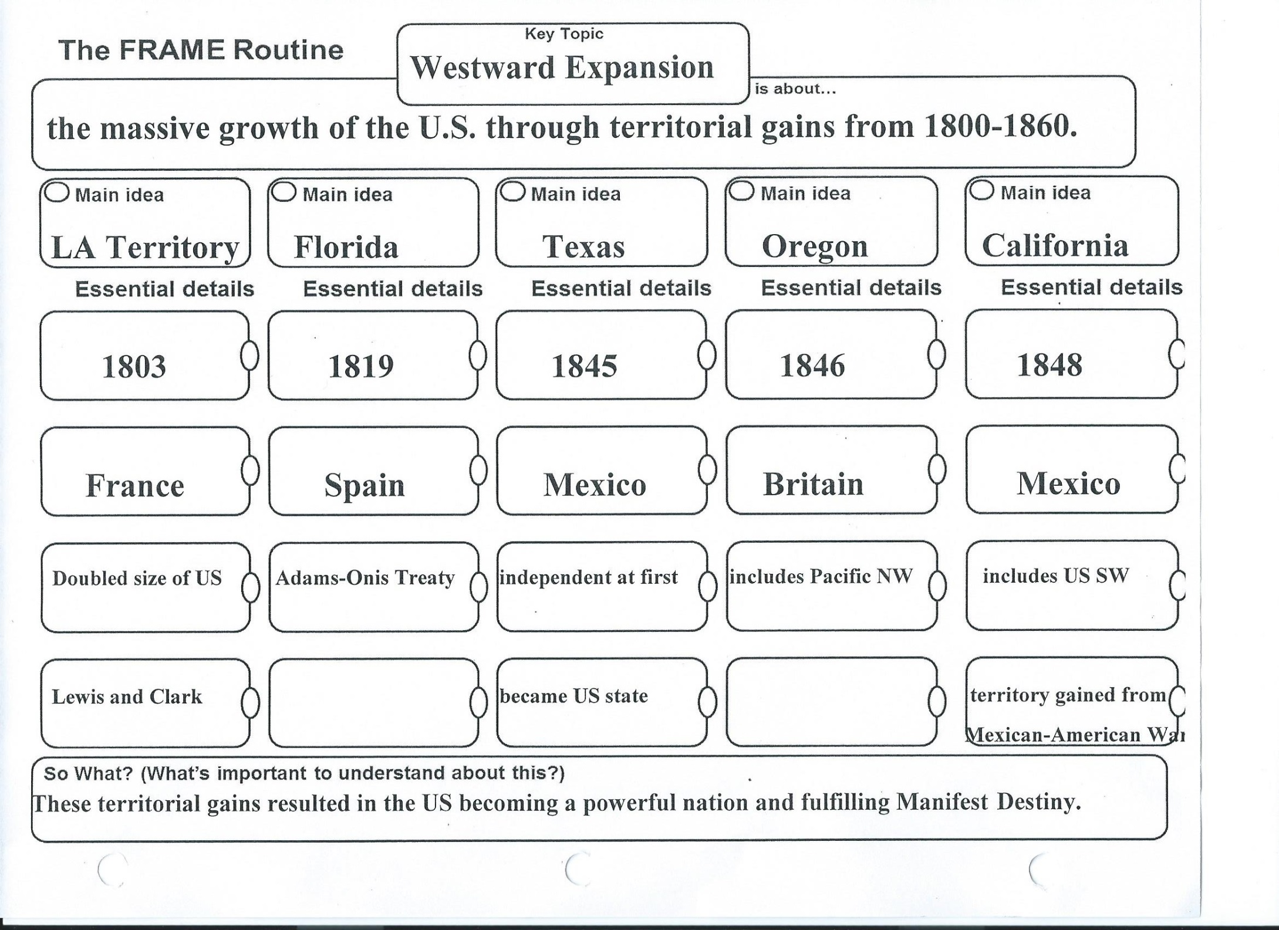

**Territorial Gains Frame:** I implemented this frame in my class the next day on March 11th. I had implemented this frame before during my micro teaching lesson in methods during February. This is the first time I implemented a frame in this class; however, I had implemented one last semester during my internship in high school. In this frame the five major territorial gains that were on SOL USI 8a were in the Main Idea box. Then I had information on each territory under the Essential details. I organized it by putting the year of acquisition by the US on the first box down, the country it was acquired from on the second box down, and other important information on that territory in the lower two boxes. I thought this frame help effectively break down the territories we gained and the important information about them. Like with later frames, I also asked the class questions throughout my explanation of this frame. I have good evidence that student learning took place during as a result of this frame activity because I told them to study this frame for their territorial gains quiz the next week, and most of the class ended up getting A’s or B’s on that quiz.

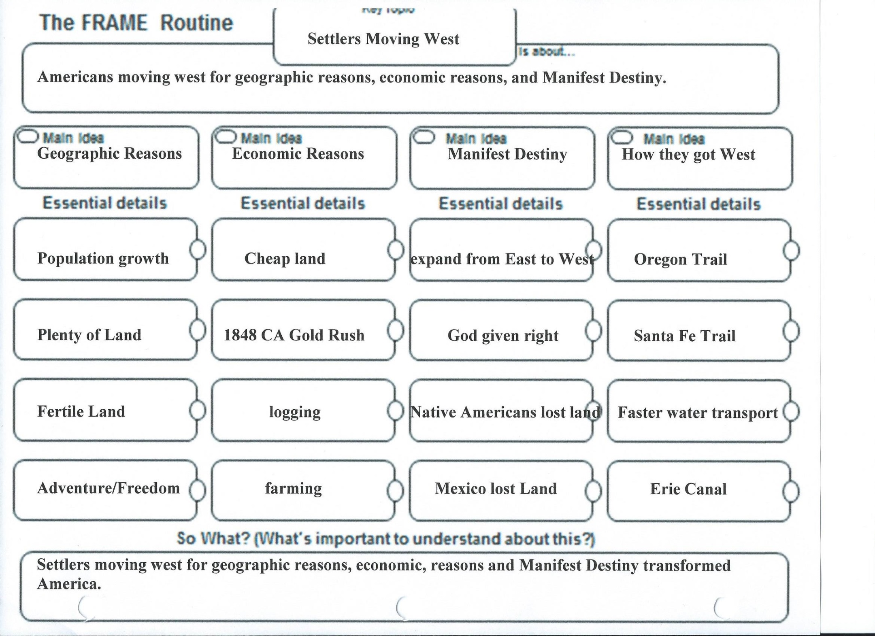

**Reasons for Moving West Frame:**  I implemented this frame in class on March 18th, and was the second frame I implemented during the unit. This frame focused on SOL USI 8b. This frame was implemented the day before students began working on Manifest Destiny Text Set that dealt with many of the SOLs that needed to be covered in the unit. I thought this frame helped provide good background knowledge for the text set, and students would be able to go more into depth about the reasons people moved west through the text set.

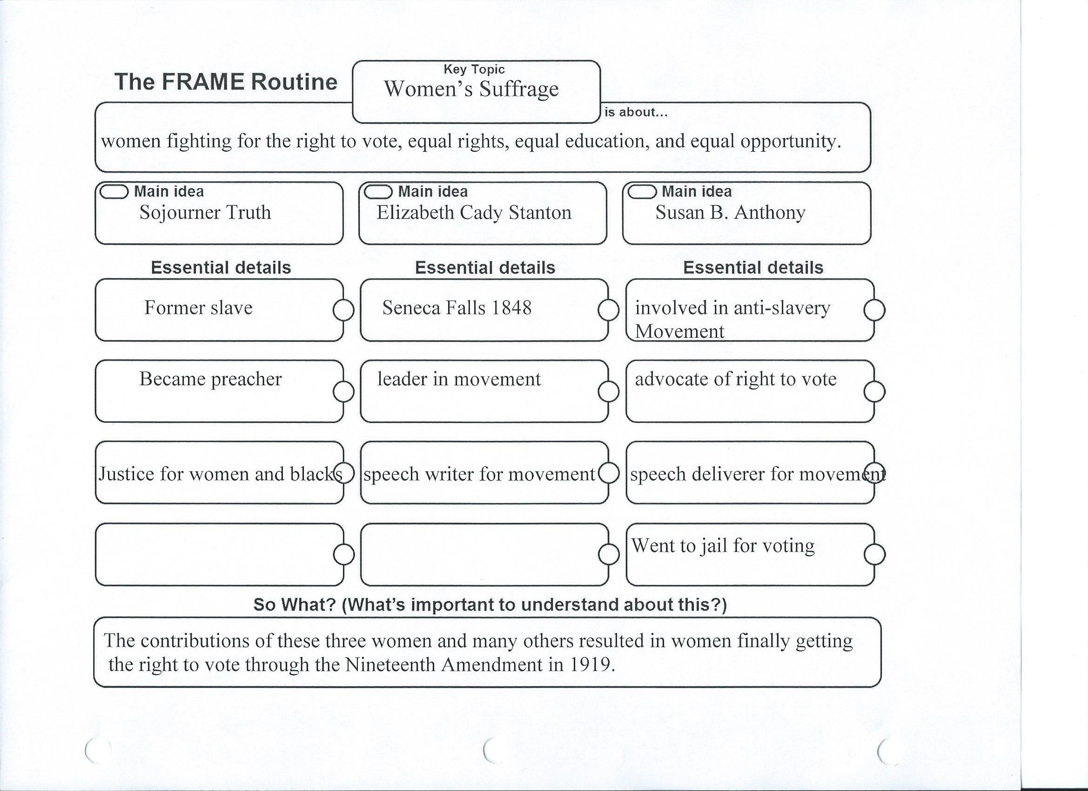

**Women’s Suffrage Frame:** I implemented this frame in class on March 27th, and it was the third frame I implemented during the unit. This frame focused on SOL USI 8d. Students had already learned some information about the women’s suffrage movement during the text set, so this was mainly a review for them. The three main women involved in the movement students needed to know were in the Main Idea box, while the important information about those women were in the Essential details box below.

**Women’s Suffrage Frame Video Clip:**  <https://www.youtube.com/watch?v=k-KqkjqF3Vg&feature=youtu.be>

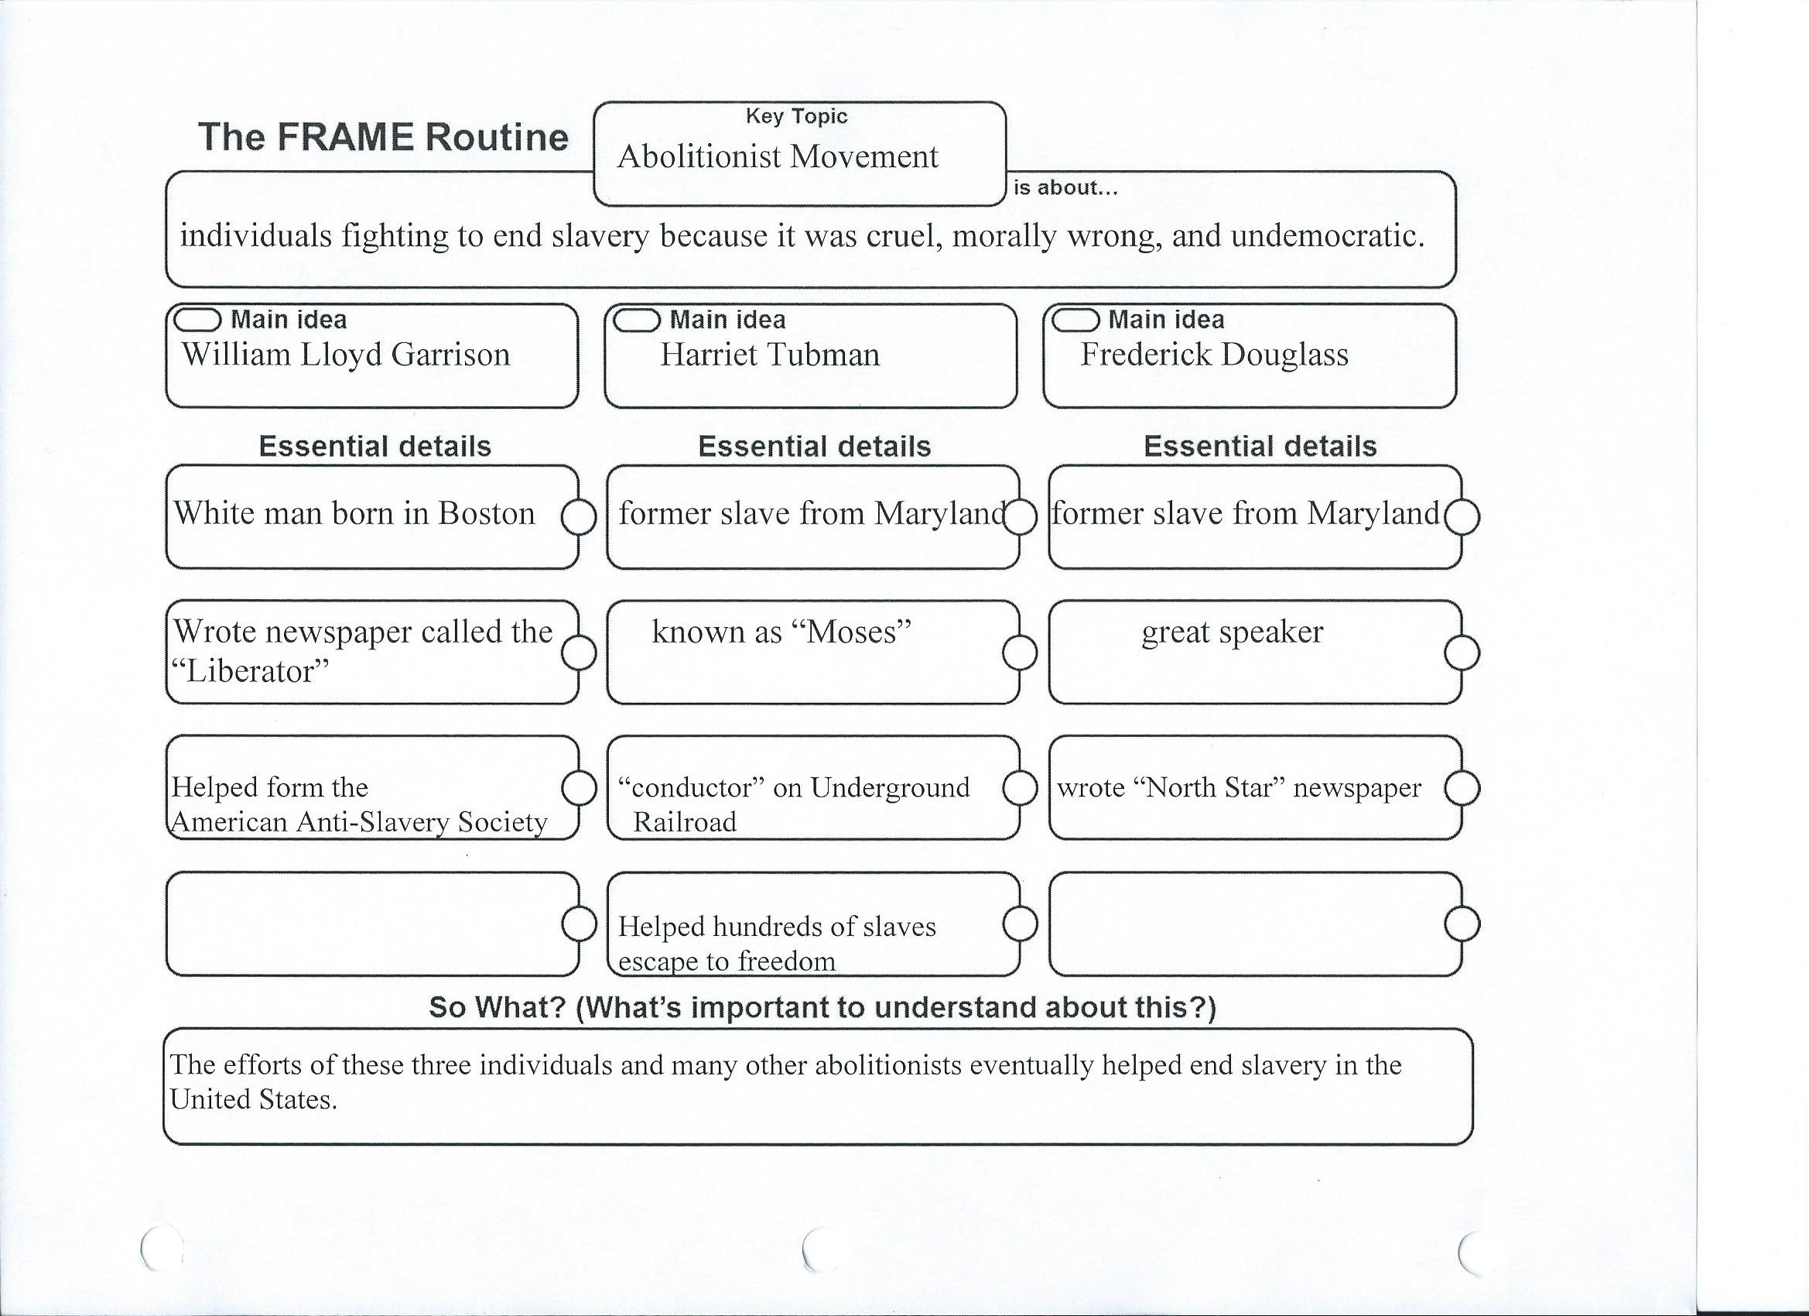

**Abolitionist Frame:** I implemented this frame in class on March 28th. It was the fourth and final frame I implemented during the unit. This frame focused on SOL USI 8d. Students had already learned some information about the abolitionist movement during the text set, so this was mainly a review for them. The three main individuals involved in the movement students needed to know were in the Main Idea box, while the important information about those individuals were in the Essential details box below. I had good evidence both the women’s suffrage and abolitionist frames were effective because most students got A’s or B’s on their quiz the following week.

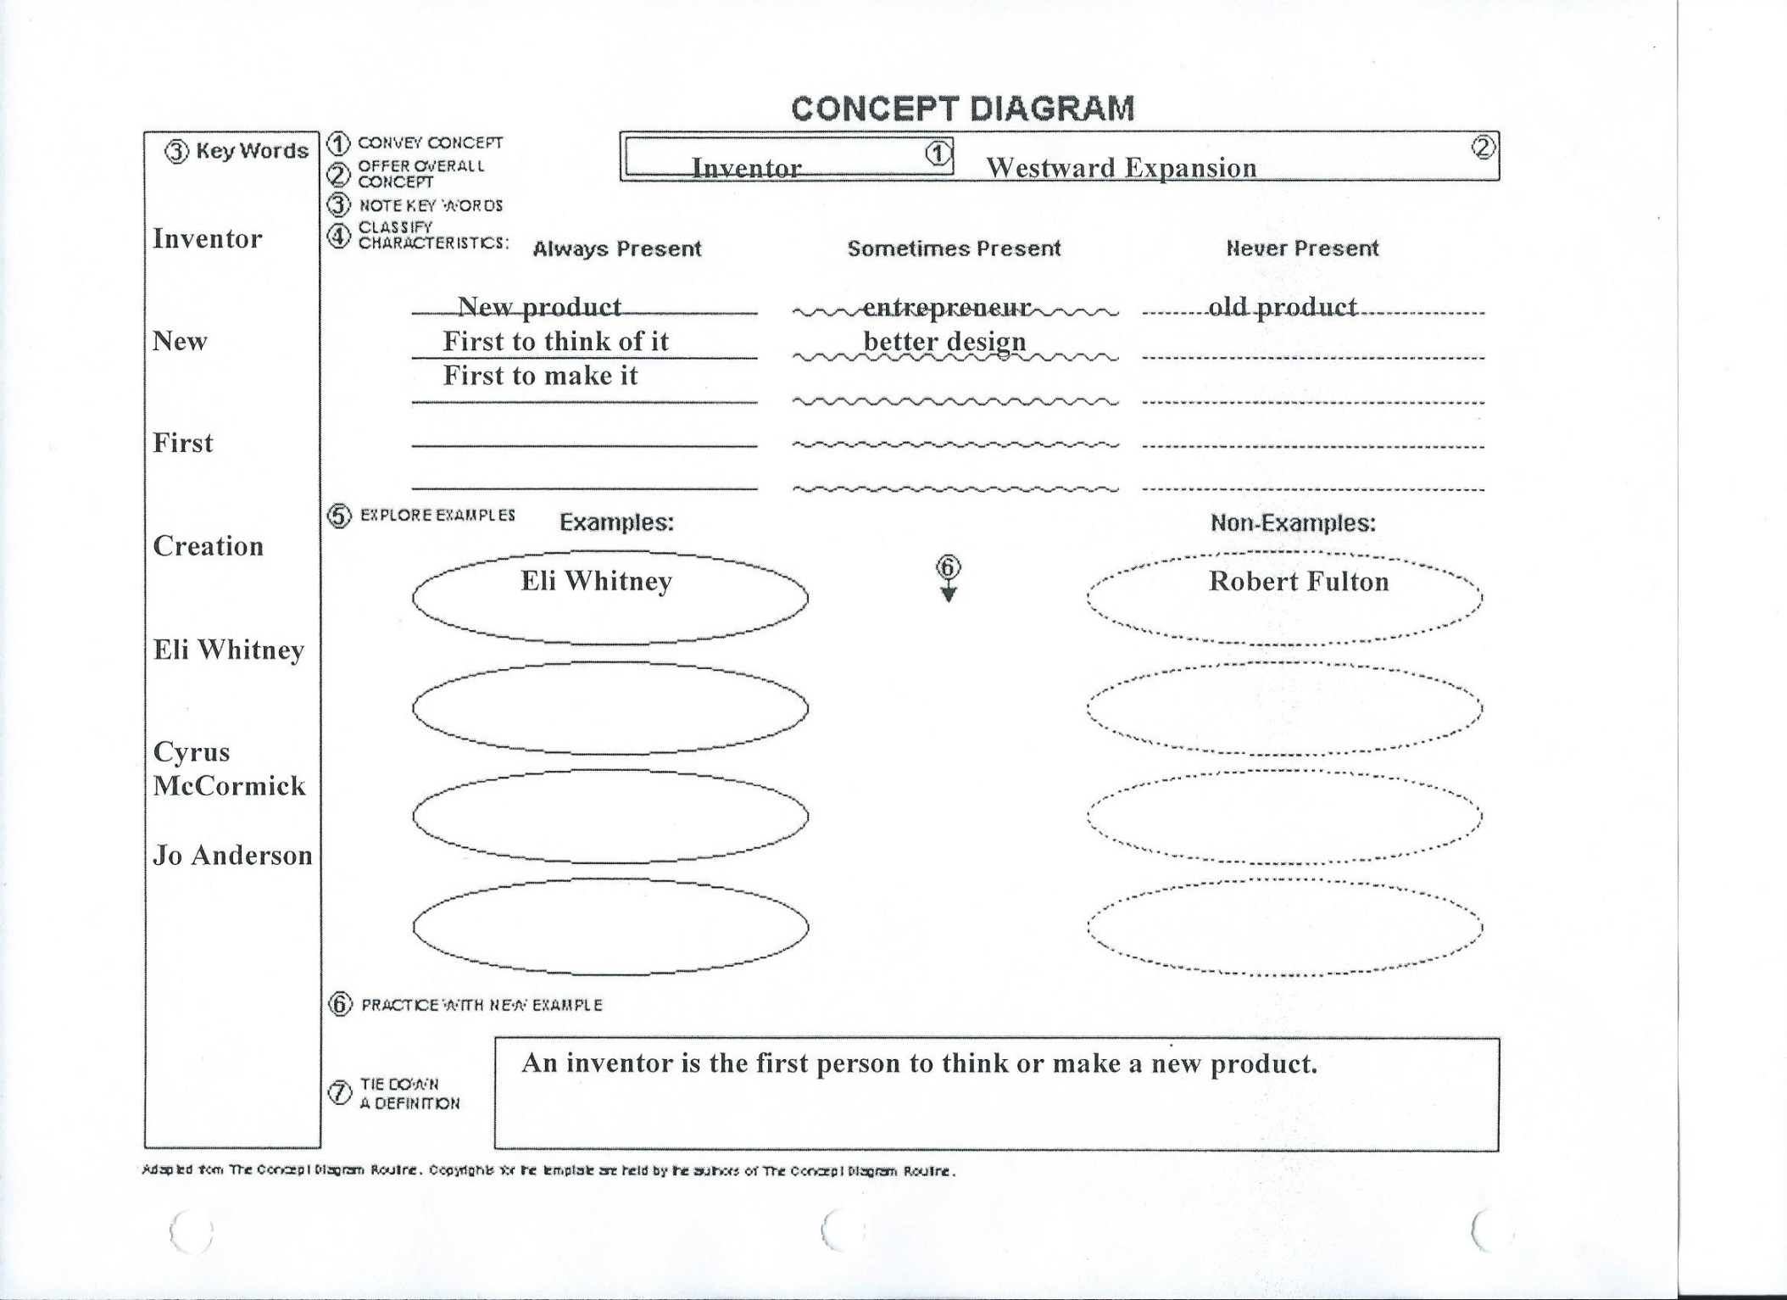

**Inventor Concept Mastery:** I implemented this concept mastery routine in class on April 1st. It was the only time I used the concept mastery routine during the entire unit. This routine focused on SOL USI 8c. All classes were given out partially completed concept mastery routines, like the one shown above. The objective of this concept mastery was for students to be able to differentiate between what is an inventor and an entrepreneur. Out of the SIM routines I did, this was the one that confused students the most. Some students were not sure what to write down and some students were confused by the Sometimes Present part up top. Some of the confusion is my fault because of my inexperience with implementing concept mastery. However, I also do believe that the concept mastery can leave some gray areas. I say this because some people would say something is Sometimes Present, while another person would say something is Never Present. There can also be gray areas on examples and non-examples, as a person might consider someone an inventor while another person would consider them an entrepreneur. Despite the confusion at times we did have some good class discussion during the routine. Some students were able to give good modern day examples (Bill Gates) and non-examples (Mark Cuban) of inventors.

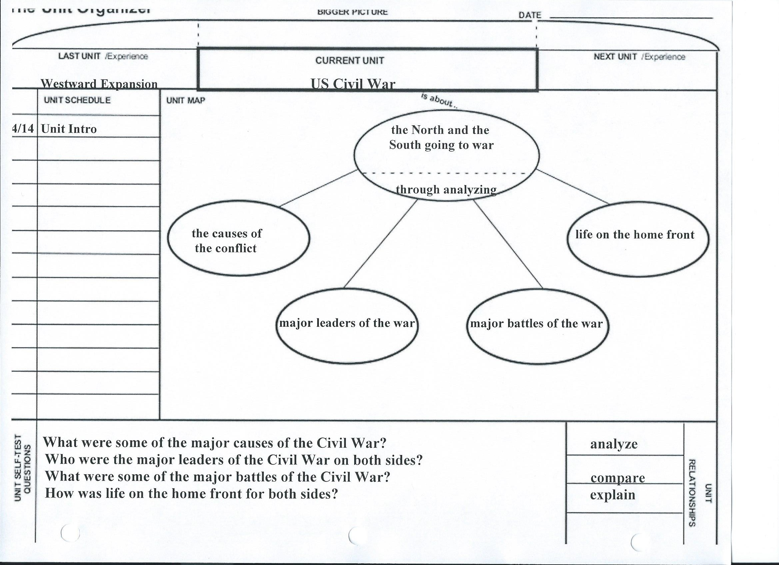

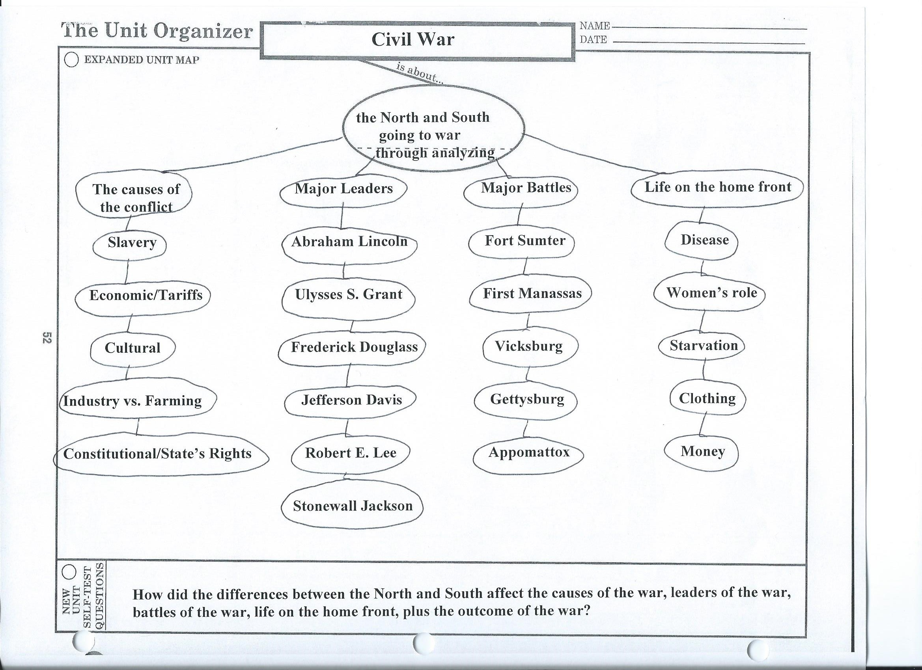

**Civil War Unit Organizer:** I implemented my second unit organizer during my student teaching on April 15th. This unit organizer was implemented on the second day of the unit because the class took a Civil War Pre-Test on this unit that they did not do for the Westward Expansion Unit. The implementation of this unit organizer was very similar in nature to the one done for Westward Expansion. I gave a brief overview of the unit and tried to hit on key points that are related to the SOL. For example while there were many battles in the Civil War, I listed the ones on the unit organizer that students will need to know for the SOL. I thought the implementation of this unit organizer went well, as we were able to have some good class discussions while I was explaining the information on the unit organizer.

**Concluding thoughts:** Overall, I thought the implementation of most of the SIM routines went well. Although some students did not like these routines or having to copy the information down, quiz and unit test scores indicate that students were learning as a result of these routines. I like the flexibility of the frames and unit organizers, and feel comfortable implementing both routines on a consistent basis in the future. I still think if the right situation came up, I could use concept mastery again in the future; however, it is something I am honestly less comfortable implementing right now in my teaching career. I think with time I will be able to implement concept mastery more effectively in future classes.

**Scoring Guide (my thoughts in bold)**

10 The assignment - completed templates, accompanying narrative, and 1 video clip of you using one of the routines- is distinguished in its focus on supporting student learning. The clarity and detail across the routines is excellent. The completed assignment consistently shows evidence that the intern has an excellent understanding of how to develop materials to support the teaching and learning of social studies using the Unit Organizing Routine, the Concept Mastery Routine and the Framing Routine.

**9 The assignment - completed templates, accompanying narrative, and 1 video clip of you using one of the routines- is proficient in its focus on supporting student learning.. The clarity and detail across the routines is good. The completed assignment shows evidence that the intern has a good understanding of how to develop materials to support the teaching and learning of social studies using the Unit Organizing Routine, the Concept Mastery Routine and the Framing Routine.**

8 The assignment -completed templates, accompanying narrative, and 1 video clip of you using one of the routines is basic. The clarity and detail across the routines is fair. The completed assignment shows evidence that the intern has a basic understanding of how to develop materials to support the teaching and learning of social studies using the Unit Organizing Routine, the Concept Mastery Routine and the Framing Routine.

6 The assignment is incomplete- clarity of work; effort and overall quality need work. There is little evidence of understanding and ability. Sigh…

0 Not done—or effort is minimal. Content is limited or unclear. Big sigh…