**Social Studies Interview Paper**

1. **Introduction**

I interviewed two students to see their level of prior knowledge about certain topics in social studies with a specific focus on topics in history and government. I showed the two students ten pictures of events in American history from the Civil War to the present and they had to arrange the pictures in chronological order, then answer a few questions about them. After that I asked them several questions about history, government, and major events in world history. Overall, I thought the two students gave very good answers and were very knowledgeable about social studies for their age. However, I did see over the course of the interview that both students did have some minor misunderstandings about historical topics and had less interest in government than history.

1. **Methodology**

The interview was divided into two main sections with the ten pictures and the question interview. I showed two pictures to begin with, then showed one picture at a time for the two students to put into chronological order. I told them to look carefully at the photos and focus on certain things, such as geographic clues. While they arranged the photos in chronological order they were correctly guessing what major events the pictures represented, but I did not tell if they were right. After they arranged the pictures I told them the correct order. They did a great job, as they had only one minor mix-up with the transcontinental railroad and civil war photo. Then I went over the pictures in detail and asked them their thoughts on the photo in terms of difficulty, as well as what they thought the photos were about. I asked the students what they thought life was back then for the people in the photos. I then moved on the question portion of the interview. I asked them general questions about history, government, and their prior knowledge about a few major events in history. Many of the questions were opinion questions and their thoughts on what they thought were major events in history, as well as their thoughts on citizen participation in government.

Overall, I thought I choose a good set of pictures for the two students to investigate. The pictures covered a wide range of American history from the Civil War to the present. I could have included photos from world history; however, I think that may have made it more challenging for the two students. I liked including the Civil War and Transcontinental Railroad photo; however, those may have been a little too close in time to each other. The photo from the Civil War was from 1864 at a Union Army Encampment and the Transcontinental Railroad photo did not have an exact date. The Transcontinental Railroad was not completed until 1869; however, construction on it began during the Civil War, so there is a possibility that photo was taken before Civil War photo. This is my fault as I should have found a railroad photo with an exact date or maybe found a Reconstruction photo. I liked the fact my photos including a diverse range of people including women, blacks, Chinese, and Japanese. The abortion protest photo also shows that some women are pro-life and the issue is still a very hotly debated topic in modern American society.

1. Participants

The two student participants in the interview are going under the pseudonyms of Bob and Tom. I have known both of these students for several years. Bob is currently a Senior in high school and plans on attending college after graduation. He does not plan on being a history or government major. Tom is currently a Junior in high school, and plans on majoring in Engineering after graduation. Both of them have some interest in social studies; however, they are not history buffs. Bob and Tom are both A-B students with pretty high levels of intelligence.

1. **Findings**

Over the course of the interview I was able to gather a couple of significant findings about both of the students. The first major finding I gathered was that both students enjoyed history, resulting in them being very knowledgeable about the subject. During the interview both students considered history at the high end of interest in school subjects (personal communication, November, 27, 2013; see pg. 8). The way the students were able to identity pictures and their answers to the interview questions also showed they were very knowledgeable in the subject matter. For example while arranging the pictures in chronological order they were able to immediately identify the Japanese Internment Camp, Great Depression breadline, World War I, Child Labor, and Civil War photos immediately without assistance. They did well on all the photos, but I thought they stood out on those five photos. Another example of their strength in history was their answers to the three most significant women in history question. I thought this may have been the most difficult history question; however, they gave great answers. I was real impressed with Bob coming up with Queen Elizabeth I and Margaret Thatcher as answers (personal communication, November, 27, 2013; see pg. 9). I was also impressed with Tom coming up with Joan of Arc as an answer (personal communication, November, 27, 2013; see pg. 9). Both students were also really knowledgeable in their answers on the Civil War, both World Wars, and the Great Depression.

The second major finding I gathered from the interview was that both students found Government to be less interesting, resulting in them not being quite as knowledgeable on it as history. They still knew a lot of information about government; however, it was not as much as history. During the interview both students considered government at the middle end of interest in terms of school subjects (personal communication, November, 27, 2013; see pg. 10). Tom did not find the subject to be that interesting, while Bob had only taken one class on government up to this point and he is a senior in high school (personal communication, November, 27, 2013; see pg. 10). Despite this both students did a good job on the government questions. Bob gave a really good answer to the question about the role in government in your life, as he realized he is currently paying sales taxes (personal communication, November, 27, 2013; see pg. 11). Bob gave good responses to all of the government questions; however, his answers showed that he had more content knowledge in history, which would make sense if he had only had one government class up to this point in his education career. Tom gave some good answers as well, as in question three he named most of the types of governments around the world (personal communication, November, 27, 2013; see pg. 11). Tom was weaker in his answer to the main features of the American political system, as he forgot the Executive was one of the three branches of government (personal communication, November, 27, 2013; see pg. 11).

The final major findings I noticed as a result of the interview were that both students had some misunderstandings or misconceptions about certain details in history. I would say most of these misunderstandings and misconceptions are minor. One example was when Tom on question three considered the medieval period to be his favorite period in history because “…it was the development of Europe and modern society.” (personal communication, November, 27, 2013; see pg. 8). I think which Bob noted as well, he may have been getting the medieval period confused with the Renaissance in terms of the development of Europe and modern society. On question seven when Bob considered Julius Caesar which I thought was a good choice. However, I thought there was a flaw to his reasoning of that choice. He said Caesar, “…was head of one of the advanced forms of government that spread over all of known world.” (personal communication, November, 27, 2013; see pg. 9) Caesar was one of the main reasons the Roman Republic failed, as Caesar became a dictator before he was assassinated. Tom’s answer to the causes of the Great Depression on question four, showed he may be a little confused. Some of his causes included “…keeping workers in the lower class, low wages, no worker rights…” (personal communication, November, 27, 2013; see pg. 13). I do not necessarily consider these major causes of the Great Depression, as those reasons were more serious issues earlier in the 20th century and the latter half of the 19th century.

1. **Instructional Implications**

Since both students did a great job in the history portion of the interview, teachers must be doing something right. If it is working there is no need to change what they are doing, unless other students are struggling. I think both World and American history should continue to be emphasized in school. One strategy I found effective during my observation this fall was to show a lot of historical videos with a purpose to students. The videos usually had worksheets and kept the students interested in the subject matter. I think another strategy that helps keep history interesting to students is to have general classroom discussion and debate on certain historical topics. The structured academic controversy and issues/values continuum are two debate strategies that can be used. I will go into more detail on those strategies in the next section on government.

I think there are several recommendations and strategies that can be used to help improve student interest in government. I assume there are several more students out there that are not interested in government either, which is a serious problem if they want to be productive members of American society. One, there needs to be a bigger emphasis on government in schools. Students should have more than one class on government before their senior year in high school. I think one strategy teachers can use to help students become more interested in government is to integrate it more into history classes, as many times those subjects overlap. Examples include the Declaration of Independence, the Constitution, and the Three Branches of Government. It is also vitally important for teachers to start off a government class with an introductory activity that makes students look forward to the rest of the class. Strategies that could be used include showing a film clip related to government or start off class reading then discussing a court case (Knight, 2013, p. 136-137).

Another strategy that can be used is the structured academic controversy, in which students work together to research, discuss, debate, and take a position on a controversial issue (Larson & Keiper, 2011, pg. 219-220). I personally think the structured academic controversy can be used to discuss controversial issues in government, resulting in students becoming more interested in government. A third strategy that can be used is the Issues/Values continuum, in which students have to decide the morality of a decision on a chart ranging from strongly agreeing to strongly disagreeing with a statement (Larson & Keiper, 2011, pg. 214-215). This could be used to discuss the morality of a government decision, policy, or action. A final strategy that can be used is for teachers to bring in a current event related to government to discuss at the beginning of class. This can be a good way to get students more interested in government.

I think there are a couple of strategies in particular that can be used to help clear up minor misunderstandings or misconceptions about social studies. Two strategies that can be used to help are the frame routine and the concept mastery routine. In a frame routine a key topic is further broken down into what the topic is about, then it is further broken down into main ideas that have essential details with it, and then at the bottom of the frame is a summary of the importance of the main topic (Ellis, 1998, p.6-7). The Great Depression is a good example of a topic that be used in a frame to help clear up Tom’s misconceptions on the causes of the Great Depression. Causes could be a main idea and the causes are described in the essential details section of the frame. In the concept mastery routine a concept is broken down through a concept diagram in which the key characteristics, examples, non-examples, and definition of the concept are discussed (Bulgren, Schumaker, & Deshler, 1993, p.6-7). The concept mastery routine could be used to discuss types of government like a dictatorship, and an example of a dictatorship would be Julius Caesar which would help clear up Bob’s misconception about Caesar.

1. **Conclusion**

Overall, I was really pleased with how the interview went. Both students had a lot of prior knowledge about American history, world history, and a decent amount of prior knowledge about government. They did really well with the pictures and they both understand chronology well. Both students had a few misunderstandings or misconceptions about certain events in social studies; however, I think that is an easily correctable problem. I am more concerned with the fact that there does not seem to be as big as an emphasis on government as it should be in schools. It is important in the future to have more government course offerings in schools, integrate government more into history classes, and implement interesting strategies in order for students to become productive members of American society in the future.

**Appendix**

1. **Photograph responses**
2. Did you think this was easy or hard to do? What things made it easy or hard?

Bob (Pseudonym): Easy

Tom (Pseudonym): Easy

1. Which pictures do you think are the most interesting? Why?

Bob: All the war ones including the Japanese Internment Camp.

Tom: Same answer.

1. Based off of the World War I picture, how do you think your life would have been different if you had been alive at this time?

Bob: We would have been fighting in the war.

Tom: I would have not gone to high school.

1. Time Period for picture? Why? What do you know about this time period? What was life like for period back then? (Bob and Tom answered together)
2. Civil War Picture: 1860’s, harsh, provided for yourself, slavery
3. Transcontinental Railroad Picture: 1860’s, rough life for Chinese laborers, building railroads part of time period
4. Child Labor Picture: early 1900’s, little Federal regulation on child labor, rough life for kids, kids had to get a job to pay for family, no education
5. World War I Picture: 1917-1918 because America joined the war in 1917, bloody war, deadliest war up to that point, first global war on that scale
6. Great Depression Picture: 1930’s, crowded cities, bread lines, Neal Deal, Dust Bowl, life was tough, no money, lived day to day
7. Japanese Internment Camp Picture: 1940’s, people were afraid of Japanese threat, life was rough at internment camp
8. Civil Rights Picture: 1950’s, boycotts, racial tension, bus burnt, not accidental
9. Vietnam War Protest Picture: Vietnam, late 1960’s-early 1970’s, anti-war, anti-draft, didn’t understand point of war, free spirits, did as they wanted, hippies
10. Desert Storm Picture: Gulf War, early 1990’s, Hussein invaded Kuwait, different environment, less deaths than previous wars, more technology, open terrain
11. Abortion Protest Picture: mid 2000’s-present day, big point of contention between political parties, comfortable, have time to protest
12. How the students did arranging the pictures in chronological order.

Bob and Tom: All right except mixed up Transcontinental Railroad picture with Civil War photo. Do not have exact date on railroad photo, slight possibility it was from Civil War. Did great job. Knew it was railroad out west.

1. **Interview**
2. **History**
3. Among school subjects, where would you rank history in terms of your interest over the years (top, middle, bottom)? Why?

Bob: Top, it is easier and more interested than other subjects. Good memory.

Tom: Same response except for good memory.

1. What is history?

Bob: Important events that have affected the way your life is today.

Tom: The study of things that have already happened.

1. Why do we study history? What is your favorite historical topic/period? Why?

Bob: To learn from mistakes from the past. Ancient civilizations because it is interesting to see how people became as advanced as they are.

Tom: To learn from past mistakes. Medieval period because it was the development of Europe and modern society.

1. What do historians do?

Bob: Explain why people did what they did.

Tom: Decode the past.

1. What is a primary source? A secondary source?

Bob: Official document or letter. Internet source is secondary.

Tom: Someone that saw the event and wrote it down or told someone. Someone taking they heard from the first person and telling other people.

1. What do you think are the three most historically significant events in history? Why?

Bob: Expansion of Romans because it spread an advance culture throughout Europe. The Renaissance because it was huge explosion of culture and had not happened in the world before on a large scale. The British colonization of others countries because it set up the American Revolution and other world events like Gandhi.

Tom: Macedonian spreading Greco-Roman culture because this culture was spread. European expansion into Americas because it gave a new life and new world. The World Wars because it killed a lot of people.

1. Who are the three most historically significant people in history? Why?

Bob: Julius Caesar because he was head of one of the advanced forms of government that spread over all of known world. Queen Elizabeth I because she completed the transition from the Catholic Church to Protestant and established Britain as world power. JFK because he initiated fight against Communism, one of most important events in 20th century.

Tom: Biblical Paul, spread to Roman Empire, established Christianity as large faith. Muhammad because he created another faith, Islam. Bill Gates because he created some of first modern computers.

1. Who are the three most historically significant women in history? Why?

Bob: Queen Elizabeth I because established Britain as world power. Susan B. Anthony, because she set the standard for how women should be treated, and reason why women have as many rights as they do today. Margaret Thatcher because she improve relations between the IRA and British government.

Tom: Joan of Arc, united France to defeat English. Rosa Parks because she stood up for African American rights on the bus. Hillary Clinton because 1st female in our lifetime to run for President in our lifetime.

1. What are the three most historically significant documents in history? Why?

Bob: Bible because it created one of most popular religions in world and set standards for societal laws. Magna Carta because it ended pure monarchy of England and set up government for more people. Declaration of Independence it was the beginning of the creation of the world’s biggest superpower and first large scale rebellion against Britain.

Tom: Hammurabi Code because first set of written laws. Bible because it started a large faith. Articles of Confederation because it shows not what to do.

1. Imagine that you could meet and talk with someone from the past. Who would it be? What questions would you ask them? Why? How could you find out the answers to your questions even if the person has passed on?

Bob: James Madison because we was really influential in creating the Constitution. Personal diaries and notebooks, reading the Constitution since he was so influential in it.

Tom: Adolf Hitler to find out why he did the things he did. Personal memoirs and books.

1. Have you ever seen a film or TV show, outside of school, on a historical topic? If so what was it? Did you wonder if it was historically accurate? Did you do anything to check on its accuracy?

Bob: Saving Private Ryan, I knew it wasn’t a true story. Movie may have been based off a family in which all the brothers except one died in the war. No.

Tom: 300. I did wonder and found out it was not historically accurate through History class, looking it up, and documentaries.

1. Do you ever discuss things that happened before 1975 with your friends? If so, what topics?

Bob: Yes, what would have happened if Hitler had not invaded the Soviet Union. What it was like to be a hippie and anti-war protests.

Tom: Yes, the size of naval cannons, Civil War what would happen if somebody else won. If Hitler had won England.

1. **Government**
2. Among your school subjects, where would you rank government & civics in terms of your interest over the years (top, middle, bottom)? Why?

Bob: Middle because only had one class on it so far. Will take Government next semester.

Tom: Middle because it is important and good knowledge to know. Not that interesting.

1. Why do we study government and civics?

Bob: Have an understanding of what is going on in government and not be ignorant and let astray.

Tom: So people can knowledge of how government works and not be ignorant about voting.

1. What is democracy? What other types of government are there?

Bob: Government where people get to choose what their government does. Socialism, Communism, Monarchies, Dictatorship.

Tom: Democracy is the people choose who represent them in government. Communism, Socialism, Oligarchy, Aristocracy, Monarchy.

1. What are the main features of the American political system?

Bob: Judicial, Executive, Legislative, Check and Balances, Separation of Powers (more knowledgeable on this question)

Tom: Senators, Judicial- decide if laws have been broken, Legislative-create laws

1. What are the rights and responsibilities of citizens in our country?

Bob: Understand and obey the laws government makes. Vote, serve in military if called, and be productive member of society.

Tom: To know laws, obey them, be educated on who in the government currently, and vote to let Senators know what you want.

1. What role does the government play in your everyday life?

Bob: If I buy something sales tax. Going to school and driver’s license.

Tom: Taxes, the kind of food we receive at school. Government frustration we receive on the news.

1. **Content Questions**
2. When did the American Civil War take place? Who was involved? What were the causes? Why is this event significant? What were the effects of the war?

Bob: 1860-1865, Union vs. Confederates, industrial north vs. agricultural South, slavery North government trying to control south, unified America, ended an important economic aspect of America in slavery, caused Jim Crow Laws

Tom: 1860’s, Confederates and Union, ways of life, slavery, who would govern, because it was America’s first Civil War, ended slavery, began to unify America

1. When did World War I take place? What were the causes? Who was involved in this war? What were the names of the opposing sides? Where was this war fought? When did the U.S. become involved? Why? What were some of the effects of the War?

Bob: 1914-1918, assassination of Franz Ferdinand and France/Germany fighting over Rhineland as well as other territory on their border, France, Germany, Russia, Ottoman Empire, Austria, America, Italy, Great Britain, didn’t know names of opposing sides, Europe, 1917-1918 because Germany started sinking American, Zimmerman telegram Germany sent to Mexico, devastated male populations in Europe, eliminated generation of males, France retained Rhineland, established America as world power and created League of Nations, it destroyed Germany’s economy with Treaty of Versailles which led to rise of Hitler and World War II

Tom: mid 1910’s-latter 1910’s, Ottomans and Hungarians having political problems with each other, Franz Ferdinand, land, France, Germany, Austria, Hungary, Ottomans, America, Russia, Canada, Allies and Central Powers, Europe and Middle Asia, 1917 and U-boat attacks on American shipping, gave into cry for American help from other Allied powers, one of biggest armed conflicts, a lot of people died, whole generation, gave birth to Adolf Hitler, Lieutenant during war, gave rise to world powers and League of Nations, introduced new type of warfare at end with aircraft and tanks, destroyed Germany’s navy

1. When did World War II take place? What were the causes? Who was involved in this war? What were the names of the opposing sides? Where was this war fought? When did the U.S become involved? Why? What were some of the effects of the War?

Bob: 1939-1945, Germany wanted to create a powerful economy/country after World War I, American embargo on Japan, invasion of Poland, invasion of Soviet Union, America, Britain, Soviet Union, some French resistance, Germany, Italy, Japan, Axis and Allies, Europe, Italy, Japan, South Pacific, Pearl Harbor, 1941 Germans were attacking American shipping, Pearl Harbor, it ended Great Depression, created one of most prosperous times in America, first war we rebuilt countries that were destroyed which led to strength of Japanese and German economies, established two rival superpowers for most of the rest of the 20th century Soviet Union vs U.S., divided Europe from communist rule to democratic rule, initiated Iron Curtain

Tom: 1939-1945, Germany followed Nazi Party and wanted land/revenge, Hitler wanted unified Europe under his command and Japan wanted control of Pacific, America, Britain, Italy, Germany, Japan, France, Russia, Canada, Allies and Axis, Europe, North Africa, and Pacific Islands, Japan, Oceania, 1941 attacks on American shipping, attack at Pearl Harbor, and England needed help, population diminished, generations of people lost, establishing world powers, destruction of Germany’s economy and military, split into East and West Germany, millions of Jews and others being exterminated, started atomic age and new weapons

1. When was the Great Depression? What were the causes? How did the Great Depression impact the lives of people? Whom did the Great Depression affect? Where did the Great Depression occur? How long did the Great Depression last? In what ways did people and the government try to overcome the problems of the Depression?

Bob: 1930’s, borrowing money to spend on stock market and losing that money, it made living conditions rough, people lost all the money they had, didn’t have enough money to buy necessities like sugar, work shortage due to loss of jobs, Dust Bowl cause tenant farmers to move, stock investors, tenant fares, business owners, everybody accept extremely wealthy people, affected whole world, lasted into beginning of World War II, people did what they could to bargain and save money, people relocated to find jobs, FDR made New Deal which created many different government programs, had camps out West similar to book “Grapes of Wrath”, people out west shunned people that moved out West

Tom: 1929-beginning of World War II, stock market crash, industry tycoons holding massive amounts of money and keeping workers in the lower class, low wages, no worker rights, live day by day, necessities came first and were slim, provided for yourself not others, people were forced to move in hope of better opportunities, everybody, people in the U.S and affected other governments due to trade, the United States, mainly in cities, lasted until beginning of World War II, New Deal and other government programs to boost economy in order to give people hope

**Interview Pictures** (pictures shown to students in larger size and without picture info)

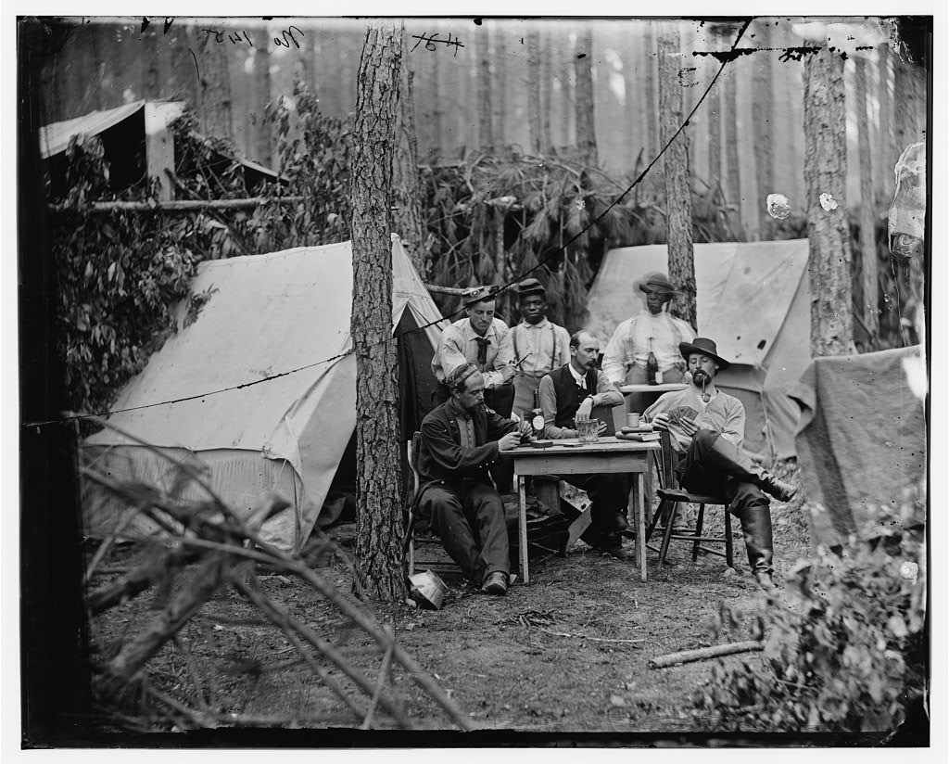

1. Union soldiers play cards at encampment near Petersburg, VA during Civil War in 1864. Picture accessed from: <http://www.learnnc.org/lp/media/uploads/2009/07/playingcards.jpg>

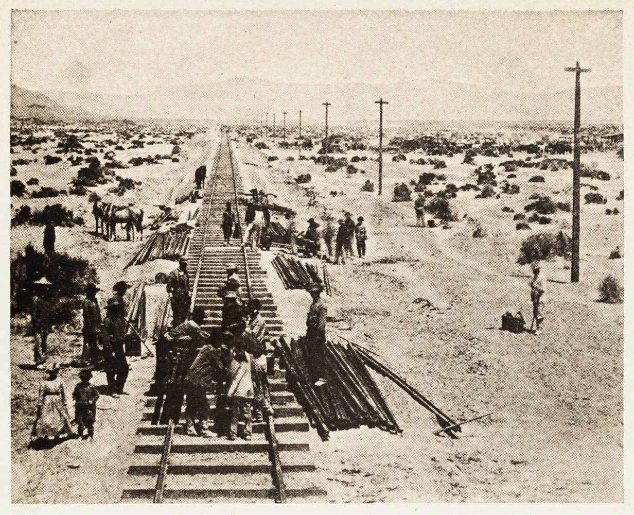

1. Picture of Chinese Central Pacific Construction crews building the Transcontinental Railroad. Picture accessed from: <http://railroad.lindahall.org/essays/cultural-impacts.html>

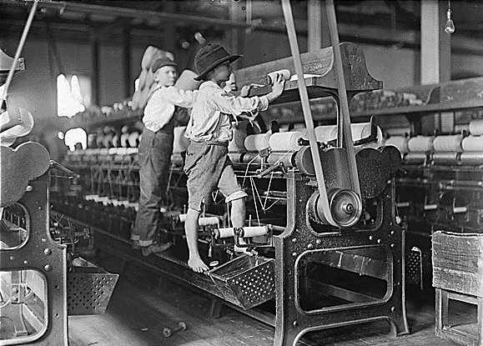

1. Picture of child laborers at a mill in Georgia sometime between 1908 and 1912. Picture accessed from: <http://geosci.uchicago.edu/~moyer/GEOS24705/Images/ChildrenSpinning.jpg>

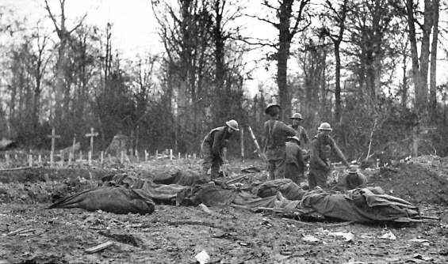

1. Americans burying their brothers in 1918 in France. Picture accessed from: <http://www.english.illinois.edu/maps/ww1/photoessay.htm>

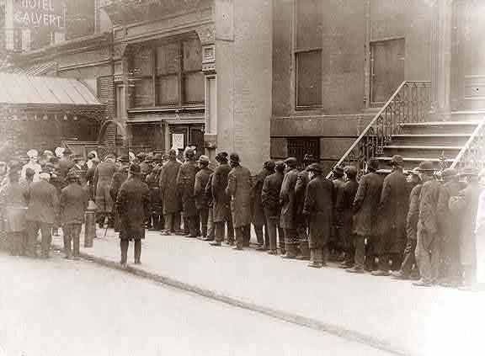

1. Picture of breadline in New York City during Great Depression. Picture accessed from: <http://blsciblogs.baruch.cuny.edu/his1005spring2011/tag/the-great-depression/>

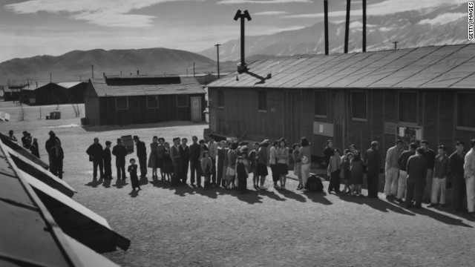

1. Picture of Manzanar Japanese Internment Camp in California in 1943. Picture accessed from: <http://www.cnn.com/2012/06/06/us/california-japanese-internment/>

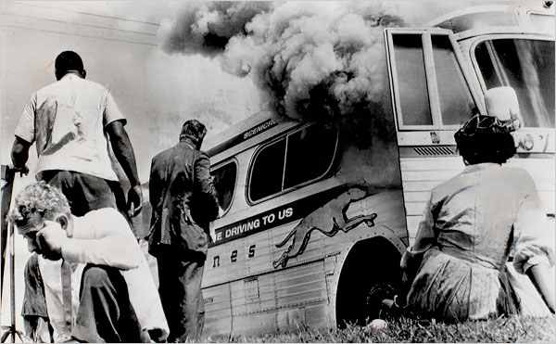

1. Picture of Freedom Riders charter bus firebombed in 1961 in Alabama. Picture accessed from: <http://www.nytimes.com/slideshow/2008/06/20/us/20080620CIVIL_index.html?_r=0>

[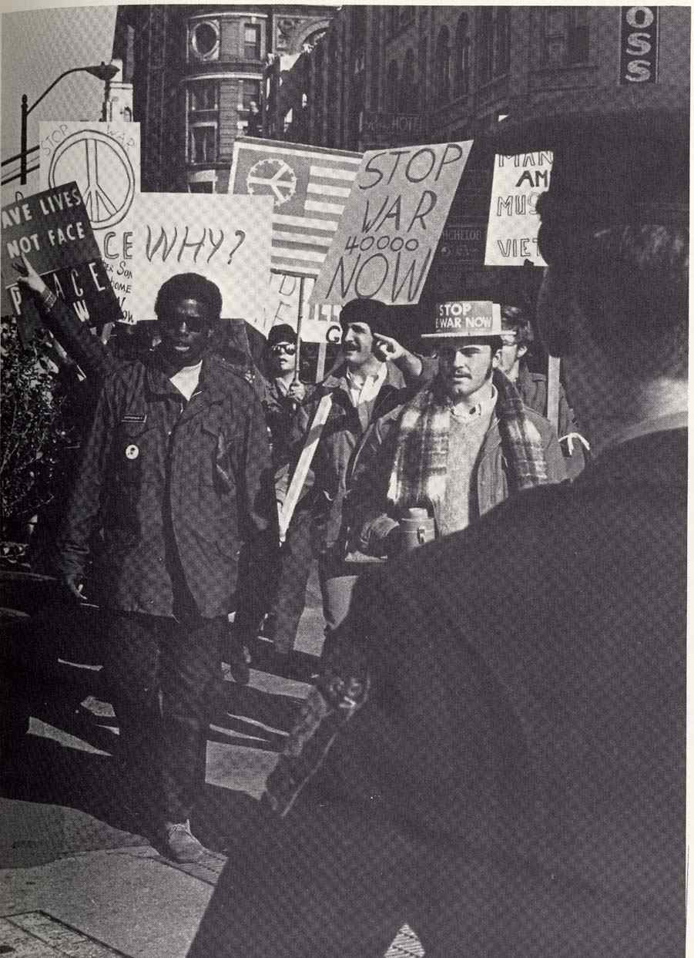](http://blog.lib.utc.edu/archivist/2011/02/10/celebrate-black-history-month/homecoming-1975/)

1. Picture of Vietnam War Protest in 1970. Picture accessed from: <http://blog.lib.utc.edu/archivist/2011/02/10/celebrate-black-history-month/vietnam-war-protest-1970/>

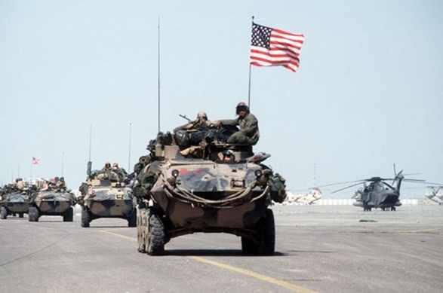

1. Picture of Desert Storm in 1991. Picture accessed from: <http://defence.pk/threads/operation-desert-storm.118835/>

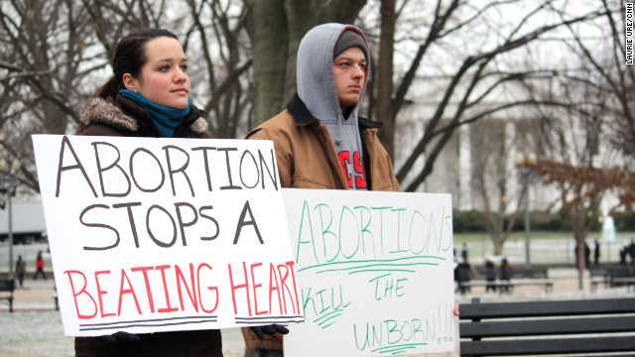

1. 39th Anniversary of Roe vs. Wade in 2012. Picture accessed from: <http://www.cnn.com/2012/01/22/us/dc-abortion-protest/>

**Bibliography**

Bulgren, J., Schumaker, J., & Deshler, D. (1993). *The Concept Mastery Routine.* Lawrence, Kansas: Edge Enterprises.

Ellis, E. (1998). *The Framing Routine.*  Lawrence, KS: Edge Enterprises.

Knight, J. (2013). *High-Impact Instruction: A Framework for Great Teaching.* Thousand Oaks, CA: Corwin.

Larson, B. & Keiper, T. (2011). *Instructional Strategies for Middle and Secondary Social Studies: Methods, Assessment, and Classroom Management.* New York, NY: Routledge.