**Section 5- Moving onto individual lesson planning (first a lesson catalogue for each lesson – followed by detailed lesson plan for each lesson)**

|  |  |
| --- | --- |
| Lesson #1 Overview  **Title**  **/Standards** | Westward Expansion Unit Overview  VA SOL: USI8a-d  The student will demonstrate knowledge of westward expansion and reform in America from 1801 to 1861 by  8a) describing territorial expansion and how it affected the political map of the United States, with emphasis on the Louisiana Purchase, the Lewis and Clark expedition, and the  acquisitions of Florida, Texas, Oregon, and California;  8b) identifying the geographic and economic factors that influenced the westward movement of settlers;  8c) describing the impact of inventions, including the cotton gin, the reaper, the steamboat, and the steam locomotive, on life in America;  8d) identifying the main ideas of the abolitionist and women’s suffrage movements.  NCSS: II: Time, Continuity, and Change  III: People, Places, and Environments |
| **Big Question for lesson**  **(from teaching thesis)** | Why is Westward Expansion an important period in U.S. History? |
| **Specific lesson Objectives (transfer from above).**  **Content focused/action verbs** | Objective 1: Students will be introduced to the Westward Expansion Unit through the Unit Organizer routine.  Objective 2: Students will be introduced to the unit through a guided reading in the *Our America to 1865* textbook. |
| **Assessment of Objective(s)**  **e.g. Obj 1=**  **Obj 2=**  **(you do not need to formally assess all objectives individually – can do them as a group if appropriate)** | Objective 1: Will assess students prior knowledge through asking them questions about whether they know where to put the answers in the Unit Organizer frame.  Objective 2: Will assess students reading level and their ability to comprehend the information through asking questions throughout the guided reading. |
| **Brief explanation of scope of lesson (explanation of tasks, and assessments)** | Students will be introduced to the Westward Expansion Unit in this lesson through an anticipation guide, the Unit Organizer Routine, a short YouTube video clip, and a guided reading from the *Our America to 1865* textbook. Through these activities I can assess student’s prior knowledge about Westward Expansion and give them the necessary background knowledge in order to further study this period of American history. |
| **How are you trying to motivate students in your opener? What is your closure?** | I am trying to motivate students in my opener by providing them statements in the anticipation guide that they will to pay attention to throughout the Unit in order to find out the answers. My closure will try to tie together what they have learned through asking “Why do you think the Westward Expansion Unit is an important period in U.S. History?” |

**Section 6. Detailed lesson Plan**

**Title: Westward Expansion Unit Overview**

**Grade and Subject: 6th Grade U.S. History to 1865**

**Time Allotted: 54 min**

|  |  |  |  |
| --- | --- | --- | --- |
| **SOL #:** | USI8a-d | **NCSS Theme:** | II, III |

|  |  |
| --- | --- |
| What is the **guiding question** for this lesson?  Must be presented in the lesson to students | Why is Westward Expansion an important period in U.S. History? |
| How will student understanding be **assessed**?  -include assessments. | Informative through how they answer oral questions from me related to the Unit Organizer Routine and Guided Reading. |

**Key Concepts (no definition necessary):**

Westward Expansion Territory

Manifest Destiny Invention

Abolitionist Women’s Suffrage

**SWBAT (as many as required by lesson):**

**#1** Students will be able to demonstrate an overview of the Westward Expansion Unit through completing the Unit Organizer Routine.

**#2** Students will be able to understand the importance of the Westward Expansion period through a guided reading.

**Materials (List and attach primary sources and additional materials-ppt and question frames /concept maps/ Frames etc.):**

Anticipation Guide Unit Organizer Frame

*Our America to 1865* Textbook

*Schoolhouse Rock-Elbow Room* YouTube Clip: <http://www.youtube.com/watch?v=FfoQBTPY7gk>

**Just Do It (hook):** 10 min- Students will complete an anticipation guide for the Unit, and we will then briefly go over their responses; however, the answers will not be given. As the unit progresses students will be able to answer the questions on the guide, and use it as a study guide.

|  |  |  |
| --- | --- | --- |
| **Obj #** | ***Description of Lesson Procedure*** | **Check for Evidence of Understanding** |
| 1 | Unit Organizer Routine 25 min- I will give the class an empty Unit Organizer Routine that we will fill in and complete as a class. Students can help each other out in filling out the routine as well. | Walk around class to make sure students are completing the Unit Organizer, and ask students questions about where evens go in the Unit Organizer Routine to assess prior knowledge. |
| Transition: Short Youtube video clip 4 min- I will play the *Schoolhouse Rock- Elbow Room* video clip in-between activities to generate student interest for the Unit. | | |
| 2 | Guided Reading activity 10 min- I will call on students to read the *America Grows Bigger Section* on pg. 124-125. | I will assess students reading ability and ask questions about the reading to assess their comprehension. |
| Transition: | | |
|  |  |  |

**Closure (How does this come back to the guiding question):**  5 min- Have students respond on their own piece of paper to the question, “Why do you think the Westward Expansion Unit is an important period in U.S. History?”

**Modifications/Differentiation:** Some students may need to be handed a partially completed copy of the Unit Organizer routine before the lesson.

**Section 5- Moving onto individual lesson planning (first a lesson catalogue for each lesson – followed by detailed lesson plan for each lesson)**

|  |  |
| --- | --- |
| Lesson #2 Overview  **Title**  **/Standards** | U.S Territorial Gains Overview  VA SOL 1f, 8a  1f) analyze and interpret maps to explain relationships among landforms, water features, climatic characteristics, and historical events  8a) describing territorial expansion and how it affected the political map of the United States, with emphasis on the Louisiana Purchase, the Lewis and Clark expedition, and the  acquisitions of Florida, Texas, Oregon, and California  NCSS: II: Time, Continuity, and Change  III: People, Places, Environments |
| **Big Question for lesson**  **(from teaching thesis)** | What territories did the U.S. gains in the first half of the 1800’s and why is this significant? |
| **Specific lesson Objectives (transfer from above).**  **Content focused/action verbs** | Objective 1: Students will complete a Frame on the territories gained by the U.S.  Objective 2: Students will be able to locate where these territorial acquisitions are located on a map. |
| **Assessment of Objective(s)**  **e.g. Obj 1=**  **Obj 2=**  **(you do not need to formally assess all objectives individually – can do them as a group if appropriate)** | Objective 1: Students prior knowledge will be assessed to see if they know where the information goes in the frame.  Objective 2: Students prior knowledge about where these territories are will be assessed in the map activity. |
| **Brief explanation of scope of lesson (explanation of tasks, and assessments)** | In this lesson students will be given an overview of the territories the U.S. gained in the early 1800’s and they will also know where they territories are located. |
| **How are you trying to motivate students in your opener? What is your closure?** | I will try to motivate students in the opener by showing them pictures of present day cities or landmarks in these territories in order to show them the relevance of the lesson to today. By the closure students should know which city or landmark is located in which territory. |

**Section 6. Detailed lesson Plan**

**Title:** U.S. Territorial Gains Overview

**Grade and Subject:** 6th Grade U.S. History to 1865

**Time Allotted:** 54 min

|  |  |  |  |
| --- | --- | --- | --- |
| **SOL #:** | 1f, 8a | **NCSS Theme:** | II, III |

|  |  |
| --- | --- |
| What is the **guiding question** for this lesson?  Must be presented in the lesson to students | What territories did the U.S. gain in the first half of the 1800’s, and why is it significant today? |
| How will student understanding be **assessed**?  -include assessments. | Students will be assessed formatively through the picture opening and close, the frame, and the map activity. |

**Key Concepts (no definition necessary):**

Territory Louisiana Purchase

Florida Texas

Oregon California

**SWBAT (as many as required by lesson):**

**#1** Students will be able to explain which territories the U.S. gained in the first half of the 1800’s.

**#2** Students will be able to locate the territories gained on a map.

**Materials (List and attach primary sources and additional materials-ppt and question frames /concept maps/ Frames etc.):**

Landmark Pictures

Territory Frame

Smartboard for US Geography Review

Copies of U.S. Maps for students

Colored Pencils

**Just Do It (hook):**  Opening pictures 5 min- students will be shown on the

Smartboard five modern pictures of cities or landmarks in the territories gained by the U.S. during this time period. They will have to guess where these pictures are. We will orally discuss the answers as a class.

|  |  |  |
| --- | --- | --- |
| **Obj #** | ***Description of Lesson Procedure*** | **Check for Evidence of Understanding** |
| 1 | Frame of Territories-25 min- I will hand out an uncompleted frame that we will fill in and complete as a class. Students can help each other in completing the frame. | Ask questions throughout the Frame to assess students’ knowledge. |
| Transition: U.S. Geography Review- 7min- I will call on students to come up to the Smart board to identity major geographic features in the U.S. like the Rocky Mountains, Mississippi River, Rio Grande River, etc. | | |
| 2 | Map Activity-13min- I will hand out students U.S. Maps. As a class we will fill out with the colored pencils where each territorial acquisition is located. Students can work together and use their textbooks as well to fill out the maps. | Walk around class during activity, and ask questions about where the students think the territories are located. |
| Transition: | | |
|  |  |  |

**Closure (How does this come back to the guiding question):**  Closing pictures-4 min- We will come back to the five opening pictures and as a class we will match the five opening pictures to the territories and other countries that they used to belong to. They will also determine if these landmarks were there before they became a part of the U.S. In many cases most of these landmarks in the pictures where not there when they were not part of the U.S. The purpose of both the opening and the closing is to make the lesson relevant to today.

**Modifications/Differentiation:** Some students may need to be provided a partially completed frame and map.

**Section 5- Moving onto individual lesson planning (first a lesson catalogue for each lesson – followed by detailed lesson plan for each lesson)**

|  |  |
| --- | --- |
| Lesson #3 Overview  **Title**  **/Standards** | Louisiana Purchase  SOL: USI 1f,8a  1f) analyze and interpret maps to explain relationships among landforms, water features, climatic characteristics, and historical events  8a) describing territorial expansion and how it affected the political map of the United States, with emphasis on the Louisiana Purchase, the Lewis and Clark expedition, and the  acquisitions of Florida, Texas, Oregon, and California  NCSS: II: Time, Continuity, and Change  III: People, Places, and Environments |
| **Big Question for lesson**  **(from teaching thesis)** | What was the Louisiana Purchase and why was it a significant event in U.S. History? |
| **Specific lesson Objectives (transfer from above).**  **Content focused/action verbs** | Objective 1: Students will be able to explain what the Louisiana Purchase is and why it is important.  Objective 2: Students will be to explain the significance of the Lewis and Clark expedition. |
| **Assessment of Objective(s)**  **e.g. Obj 1=**  **Obj 2=**  **(you do not need to formally assess all objectives individually – can do them as a group if appropriate)** | Objective 1: I will informatively assess students responses from the Jigsaw  Objective 2: The questions on the video worksheet and the closing question will help students in answering that question. |
| **Brief explanation of scope of lesson (explanation of tasks, and assessments)** | In this Lesson students will learn about the Louisiana Purchase and its importance in U.S. History. The class will do a Jigsaw through dividing the textbook reading pg. 126-129 of *Our America to 1865* on the Louisiana Purchase, as well as the Lewis and Clark expedition. We will then watch part of a video on the Lewis and Clark Expedition. Students will complete a short worksheet on the video. |
| **How are you trying to motivate students in your opener? What is your closure?** | I will try to motivate students in the opener by having them brainstorm a list of what $15 million will have you buy today, in order to show them the importance of the Louisiana Purchase. The closing question will ask the students what they think the importance of the Louisiana Purchase is. |

**Section 6. Detailed lesson Plan**

**Title: Louisiana Purchase**

**Grade and Subject: 6th U.S. History to 1865**

**Time Allotted: 54 min**

|  |  |  |  |
| --- | --- | --- | --- |
| **SOL #:** | 1f, 8a | **NCSS Theme:** | II, III |

|  |  |
| --- | --- |
| What is the **guiding question** for this lesson?  Must be presented in the lesson to students | Why is the Louisiana Purchase a significant event in U.S. History? |
| How will student understanding be **assessed**?  -include assessments. | Student understanding will be assessed through the Jigsaw and Video worksheet. |

**Key Concepts (no definition necessary):**

Louisiana Purchase

Meriwether Lewis

William Clark

**SWBAT (as many as required by lesson):**

**#1** Students will be able to explain the importance of the Louisiana Purchase in American history.

**#2** Students will be able to explain the importance of the Lewis and Clark Expedition.

**Materials (List and attach primary sources and additional materials-ppt and question frames /concept maps/ Frames etc.):**

*Our America to 1865* Textbook

Smartboard

National Geographic *1804-1806 Lewis and Clark Documentary* on YouTube: <http://www.youtube.com/watch?v=Mc9tG9aD3P4>

Video Worksheet

**Just Do It (hook):** 5 min-On a sheet of paper students will brainstorm a list of things they could buy for $15 million dollars today. The purpose of this is to show them how much of a bargain the Louisiana Purchase was.

|  |  |  |
| --- | --- | --- |
| **Obj #** | ***Description of Lesson Procedure*** | **Check for Evidence of Understanding** |
| 1 | Louisiana Purchase Jigsaw- 24 min- The Jigsaw activity will cover pg. 126-129 of our America to 1865. There will be four experts groups as readings will be divided by page. We will come back together as a class and discuss the readings. | Walk around during the Jigsaw to check on student progress and students answers during the discussion. |
| Transition: 5 min-Have a couple of students come up to draw the Louisiana Purchase on the Smart board map, good review | | |
| 2 | 15 min-Students will watch the first part of the National Geographic *1804-1806 Lewis and Clark Documentary* and then we will go over the answers to the video worksheet. | Answers students write on their worksheets. |
| Transition: | | |
|  |  |  |

**Closure (How does this come back to the guiding question):** 5 min-On the back of their video worksheet students will list three reasons why they think the Louisiana Purchase is such an important event in U.S. History?

**Modifications/Differentiation:** Some students may have to be provided some answers for the video worksheet. Make sure certain students are paired with certain students during the Jigsaw activity.

**Section 5- Moving onto individual lesson planning (first a lesson catalogue for each lesson – followed by detailed lesson plan for each lesson)**

|  |  |
| --- | --- |
| Lesson #4 Overview  **Title**  **/Standards** | Other U.S. Territorial Gains  SOL: 1f,8a  1f) analyze and interpret maps to explain relationships among landforms, water features, climatic characteristics, and historical events  8a) describing territorial expansion and how it affected the political map of the United States, with emphasis on the Louisiana Purchase, the Lewis and Clark expedition, and the  acquisitions of Florida, Texas, Oregon, and California  NCSS: II: Time, Continuity, and Change  III: People, Places, and Environments |
| **Big Question for lesson**  **(from teaching thesis)** | What other territories did the U.S. gain in the first half of the 1800’s and why is this important. |
| **Specific lesson Objectives (transfer from above).**  **Content focused/action verbs** | Objective 1: Students will learn what territories the U.S. gained in the first half of the 1800’s and how they were gained.  Objective 2: Students will understand the importance of U.S. territorial gains from Mexico. |
| **Assessment of Objective(s)**  **e.g. Obj 1=**  **Obj 2=**  **(you do not need to formally assess all objectives individually – can do them as a group if appropriate)** | Objective 1: The Read- Think-Pair-Share will help formatively assess student’s comprehension of this objective.  Objective 2: The Read- Think-Pair-Share, Video Worksheet, and Current Event closure can help assess whether students have met this objective. |
| **Brief explanation of scope of lesson (explanation of tasks, and assessments)** | This lesson will be in similar format to the previous lesson. There will be Read-Think-Pair-Share activity on pg. 130-131 of the *Our America to 1865* and a part of the PBS video on the Mexican-American War related to the treaty of Guadalupe Hidalgo. Students will complete a worksheet on the video and the closure will be an article on the Mexican viewpoint of losing half of their territory to the U.S. |
| **How are you trying to motivate students in your opener? What is your closure?** | I will try to motivate students in the opener with assessing their prior knowledge on the Mexican-American War. This should get their interest up in wanting to learn more about the war, and the massive territorial gains resulting from the war. The closure will be an article related to the lesson, to show that the impacts from these territorial gains are still felt today. |

**Section 6. Detailed lesson Plan**

**Title: Other U.S. Territorial Gains**

**Grade and Subject: 6th U.S. History to 1865**

**Time Allotted: 54 min**

|  |  |  |  |
| --- | --- | --- | --- |
| **SOL #:** | 1f, 8a | **NCSS Theme:** | II, III |

|  |  |
| --- | --- |
| What is the **guiding question** for this lesson?  Must be presented in the lesson to students | What other territories did the U.S gain the in first half of the 1800’s, and why are these gains still significant today? |
| How will student understanding be **assessed**?  -include assessments. | Students prior knowledge will be assessed in the opening. The Read-Write-Think-Pair-Share, and video worksheet will formatively assess students comprehension of the material. The current event at the close of class will assess students making connections from historical events to today. |

**Key Concepts (no definition necessary):**

Florida Texas

Oregon Mexican-American War

California

**SWBAT (as many as required by lesson):**

**#1** Students will be able to identity which territories the U.S. gained in the first half of the 1800’s.

**#2** Students will be able to explain the significance of U.S. territorial gains from Mexico.

**Materials (List and attach primary sources and additional materials-ppt and question frames /concept maps/ Frames etc.):**

*Our America to 1865* textbook

Smartboard

PBS Video on Mexican-American War on YouTube: <http://www.youtube.com/watch?v=PdfYPI_3ojs&list=PL4FB761427E3E310F>

Video Worksheet

*The Opposing Viewpoints* Article: <http://www.umich.edu/~ac213/student_projects06/magsylje/viewpoints.html>

**Just Do It (hook):** Opening question 5min- students will answer the opening question “What do you know about the Mexican American War?”

|  |  |  |
| --- | --- | --- |
| **Obj #** | ***Description of Lesson Procedure*** | **Check for Evidence of Understanding** |
| 1 | Read- Think-Pair -Share: 20 min- Our class will do this activity on pg. 130-131 of *Our America to 1865*, and wrap the activity up with a class discussion. | Checking on student progress during the Read-Think-Pair-Share and assessing the responses students give during the discussion. |
| Transition: 4 min-have a couple of students come up to identify the territorial gains on the Smartboard | | |
| 2 | PBS Mexican-American War video 15 min- Students will watch the portion of the video on the Treaty of Guadalupe Hidalgo which resulted in Mexico losing half its territory to the U.S. | Student responses on video worksheet |
| Transition: | | |
|  |  |  |

**Closure (How does this come back to the guiding question):** Closing article 10 min- students will read the article *The Opposing Viewpoints* and we will have a class discussion on how Mexicans feel about losing half of their territory to the U.S. This will help students answer the part of the big question on why these territorial gains are still significant today.

**Modifications/Differentiation:** Some students may have to be provided some answers on the video worksheet. Certain students may need by paired with certain students during the Read-Think-Pair-Share.

**Section 5- Moving onto individual lesson planning (first a lesson catalogue for each lesson – followed by detailed lesson plan for each lesson)**

|  |  |
| --- | --- |
| Lesson #5 Overview  **Title**  **/Standards** | Westward Expansion Territorial Gains Timeline  VA SOL: 1c, 8a  1c) sequence events in United States history from pre-Columbian times to 1865;  8a) describing territorial expansion and how it affected the political map of the United States, with emphasis on the Louisiana Purchase, the Lewis and Clark expedition, and the  acquisitions of Florida, Texas, Oregon, and California  NCSS: II: Time, Continuity, and Change |
| **Big Question for lesson**  **(from teaching thesis)** | What is a timeline and how can it be used to help understand historical events? |
| **Specific lesson Objectives (transfer from above).**  **Content focused/action verbs** | Objective 1: Students will learn what a timeline is and how it can be used.  Objective 2: Students will construct a timeline of the territorial gains during the Westward Expansion time period. |
| **Assessment of Objective(s)**  **e.g. Obj 1=**  **Obj 2=**  **(you do not need to formally assess all objectives individually – can do them as a group if appropriate)** | Objective 1: I will formatively assess student’s construction of a timeline of their own life journeys.  Objective 2: I will formatively assess student’s construction of their territorial gain outline. |
| **Brief explanation of scope of lesson (explanation of tasks, and assessments)** | This lesson will help bring together the information students learned earlier in the week. They will learn about timelines, create one of their own life journeys, and then create one on U.S. territorial gains during Westward Expansion. This timeline can be a good study guide for the students. |
| **How are you trying to motivate students in your opener? What is your closure?** | I am trying to motivate students in the opener by relating the lesson to their personal lives. My closure will be an Exit Slip to assess whether students had learned anything from this week or if I need to re-assess what I did in order to help students learn. |

**Section 6. Detailed lesson Plan**

**Title:** Westward Expansion Territorial Gains Timeline

**Grade and Subject:** 6th U.S. History to 1865

**Time Allotted:** 54 min

|  |  |  |  |
| --- | --- | --- | --- |
| **SOL #:** | 1c, 8a | **NCSS Theme:** | II |

|  |  |
| --- | --- |
| What is the **guiding question** for this lesson?  Must be presented in the lesson to students | How can a timeline be used to help students better understand historical events? |
| How will student understanding be **assessed**?  -include assessments. | Construction their own personal timeline, a timeline of territorial gains, and the Exit Slip |

**Key Concepts (no definition necessary):**

Timeline

**SWBAT (as many as required by lesson):**

**#1** Students will be able to create a timeline of important events in their lives.

**#2** Students will be able to create a timeline of U.S. territorial gains during Westward Expansion.

**Materials (List and attach primary sources and additional materials-ppt and question frames /concept maps/ Frames etc.):**

Copies of Timelines for the students

Colored Pencils

**Just Do It (hook):** 5 min- Brainstorm a list of important events in your life

|  |  |  |
| --- | --- | --- |
| **Obj #** | ***Description of Lesson Procedure*** | **Check for Evidence of Understanding** |
| 1 | Personal Timeline 15 min- Students will complete a personal timeline of important events in their lives. I will demonstrate mine as an example before the students complete their own. | Walk around the classroom to see how students are completing their timelines. |
| Transition:5 min- a couple of students will share their Personal Timelines | | |
| 2 | Territorial Gain Timeline 25 min- students will complete this timeline and write information about that event, fill in boxes will be provided, and students can color the timeline. Students can also work together on them. | Walk around classroom to check on student progress on timeline, and collect them. The timelines will be returned to them on Monday. |
| Transition: | | |
|  |  |  |

**Closure (How does this come back to the guiding question):** Exit Slip 5 min- Students will be handed a 3-2-1 Exit Slip to complete and turn in on their way out the door. The Exit Slip will help me assess whether the students understood the use of the timeline and comprehended other concepts earlier in the week. We will go over them as a class on Monday.

**Modifications/Differentiation:** Some students may have to be provided partially completed timelines.

**Appendix**

Lesson #1

**Westward Expansion Unit Anticipation Guide**

**Directions:** For each statement circle whether you believe it to be True of False. We will go your responses; however, the answers will not be revealed because we will discover the answers as we go further along in the unit.

**Before Unit**

1. George Washington was the President that bought the Louisiana Purchase from France.

TRUE FALSE

2. For a brief period during its history, Texas was an independent country.

TRUE FALSE

3. Before the Mexican-American War California was a part of Mexico.

TRUE FALSE

4. In the 1800’s Americans did not believe in Manifest Destiny.

TRUE FALSE

5. Cheap land was a major why many Americans migrated West.

TRUE FALSE

6. Eli Whitney invented the Cotton Gin, which resulted in the need for increased slave labor in the South.

TRUE FALSE

7. The tugboat was a major invention in the 1800’s that improved water transportation.

TRUE FALSE

8. Abraham Lincoln was a leader of both the abolitionist and Women’s Suffrage Movements.

TRUE FALSE

9. Abolitionists believed that slavery was morally wrong and therefore should be ended.

TRUE FALSE

10. One of the goals of the Women’s Suffrage Movement was to help promote equal education opportunities for women.

TRUE FALSE

**During Unit**

1. George Washington was the President that bought the Louisiana Purchase from France.

TRUE FALSE

2. For a brief period during its history, Texas was an independent country.

TRUE FALSE

3. Before the Mexican-American War California was a part of Mexico.

TRUE FALSE

4. In the 1800’s Americans did not believe in Manifest Destiny.

TRUE FALSE

5. Cheap land was a major why many Americans migrated West.

TRUE FALSE

6. Eli Whitney invented the Cotton Gin, which resulted in the need for increased slave labor in the South.

TRUE FALSE

7. The tugboat was a major invention in the 1800’s that improved water transportation.

TRUE FALSE

8. Abraham Lincoln was a leader of both the abolitionist and Women’s Suffrage Movements.

TRUE FALSE

9. Abolitionists believed that slavery was morally wrong and therefore should be ended.

TRUE FALSE

10. One of the goals of the Women’s Suffrage Movement was to help promote equal education opportunities for women.

TRUE FALSE

Lesson#2

**Opening Pictures**

Note: These pictures would be shown on the Smart board at the beginning of class. We will go over the answers orally. At the end of class we will come back to these pictures and match them with the territory and country they were a part of before they became a part of the U.S. Students will also have to determine whether these landmarks were in place before they became a part of the U.S. or not.



Epcot at Walt Disney World Florida, Picture accessed from: <https://disneyworld.disney.go.com/destinations/epcot/>

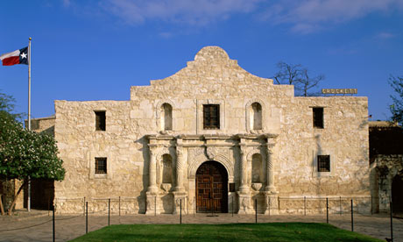

The Alamo, Picture accessed from: <http://www.theguardian.com/world/2013/oct/19/alamo-gun-control-protest-texas>

Plume of steam, gas, and ash viewed from Harry's Ridge (8 km/5 mi north of Mount St. Helens). This particular plume rose nearly 3,000 ft (1,000 m) above the volcano's rim. May 19, 1982.
 (Click image to view full size.)

Mt. Saint Helens 1982, Picture accessed from: <http://volcanoes.usgs.gov/volcanoes/st_helens/st_helens_geo_hist_103.html>

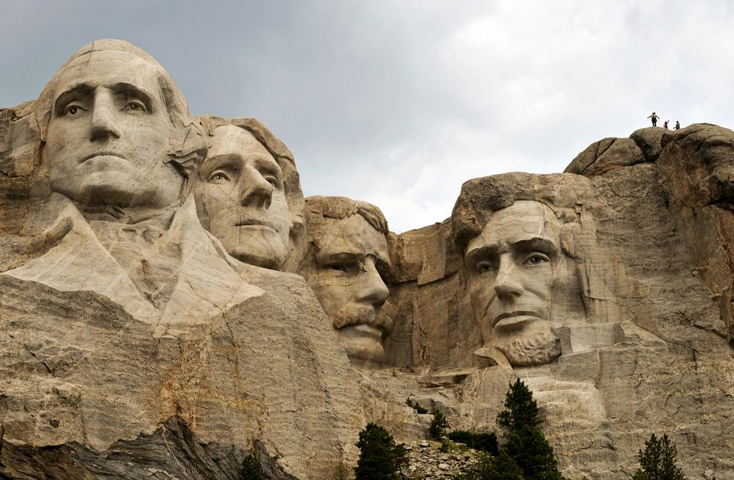

Mount Rushmore, Picture accessed from: <http://travel.nationalgeographic.com/wallpaper/travel/national-parks/your-national-parks-photos/mount-rushmore-national-monument/>

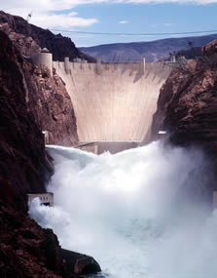

Hoover Dam, Picture accessed from: <https://www.usbr.gov/lc/hooverdam/>

**Sample Map**

Note: This is an example of a map that could be used to complete the map activity, as the territories can be shaded in on the map.

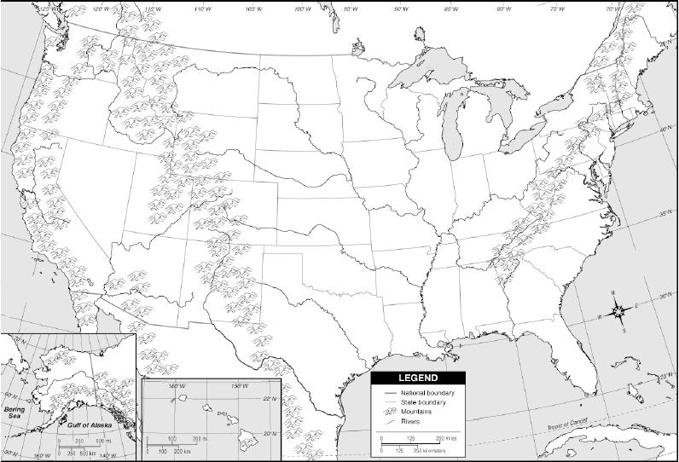

Picture accessed from: <http://courses.ttu.edu/mstoll/HIST2301/2011/Syllabus.htm>

Lesson #3

**Lewis and Clark Expedition Video Worksheet**

1. How old were Meriwether Lewis and William Clark when they began their expedition?

**Answer: 28 and 32**

2. The Louisiana Purchase increased the size of the U.S. by how much?

**Answer: double**

3. What was the main objective of the Lewis and Clark expedition?

**Answer: Find waterway to Pacific or Northwest Passage**

4. On what river did Lewis and Clark begin their expedition on?

**Answer: Missouri River**

5. List at three reasons why the Lewis and Clark expedition so dangerous, even after the journey had just begun?

**Answer: Going upstream on Missouri, in unfamiliar territory, Lewis almost fell to his death just a couple days into the trip, unfriendly Indian tribes, and extreme cold**

Lesson #4

**Mexican Cession Video Worksheet**

1. What was the first foreign capital U.S. troops occupied?

**Answer: Mexico City**

2. Who the chief American negotiator in Mexico City?

**Answer: Nicholas Trist**

3. What was the name of the treaty that ended the Mexican-American War and resulting in Mexico losing a significant amount of its territory to the U.S.? How much money did the U.S. pay Mexico as a result of the treaty?

**Answer: Treaty of Guadalupe Hidalgo, 15 million**

4. Did most Mexicans that lived in territory now under U.S. control stay or moved south into territory controlled by Mexico?

**Answer: they stayed**

5. How much and which territories did Mexico lose to the U.S.?

**Possible Answers: half, California, New Mexico, South Texas**

Lesson #5

**Personal Timeline Example**

Note: Students can color their own timelines or draw important events on it with their color pencils. Also the timelines handed out to students would be in larger than the example on here, and they could go into greater detail on their timelines than on this example.

.

Birth Graduated Dinwiddie High Graduated RBC VT Grad

December 27th 1989 2008 2010 2012

**US Territorial Gains Timeline**

Note: Students can color their own timelines and draw important events on it with their color pencils. Also the timelines handed out to students would be in larger than the example on here, and they could go into greater detail on their timelines than on this example.

.1800 1825

1803- Louisiana Purchase 1819- US gets Florida from Spain

Bought from France for $15 million

Doubled Size of U.S.

1825 1850

1836- Texas breaks 1845-Texas 1846-Oregon 1848- US gains

away from Mexico joins US joins US half of

Mexico

**Territorial Gains Exit Slip**

1. List three new things you learned about U.S. territorial gains in the first half of the 1800’s.

2. What are two questions you have about U.S. territorial gains?

3. What is one thing you want to learn more about with U.S. territorial gains?