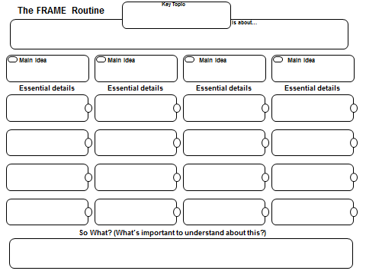

**Settlers Moving West**

**Americans moving west for geographic reasons, economic reasons, and Manifest Destiny.**

**Geographic Reasons Economic Reasons Manifest Destiny How they got West**

**Population growth Cheap land expand from East to West Oregon Trail**

**Plenty of Land 1848 CA Gold Rush God given right Santa Fe Trail**

**Fertile Land logging Native Americans lost land Faster water transport**

**Adventure/Freedom farming Mexico lost Land Erie Canal**

**Settlers moving west for geographic reasons, economic, reasons and Manifest Destiny transformed**

**America.**